**MINISTRY OF EDUCATION AND TRAINING**

**FPT UNIVERSITY**

Capstone Project Document

Website of Law Firm Management System

Report #4 – Software Design Specification

|  |  |
| --- | --- |
| Group 14 | |
| Group Members | Lê Duy Hoàng – Team Leader – SE60744  Đặng Nguyễn Khiêm – Team Member – SE60595  Trần Anh Tuấn – Team Member – SE60631  Phạm Văn Duy – Team Member – SE60634 |
| Supervisor | Nguyễn Văn Sang |
| Capstone Project code | LFMS |

- Ha Noi, 09/2014 –

Contents

**No table of contents entries found.**

## Design Overview

* This document describes the detailed design for both architectural and user interface design of the Law Firm Management System. It includes the architectural design and the detailed design of common functions and business functions. It also includes the design of database model. Each section in this report will describe a perspective of the system specifically.
* The architectural design describes the overall architecture of the system, and the architecture of each main component and subsystem. It will describe the patterns being used, the role of each component and the role of the system in the working environment, gives you an overview how the system is about to work.
* The detailed design describes static and dynamic structure for each component and function. It includes class diagrams, class explanations, and sequence diagrams of the main use cases.
* The database design describes the relationship between entities, and details of each entity.
* The user interface design describes the layout of the system, and some design for the screens.

## System Architectural Design

### Choice of System Architecture

#### System Architecture



Figure 4-1: System Architecture

* Database: This is the central data storage for the system.
* Management site: This is the website to manage Case, Customer, Staff, Service, Office.

#### MVC Architecture

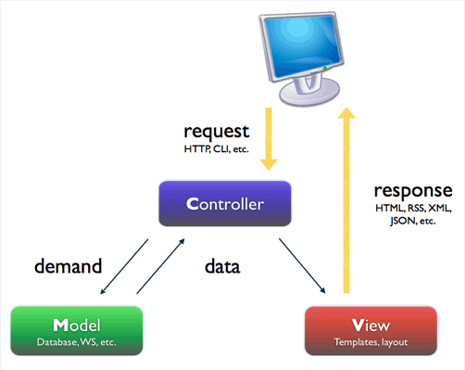

Figure 4-2: MVC Architecture

* Model: Functions that interact with the database or perform complex operations. In this architecture, model includes business logic and data access in one layer.
* View: The view displays the data and also takes input form user. It renders the model data into a form, such as graphics, buttons, and tables, and so on to display to the user.
* Controller: The controller handles all requests coming from the view or user interface. The data flows to whole application are controlled by controller.

### Discussion of Alternative Designs

### Description of System Interface

#### User Interfaces

UI should be simple, model and easy to use.

Support drag & drop easy for using Calendar Event.

#### Hardware Interfaces

The site should be deployed and available to a many devices can be use online.

* Server hardware: Support Windows hosting
* Client hardware: Can be desktop, laptop, smart phone, tablet,.. have internet connection

#### Software Interfaces

Run best on FireFox browser.

#### Communication Interfaces

The system using HTTP protocol to communicate between server and clients.

### Architectural Presentation

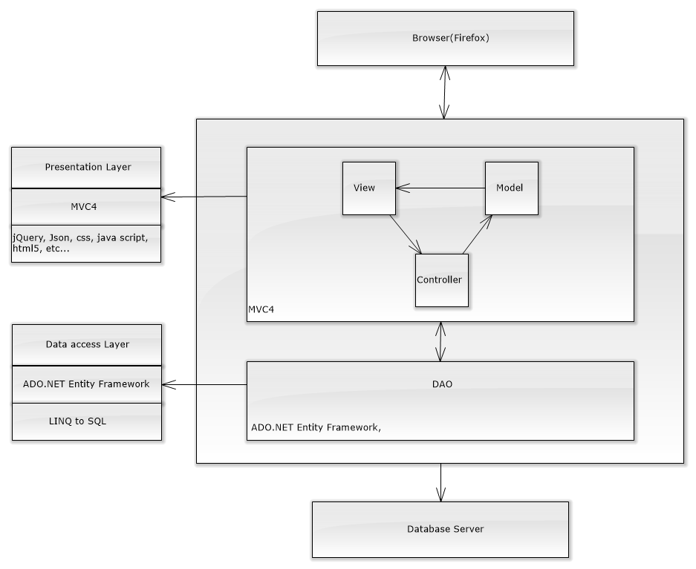

Figure 4-3: System overview

### Package Diagram

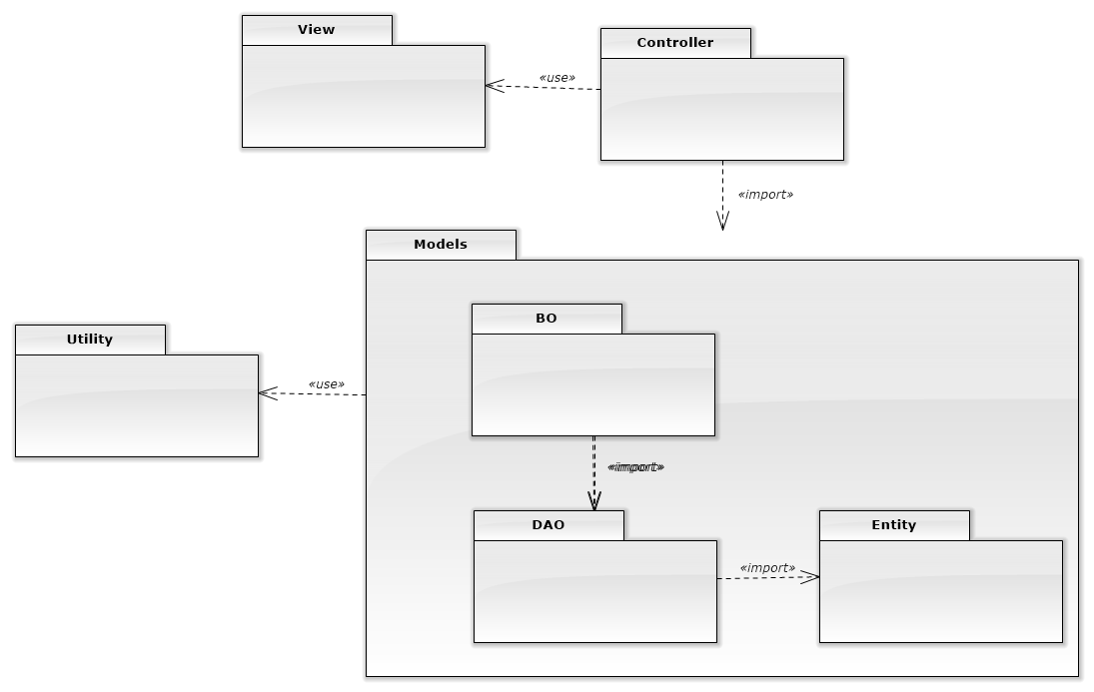

Figure 4-4: Package Diagram

## Detailed Design

### Data Transfer

#### Data Transfer Class Diagram

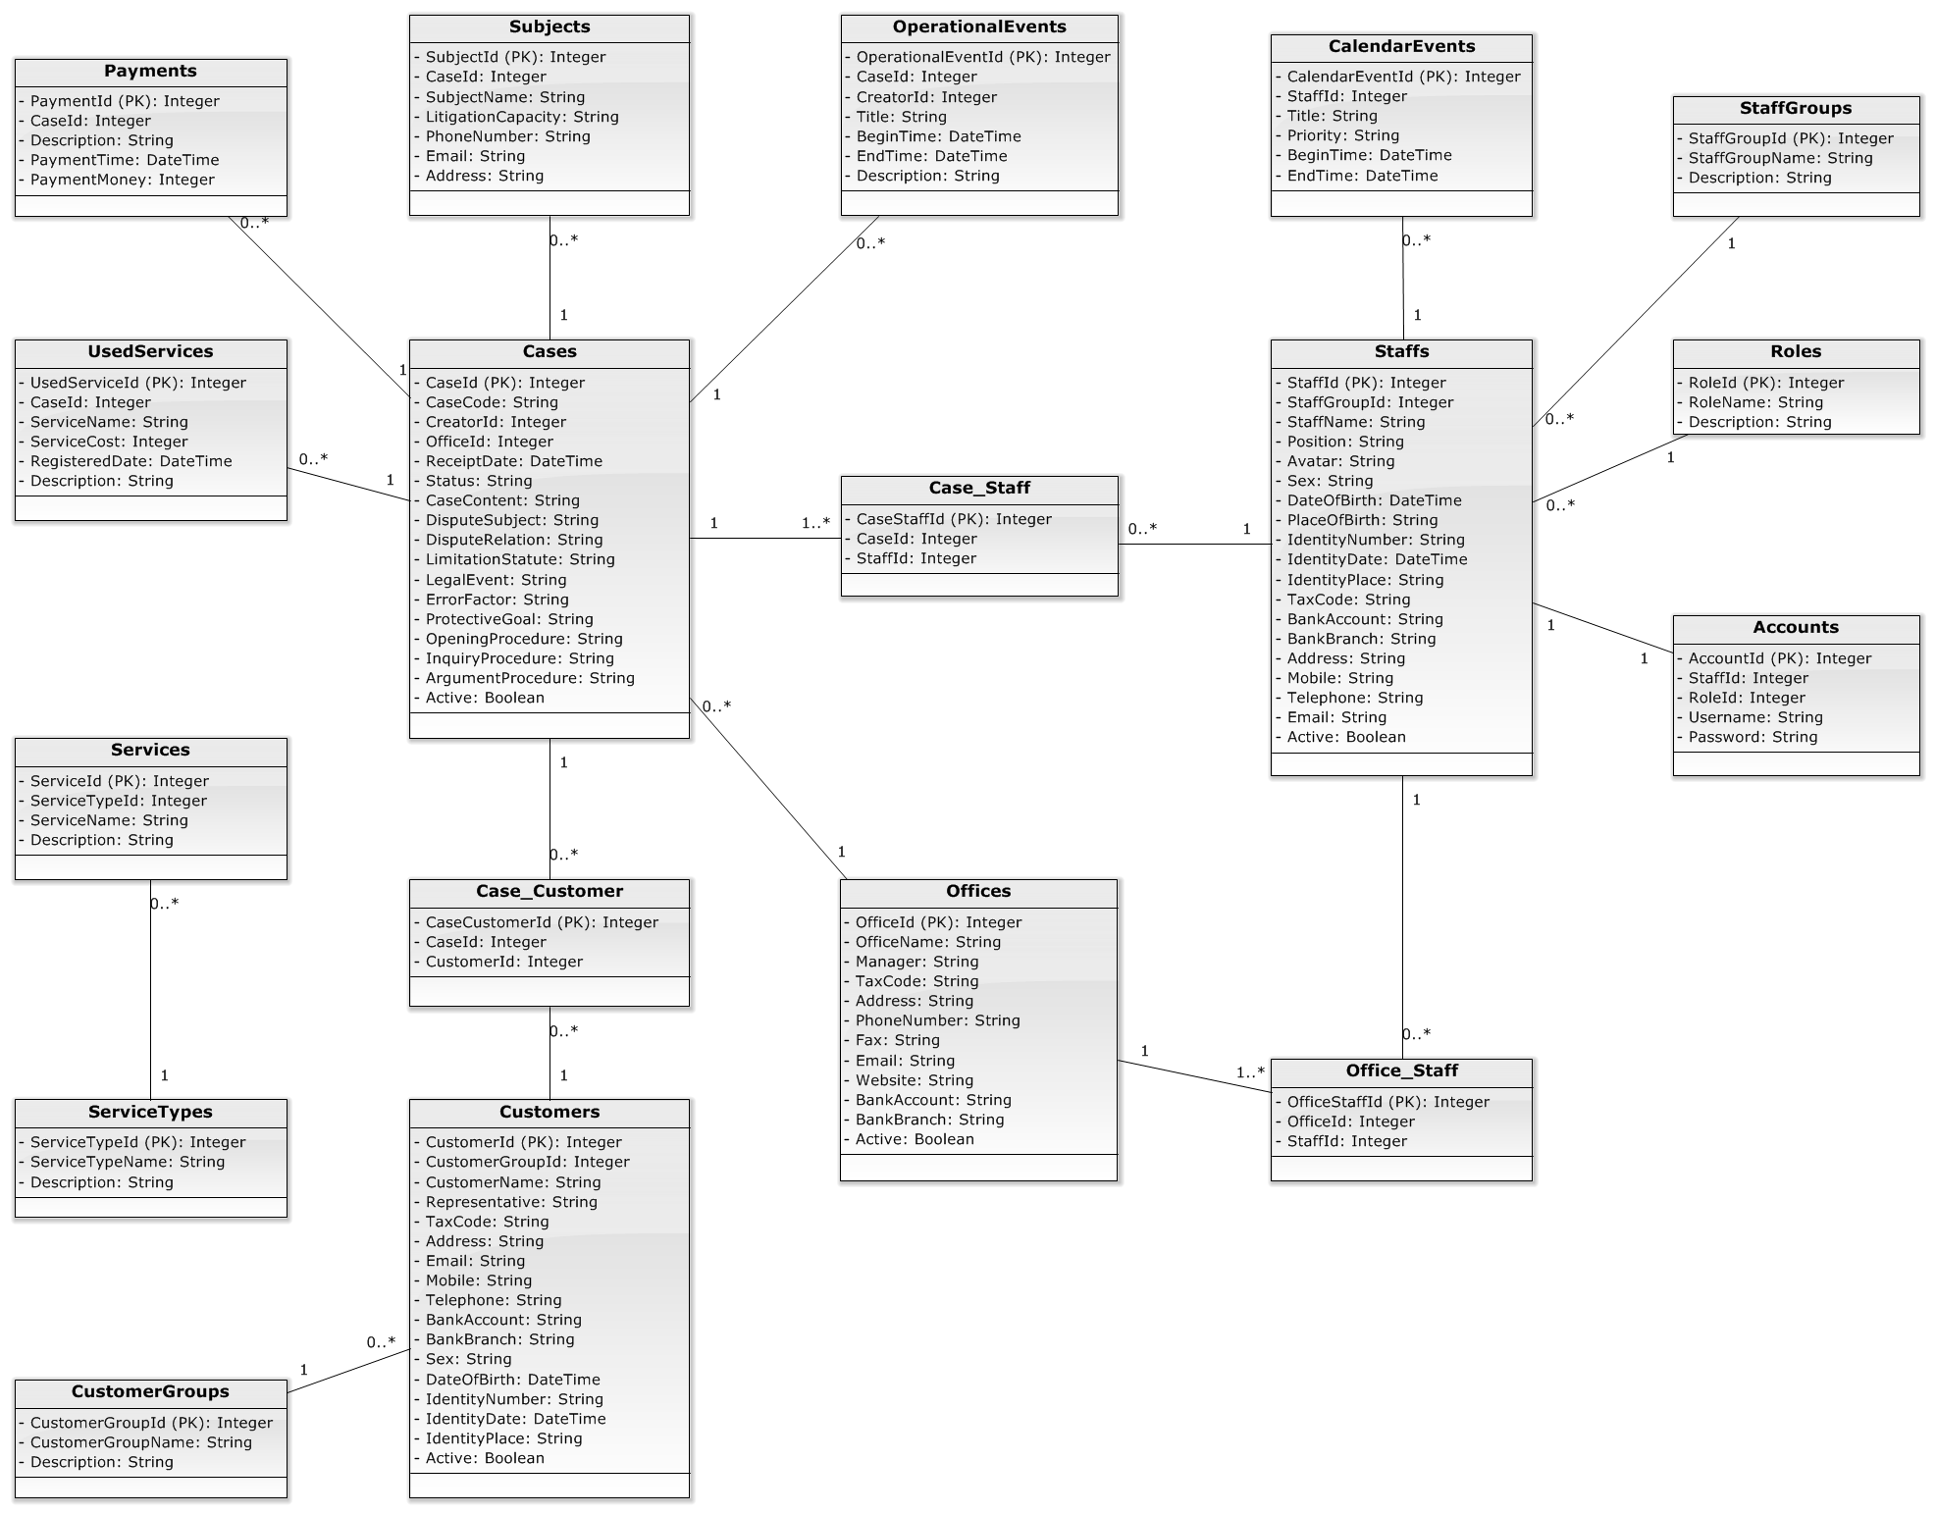

Figure 4-6: Data Transfer Class Diagram

#### Data Transfer Class Diagram Explanation

Reference to DVD: <root>/Documents/LFMS Project Document - Full Report.docx

### Controller

#### Controller Class Diagram

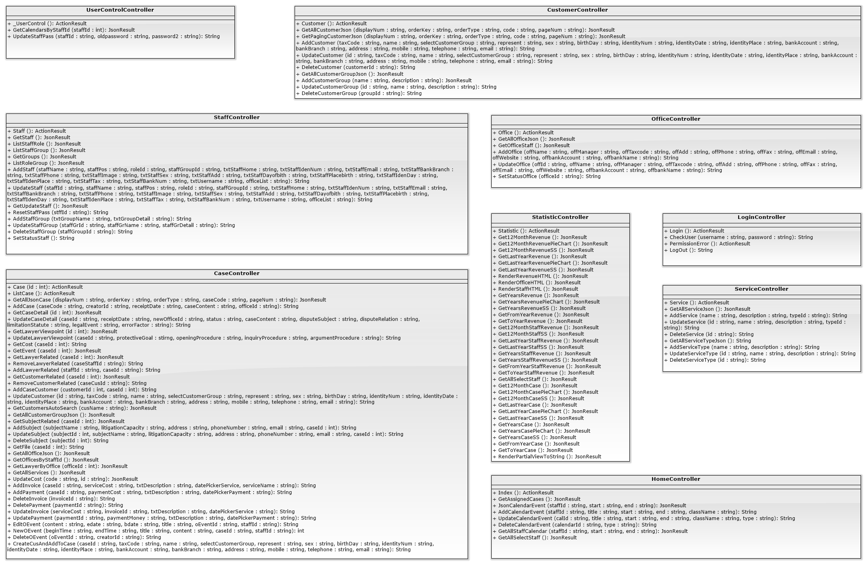

Figure 4-7: Controller Class Diagram

#### Controller Class Diagram Explanation

### Business

#### Business Logic Class Diagram

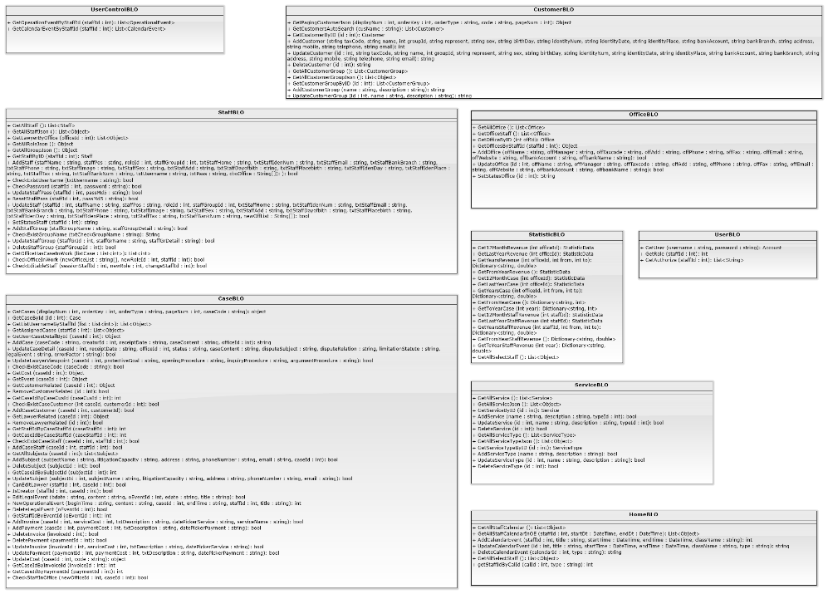

Figure 4-8: Business Class Diagram

#### Business Logic Class Diagram Explanation

##### CustomerBLO

|  |  |  |  |  |
| --- | --- | --- | --- | --- |
| Class | **CustomerBLO** | | | |
| **Description** | Store validation for customerDAO | | | |
| **Base Class** | customerDAO | | | |
| **Constructor** | CustomerBLO | | | |
| **Prototype** | N/A | | | |
| **Source File** | CustomerBLO.m, CustomerBLO.h | | | |
| **Namespace** | N/A | | | |
| **Attributes** | N/A | | | |
| **Methods** | **Name** | **Input** | **Output** | **Description** |
| GetPagingCustomerJson | int displayNum,  int orderKey,  string orderType,  string code,  int pageNum | Object | This method call method of customerDAO to get customer after paging and customer group |
| GetCustomersAutoSearch | string cusName | List<Customer> | This method call method of CustomerDAO to get customer in auto search |
| GetCustomerByID | int id | Customer | This method call method of CustomerDAO to get customer by id |
|  | AddCustomer | string taxCode, string name,  int groupId,  string represent,  string sex,  string birthDay, string identityNum, string identityDate, string identityPlace, string bankAccount, string bankBranch, string address, mobile, telephone, email | int | This method call method of CustomerDAO to add new customer |
|  | UpdateCustomer | int id,  string taxCode, string name,  int groupId,  string represent, string sex, string birthDay, string identityNum, string identityDate, string identityPlace, string bankAccount, string bankBranch, string address,  string mobile,  string telephone, string email | string | This method call method of CustomerDAO to update customer |
|  | DeleteCustomer | int id | string | This method call method of CustomerDAO to delete customer |
|  | GetAllCustomerGroup | N/A | List<CustomerGroup> | This method call method of CustomerDAO to get all customer group |
|  | GetAllCustomerGroupJson | N/A | List<Object> | This method call method of CustomerDAO to get all customer group by Json |
|  | GetCustomerGroupByID | int id | CustomerGroup | This method call method of CustomerDAO to get customer group by id |
|  | AddCustomerGroup | string name,  string description | string | This method call method of CustomerDAO to add new customer group |
|  | UpdateCustomerGroup | int Id,  string name,  string description | string | This method call CustomerDAO to UpdateCustomerGroup |
|  | DeleteCustomerGroup | int id | string | This method call method of CustomerDAO to delete customer group |

##### OfficeBLO

|  |  |  |  |  |
| --- | --- | --- | --- | --- |
| **Class** | **OfficeBLO** | | | |
| **Description** | Store validation for OfficeDAO | | | |
| **Base Class** | OfficeDAO | | | |
| **Constructor** | OfficeBLO | | | |
| **Prototype** | N/A | | | |
| **Source File** | OfficeBLO.m, OfficeBLO.h | | | |
| **Namespace** | N/A | | | |
| **Attributes** | N/A | | | |
| **Methods** | **Name** | **Input** | **Output** | **Description** |
| GetAllOffice | N/A | List<Office> | This method call method of OfficeDAO to get all office |
| GetOfficeStaff | N/A | List<Office> | This method call method of OfficeDAO to get office staff |
| GetOfficeByID | int offId | Office | This method call method of OfficeDAO to get office by id |
|  | GetOfficesByStaffId | int staffId | Object | This method call method of OfficeDAO to get office by staff id |
|  | AddOffice | string offName,  string offManager, string offTaxcode, string offAdd,  string offPhone, string offFax, string offEmail,  string offWebsite, string offbankAccount, string offbankName | bool | This method call method of OfficeDAO to add office |
|  | UpdateOffice | int offId,  string offName,  string offManager, string offTaxcode, string offAdd, string offPhone,  string offFax,  string offEmail,  string offWebsite, string offbankAccount, string offbankName | bool | This method call method of OfficeDAO to update office |
|  | SetStatusOffice | int offId | string | This method call method of OfficeDAO to set status office |

##### StaffBLO

|  |  |  |  |  |
| --- | --- | --- | --- | --- |
| **Class** | **StaffBLO** | | | |
| **Description** | Store validation for staffBLO | | | |
| **Base Class** | staffDAO | | | |
| **Constructor** | staffBLO | | | |
| **Prototype** | N/A | | | |
| **Source File** | staffBLO.m, staffBLO.h | | | |
| **Namespace** | N/A | | | |
| **Attributes** | N/A | | | |
| **Methods** | **Name** | **Input** | **Output** | **Description** |
| GetAllStaff | N/A | List<Staff> | This method call method of staffDAO to get all staff |
| GetAllStaffJson | N/A | List<Staff> | This method call method of staffDAO to get all staff by Json |
| GetLawyerByOffice | int officeId | List<Object> | This method call method of staffDAO to get lawyer by office |
|  | GetAllRoleJson | N/A | Object | This method call method of staffDAO to get all role by Json |
|  | GetAllGroupJson | N/A | Object | This method call method of staffDAO to get all group by Json |
|  | GetStaffByID | int staffId | Staff | This method call method of staffDAO to get staff by id |
|  | AddStaff | string staffName,  string staffPos,  int roleId, int staffGroupId,  string txtStaffHome, string txtStaffIdenNum, string txtStaffEmail,  string txtStaffBankBranch, string txtStaffPhone, string txtStaffImage, string txtStaffSex,  string txtStaffAdd,  string txtStaffDayofbith, string txtStaffPlacebirth, string txtStaffIdenDay, string txtStaffIdenPlace, string txtStaffTax,  string txtStaffBankNum, string txtUsername,  int txtAppendantPeople, string [] cboOffice | bool | This method call method of staffDAO to add new staff |
|  | CheckExistUserName | string txtUsername | bool | This method call method of staffDAO to check exist username |
|  | CheckPassword | int staffId, string password | bool | This method call method of staffDAO to check password |
|  | UpdateStaffPass | int staffId,  string password2 | bool | This method call method of staffDAO to update staff pass |
|  | ResetStaffPass | int staffId | bool | This method call method of staffDAO to reset staff pass |
|  | UpdateStaff | int staffId,  string staffName,  string staffPos,  int roleId, int staffGroupId,  string txtStaffHome, string txtStaffIdenNum, string txtStaffEmail,  string txtStaffBankBranch, string txtStaffPhone,  string txtStaffImage,  string txtStaffSex,  string txtStaffAdd,  string txtStaffDayofbith, string txtStaffPlacebirth, string txtStaffIdenDay, string txtStaffIdenPlace, string txtStaffTax,  string txtStaffBankNum, int detailAppendantPeople, String [] newOffList | bool | This method call method of staffDAO to update staff |
|  | SetStatusStaff | int staffId | string | This method call method of staffDAO to set status staff |
|  | AddStaffGroup | string staffGroupName, string staffGroupDetail, double txtBaseSalary | bool | This method call method of staffDAO to add staff group |
|  | CheckExistGroupName | string txtCheckGroupName | bool | This method call method of staffDAO to check exist group name |
|  | UpdateStaffGroup | int StaffGrId,  string staffGrName,  string staffGrDetail, string txtEditMoney | bool | This method call method of staffDAO to update staff group |
|  | DeleteStaffGroup | int staffGroupId | bool | This method call method of staffDAO to delete staff group |
|  | GetOfficeHasCaseInWork | List<int> listCase | List<int> | This method call method of staffDAO to get office has case in work |
|  | CheckOfficeInWork | String[] newOfficeList,  int newRoleId,  int staffId | bool | This method call method of staffDAO to check office in work |
|  | CheckEditableStaff | int sessionStaffId,  int newRole,  int changeStaffId | bool | This method call method of staffDAO to check editable staff |

### Data Access

#### Data Access Class Diagram

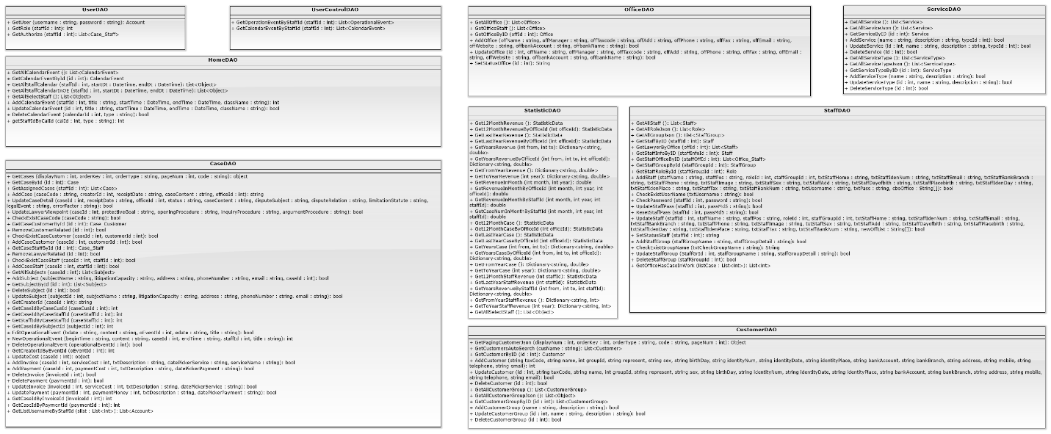

Figure 4-9: Data Access Class Diagram

#### Data Access Class Diagram Explanation

##### UserDAO

|  |  |  |  |  |
| --- | --- | --- | --- | --- |
| **Class** | **UserDAO** | | | |
| **Description** | This class excute all authorization to database | | | |
| **Base Class** | N/A | | | |
| **Constructor** | UserDAO | | | |
| **Prototype** | N/A | | | |
| **Source File** | UserDAO.cs | | | |
| **Attributes** | N/A | | | |
| **Methods** | **Name** | **Input** | **Output** | **Description** |
| GetUser | string username, string password | Account | Get account from database to check in login. |
| GetRole | int staffId | int | Get role of staff from database |
| GetAuthorize | int staffId | List<Case_Staff> | Get all id of case of staff to check Authorize from database |

##### UserControlDAO

|  |  |  |  |  |
| --- | --- | --- | --- | --- |
| **Class** | UserControlDAO | | | |
| **Description** | This class excute to get notification of staff about event and calendar from database | | | |
| **Base Class** | N/A | | | |
| **Constructor** | UserControlDAO | | | |
| **Prototype** | N/A | | | |
| **Source File** | UserControlDAO.cs | | | |
| **Attributes** | N/A | | | |
| **Methods** | **Name** | **Input** | **Output** | **Description** |
| GetOperationEventByStaffId | int staffId | List<OperationalEvent> | System excute to get operation event by staff id from database. |
| GetCalendarEventByStaffId | int staffId | int | System excute to get calendar event by staff id from database |

##### OfficeDAO

|  |  |  |  |  |
| --- | --- | --- | --- | --- |
| **Class** | **OfficeDAO** | | | |
| **Description** | This class excute all action of office to database | | | |
| **Base Class** | N/A | | | |
| **Constructor** | OfficeDAO | | | |
| **Prototype** | N/A | | | |
| **Source File** | OfficeDAO.cs | | | |
| **Attributes** | N/A | | | |
| **Methods** | **Name** | **Input** | **Output** | **Description** |
| GetActiveOffice | N/A | List<Office> | System excute to get all active office from database |
| GetRole | N/A | List<Office> | System excute to get all office from database. |
| GetOfficeStaff | N/A | List<Office> | System excute to get all active office from database. |
|  | GetOfficeByID | int offId | Office | System excute to get office by office id from database. |
|  | AddOffice | string offName,  string offManager, string offTaxcode, string offAdd, string offPhone,  string offFax,  string offEmail,  string offWebsite, string offbankAccount, string offbankName | bool | System excute to add new office to database. |
|  | UpdateOffice | int offId,  string offName,  string offManager, string offTaxcode, string offAdd, string offPhone,  string offFax,  string offEmail,  string offWebsite,  string offbankAccount, string offbankName | bool | System excute to update an office to database. |
|  | SetStatusOffice | int id | String | System excute to set the active of office to database. |
|  | CheckExistOfficeName | string txtOfficename | bool | System excute to check the name of office of office from database. |

##### ServiceDAO

|  |  |  |  |  |
| --- | --- | --- | --- | --- |
| **Class** | **ServiceDAO** | | | |
| **Description** | This class excute all action of service to database | | | |
| **Base Class** | N/A | | | |
| **Constructor** | ServiceDAO | | | |
| **Prototype** | N/A | | | |
| **Source File** | ServiceDAO.cs | | | |
| **Attributes** | N/A | | | |
| **Methods** | **Name** | **Input** | **Output** | **Description** |
| GetAllService | N/A | List<Service> | System excute to get all service from database. |
| GetAllServiceJson | N/A | List<Object> | System excute to get all service type from database. |
| GetServiceByID | int id | Service | System excute to get service by id from database. |
|  | AddService | string name,  string description, int typeId | bool | System excute to add new service to database. |
|  | UpdateService | int id,  string name,  string description, int typeId | bool | System excute to update an service to database. |
|  | DeleteService | int id | bool | System excute to delete a service to database. |
|  | GetAllServiceType | N/A | List<ServiceType> | System excute to get all service type from database. |
|  | GetAllServiceTypeJson | N/A | List<Object> | System excute to get all service from database. |
|  | GetServiceTypeByID | int id | ServiceType | System excute to get service type by id from database. |
|  | AddServiceType | string name,  string description | bool | System excute to add new service type to database. |
|  | UpdateServiceType | int id,  string name, string description | bool | System excute to update a service type to database. |
|  | DeleteServiceType | int id | bool | System excute to delete a service type to database. |

##### HomeDAO

|  |  |  |  |  |
| --- | --- | --- | --- | --- |
| **Class** | **HomeDAO** | | | |
| **Description** | This class excute all action in Home view to database | | | |
| **Base Class** | N/A | | | |
| **Constructor** | HomeDAO | | | |
| **Prototype** | N/A | | | |
| **Source File** | HomeDAO.cs | | | |
| **Attributes** | N/A | | | |
| **Methods** | **Name** | **Input** | **Output** | **Description** |
| GetAllCalendarEvent | N/A | List<CalendarEvent> | System excute to get all calendar event from database |
| GetCalendarEventById | int id | CalendarEvent | System excute to get calendar event by id from database. |
| GetAllStaffCalendar | int staffId, DateTime startDt, DateTime endDt | List<Object> | System excute to get calendar event of staff by staff id from database. |
|  | GetAllStaffCalendarInOE | int staffId, DateTime startDt, DateTime endDt | List<Object> | System excute to get operation event of staff by staff id from database. |
|  | GetAllSelectStaff | int staffId | List<Object> | System excute to get account and password from database. |
|  | AddCalendarEvent | int staffId,  string title, DateTime startTime, DateTime endTime, string className | int | System excute to add new a calendar event to database. |
|  | UpdateCalendarEvent | int id,  string title, DateTime startTime, DateTime endTime, string className, string type | bool | System excute to update a calendar or operation event to database. |
|  | DeleteCalendarEvent | int calendarId,  string type | bool | System excute to delete a calendar or anoperation event to database. |
|  | getStaffIdByCalId | int calId,  string type | int | System excute to get calendar or operation event by calendar id from database. |

##### CaseDAO

|  |  |  |  |  |
| --- | --- | --- | --- | --- |
| **Class** | **CaseDAO** | | | |
| **Description** | This class excute all action of Case to database | | | |
| **Base Class** | N/A | | | |
| **Constructor** | CaseDAO | | | |
| **Prototype** | N/A | | | |
| **Source File** | CaseDAO.cs | | | |
| **Attributes** | N/A | | | |
| **Methods** | **Name** | **Input** | **Output** | **Description** |
| GetCases | int displayNum, int orderKey,  string orderType,  int pageNum,  string code, List<String> author | object | System excute to get all case after sort from database. |
| GetCaseById | int id | Case | System excute to get case by case id from database. |
| GetAssignedCases | int staffId | List<Case> | System excute to get all case of staff y staff id from database. |
|  | AddCase | string caseCode,  int creatorId,  string receiptDate, string caseContent, int officeId | string | System excute to add new a case to database. |
|  | UpdateCaseDetail | int caseId,  string receiptDate,  int officeId,  string status,  string caseContent, string disputeSubject, string disputeRelation, string limitationStatute, string legalEvent, string errorFactor | bool | System excute to update a case to database. |
|  | DeleteService | int id | bool | System excute to delete a service to database. |
|  | UpdateLawyerViewpoint | int caseId,  string protectiveGoal, string openingProcedure, string inquiryProcedure, string argumentProcedure | bool | System excute to update view point of lawyer to database. |
|  | CheckExistCaseCode | string caseCode | bool | System excute to check exist casecode from database. |
|  | GetCaseByCaseCode | string caseCode | Case | System excute to get case by casecode from database. |
|  | GetCaseCustomerById | int id | Case_Customer | System excute to get case of customer from database. |
|  | RemoveCustomerRelated | int id | bool | System excute to remove customer from a case to database. |
|  | CheckExistCaseCustomer | int caseId, int customerId | bool | System excute to check exist customer of case from database. |
|  | AddCaseCustomer | int caseId, int customerId | bool | System excute to add new casecustomer to database. |
|  | GetCaseStaffById | int id | Case_Staff | System excute to get casestaff from database. |
|  | RemoveLawyerRelated | int id | bool | System excute to remove lawyer from case to database |
|  | CheckExistCaseStaff | int caseId,  int staffId | bool | System excute to check exist case staff from database |
|  | AddCaseStaff | int caseId,  int staffId | bool | System excute to add new a case staff to database |
|  | GetAllSubjects | int caseId | List<Subject> | System excute to get all subjects of case from database. |
|  | AddSubject | string subjectName,  string litigationCapacity, string address,  string phoneNumber,  string email,  int caseId | bool | System excute to add new a subjects of case to database. |
|  | GetSubjectById | int id | Subject | System excute to get subjects by subject id from database |
|  | DeleteSubject | int id | bool | System excute to remove a subject to database. |
|  | UpdateSubject | int subjectId,  string subjectName,  string litigationCapacity, string address,  string phoneNumber,  string email | bool | System excute to update a subject to database. |
|  | GetCreatorId | int caseId | string | System excute to get creator id of case from database |
|  | GetCaseIdByCaseCusId | int caseCusId | int | System excute to get case id of case by case customer id from database |
|  | GetCaseIdByCaseStaffId | int caseStaffId | int | System excute to get case id of case by case staff id from database |
|  | GetStaffIdByCaseStaffId | int caseStaffId | Int | System excute to get staff id of case by case staff id from database |
|  | GetCaseIdBySubjectId | int subjectId | int | System excute to get case id of case by subject id from database |
|  | EditOperationalEvent | string bdate,  string content,  int oEventId,  string edate,  string title | bool | System excute to edit operation event of case to database |
|  | NewOperationalEvent | string beginTime,  string content,  int caseId,  string endTime,  int staffId,  string title | int | System excute to add new operation event of case to database |
|  | DeleteOperationalEvent | int operationalEventId | bool | System excute to delete operation event of case to database |
|  | GetCreatorIdByEventId | int oEventId | int | System excute to get creator id by operation id from database |
|  | UpdateCost | int caseId | object | System excute to update cost of case to database. |
|  | AddInvoice | int caseId,  int serviceCost,  string txtDescription,  string datePickerService, string serviceName | bool | System excute to new invoice of case to database. |
|  | AddPayment | int caseId,  int paymentCost,  string txtDescription,  string datePickerPayment | bool | System excute to add new payment of case to database. |
|  | DeleteInvoice | int invoiceId | bool | System excute to delete invoice of case to database. |
|  | DeletePayment | int paymentId | bool | System excute to delete payment of case to database. |
|  | UpdateInvoice | int invoiceId,  int serviceCost,  string txtDescription,  string datePickerService | bool | System excute to update invoice of case to database. |
|  | UpdatePayment | int paymentId,  int paymentMoney,  string txtDescription,  string datePickerPayment | bool | System excute to update payment of case to database. |
|  | GetCaseIdByInvoiceId | int invoiceId | int | System excute to get case id by invoice id from database. |
|  | GetCaseIdByPaymentId | int paymentId | int | System excute to get case id by payment id from database. |
|  | GetListUsernameByStaffId | List<int> slist | List<Account> | System excute to get list username of staff by list of staff id from database. |

##### StaffDAO

|  |  |  |  |  |
| --- | --- | --- | --- | --- |
| **Class** | **StaffDAO** | | | |
| **Description** | This class excute all action of Staff to database | | | |
| **Base Class** | N/A | | | |
| **Constructor** | StaffDAO | | | |
| **Prototype** | N/A | | | |
| **Source File** | StaffDAO.cs | | | |
| **Attributes** | N/A | | | |
| **Methods** | **Name** | **Input** | **Output** | **Description** |
| GetAllStaff | N/A | List<Staff> | System excute to get all staff from database. |
| GetAllRoleJson | N/A | List<Role> | System excute to get all role from database. |
| GetAllGroupJson | N/A | List<StaffGroup> | System excute to get all group of staff from database. |
|  | GetStaffByID | int staffId | Staff | System excute to get staff by staff id from database. |
|  | GetLawyerByOffice | int offId | List<Staff> | System excute to get lawyer by office id from database. |
|  | GetStaffInfoByID | int staffInfoId | int | System excute to get staff infomation by id from database. |
|  | GetStaffOfficeByID | int staffOffId | List<Office_Staff> | System excute to get staff office by id from database. |
|  | GetStaffGroupById | int staffGroupId | StaffGroup | System excute to get staff group by id from database. |
|  | GetStaffRoleById | int staffGroupId | Role | System excute to get staff role by id from database. |
|  | AddStaff | string staffName,  string staffPos,  int roleId,  int staffGroupId,  string txtStaffHome,  string txtStaffIdenNum, string txtStaffEmail,  string txtStaffBankBranch, string txtStaffPhone,  string txtStaffImage,  string txtStaffSex,  string txtStaffAdd,  string txtStaffDayofbith,  string txtStaffPlacebirth, string txtStaffIdenDay,  string txtStaffIdenPlace, string txtStaffTax,  string txtStaffBankNum, string txtUsername,  int txtAppendantPeople, string txtPass,  String[] cboOffice | bool | System excute to add new staff to database. |
|  | CheckPassword | int staffId,  string password | bool | System excute to check password of staff from database. |
|  | UpdateStaffPass | int staffId,  string passMd5 | bool | System excute to update password of staff to database. |
|  | ResetStaffPass | int staffId,  string passMd5 | bool | System excute to reset password of staff to database. |
|  | UpdateStaff | int staffId,  string staffName, string staffPos,  int roleId,  int staffGroupId,  string txtStaffHome,  string txtStaffIdenNum, string txtStaffEmail,  string txtStaffBankBranch, string txtStaffPhone,  string txtStaffImage,  string txtStaffSex,  string txtStaffAdd,  string txtStaffDayofbith, string txtStaffPlacebirth, string txtStaffIdenDay,  string txtStaffIdenPlace, string txtStaffTax,  string txtStaffBankNum, int detailAppendantPeople, String[] newOffList | bool | System excute to update informtion of staff to database. |
|  | CheckExistUserName | string txtUsername | bool | System excute to check username of staff from database. |
|  | CheckExistGroupName | string txtCheckGroupName | bool | System excute to check group name of staff from database. |
|  | SetStatusStaff | int staffId | String | System excute to set status of staff to database. |
|  | AddStaffGroup | string staffGroupName,  string staffGroupDetail, double txtBaseSalary | bool | System excute to add new group of staff to database. |
|  | UpdateStaffGroup | int StaffGrId,  string staffGrName,  string staffGrDetail,  double txtEditMoney | bool | System excute to update group of staff to database. |
|  | DeleteStaffGroup | int staffGroupId | bool | System excute to delete group of staff to database. |
|  | GetOfficeHasCaseInWork | List<int> listCase | List<int> | System excute to get office in work from database. |

### Login

#### Class diagram

#### 

#### Screen design

#### 

|  |  |  |  |  |
| --- | --- | --- | --- | --- |
| No | Object/ControlName | Type | Required | Description |
| 1 | Tên đăng nhập | Textbox | Yes | Username for login |
| 2 | Mật khẩu | Textbox | Yes | Password for login |
| 3 | Đăng nhập | Button | Yes | Click for login to website |

#### Sequence diagram

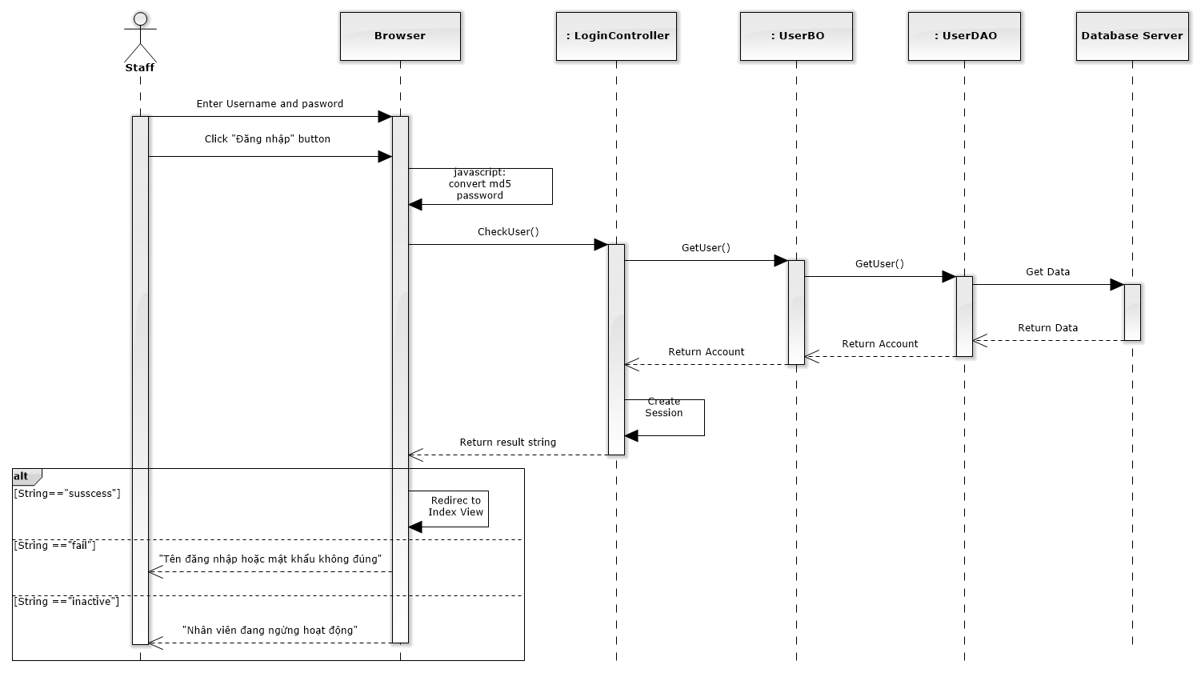

Figure 4-10: Login Sequence Diagram

### Change password

#### Class diagram

### 

#### Screen design

#### 

|  |  |  |  |  |
| --- | --- | --- | --- | --- |
| No | Object/ControlName | Type | Required | Description |
| 1 | Mật khẩu cũ | Textbox | Yes | Your old password |
| 2 | Mật khẩu mới | Textbox | Yes | Your new password |
| 3 | Lặp lại mật khẩu mới | Textbox | Yes | Re-input your new password |

#### Sequence diagram

Figure 4-11: Change Password Sequence Diagram

### View Home

#### Class diagram

### 

#### Screen design

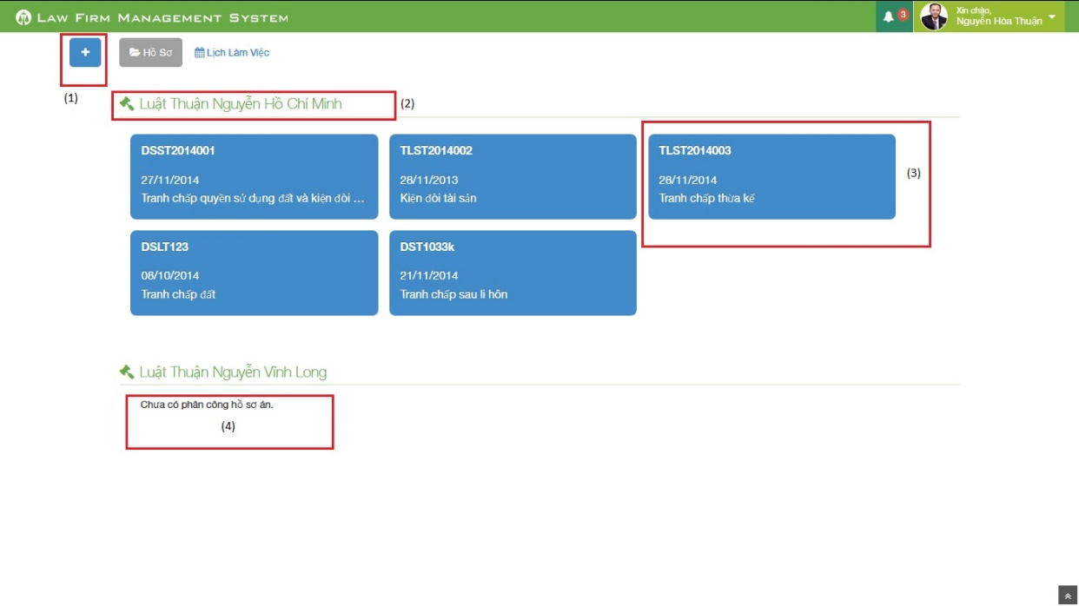

Figure 212: Home Screen Image

|  |  |  |  |  |
| --- | --- | --- | --- | --- |
| No | Object/ControlName | Type | Required | Description |
| 1 | Plus | Button | Yes | Click to show popup for add new case |
| 2 | Office name | Label | Yes | Show name of office the staff work in |
| 3 | Case information | Button | Yes | Show important information of the case, click and redirect to view case detail page |
| 4 | “Chưa có phân công hồ sơ án” | Label | Yes | If the office have no “Đang thụ lý” case, message will be show |

#### Sequence diagram

Figure 4-12: View Home Sequence Diagram

### Notify

#### Class diagram

### 

#### Screen design

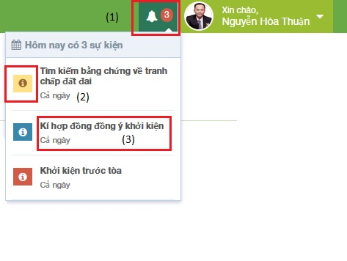

Figure 213: Notify Event Screen Image

|  |  |  |  |  |
| --- | --- | --- | --- | --- |
| No | Object/ControlName | Type | Required | Description |
| 1 | Event count | Label | Yes | Event quantity in “today” need to do. If there is at least 1 event, ring the bell |
| 2 | Priority | Icon | Yes | Show priority of event |
| 3 | Title | Label | Yes | Show title and time range of event |

#### Sequence diagram

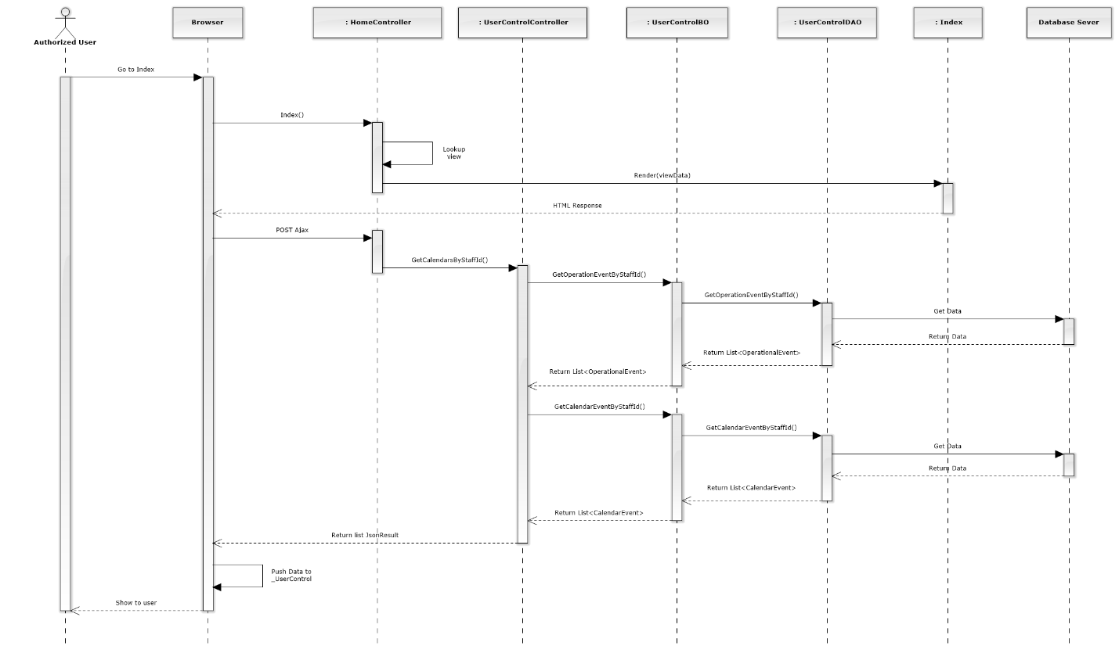

Figure 4-13: Notify Sequence Diagram

### List Calendar Events

#### Class diagram

### 

#### Screen design

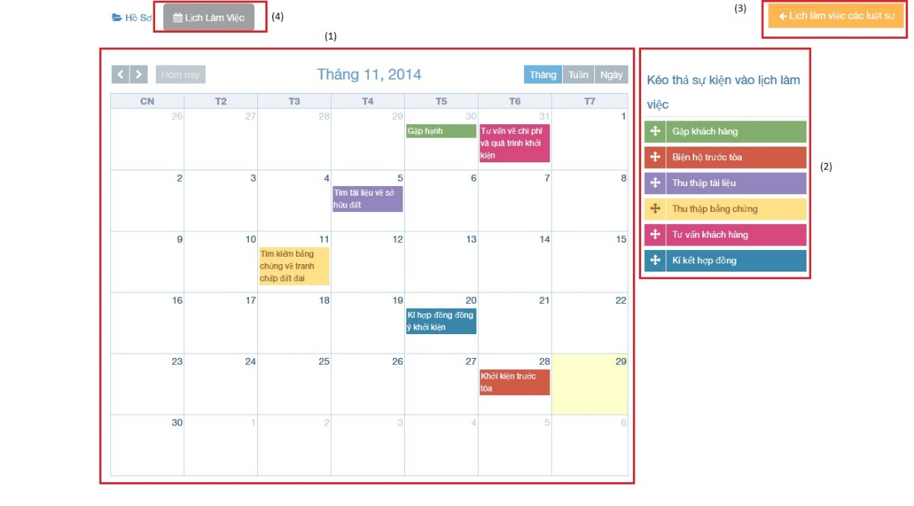

Figure 215: :List calendar events

|  |  |  |  |  |
| --- | --- | --- | --- | --- |
| No | Object/ControlName | Type | Required | Description |
| 1 | Calendar | Full Calendar | Yes | Show all event of Staff on calendar |
| 2 | Dropable event | Object | Yes | Drag and drop into calendar to create new event |
| 3 | Lịch làm việc của các luật sư | Button | Yes | Show other staff calendar pop-up |
| 4 | “Lịch làm việc” | Label | Yes | Tab for view calendar events |

#### Sequence diagram

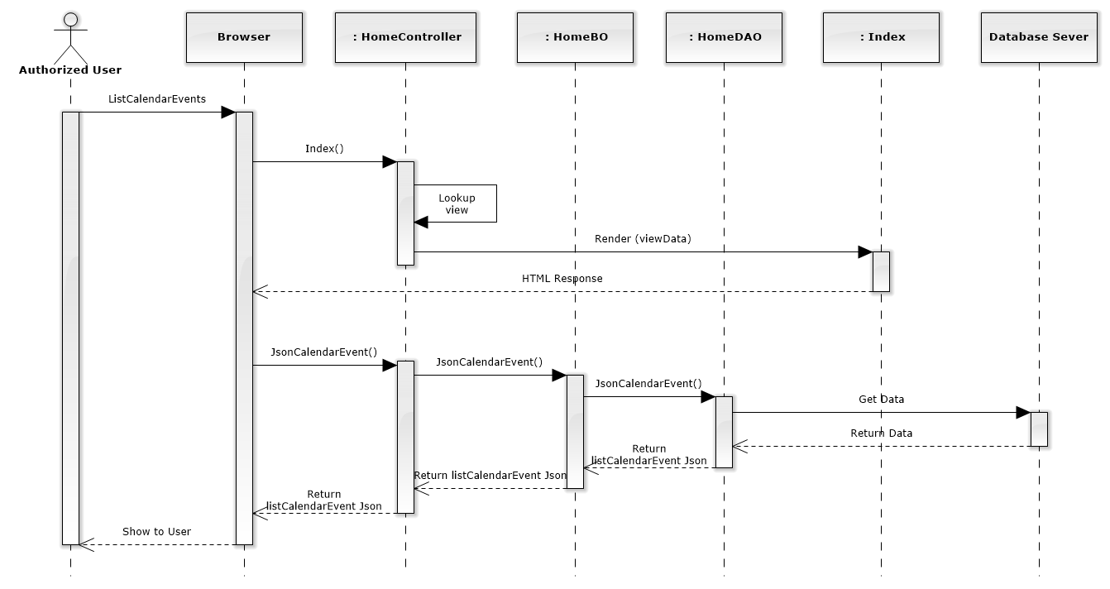

Figure 152: List Calendar Events Sequence Diagram

### Add new calendar event

#### Screen design

#### 

|  |  |  |  |  |
| --- | --- | --- | --- | --- |
| No | Object/ControlName | Type | Required | Description |
| 1 | “Tên Sự Kiện Mới:” | Label | Yes | View name event |
| 2 | “Tên sự kiện” | Textbox | Yes | Name event |
| 3 | “Bỏ Qua” | Button | Yes | Click to close Add new calendar event pop-up |
| 4 | “Xác Nhận” | Button | Yes | Click to create a new calendar event |

#### Sequence diagram

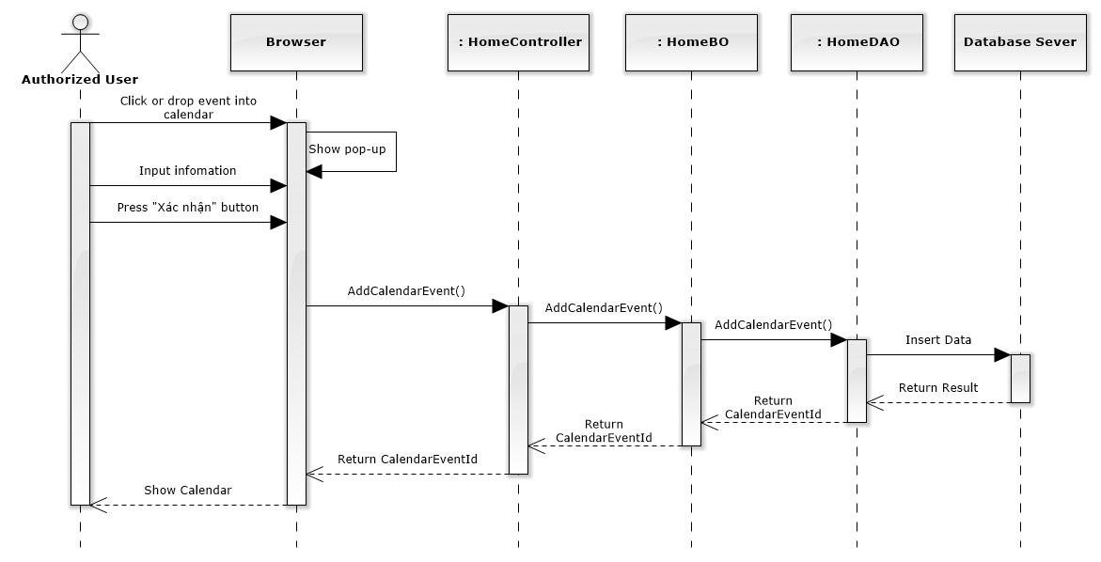

Figure 153: Add New Calendar Event Sequence Diagram

### Edit calendar event

#### Screen design

#### 

|  |  |  |  |  |
| --- | --- | --- | --- | --- |
| No | Object/ControlName | Type | Required | Description |
| 1 | “Tên sự kiện” | Textbox | Yes | Name event |
| 2 | “Lưu” | Button | Yes | Click to save edit new calendar event |
| 3 | “Đóng” | Button | Yes | Click to close Edit new calendar event pop-up |

#### Sequence diagram

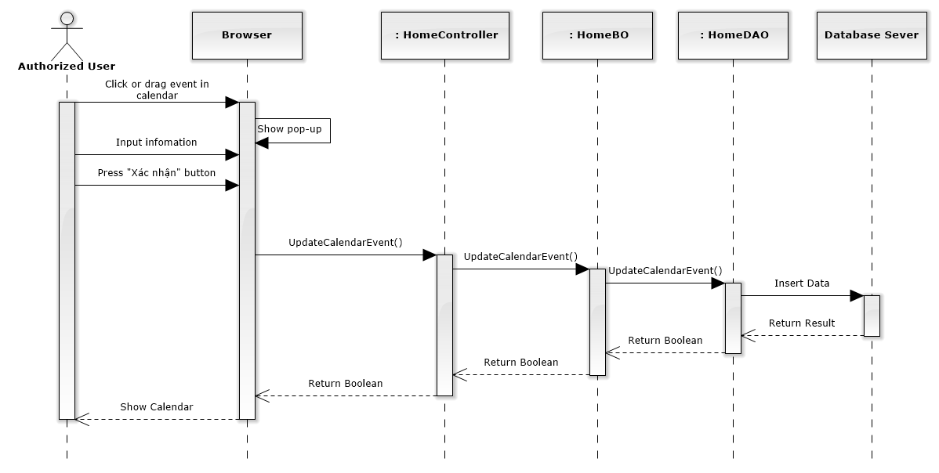

Figure 154: Edit Calendar Event Sequence Diagram

### Delete calendar event

#### Screen design

#### 

|  |  |  |  |  |
| --- | --- | --- | --- | --- |
| No | Object/ControlName | Type | Required | Description |
| 1 | “Tên sự kiện” | Textbox | Yes | Name event |
| 2 | “Xóa sự kiện” | Button | Yes | Click to delete calendar event |
| 3 | “Đóng” | Button | Yes | Click to close Delete calendar event pop-up |

#### Sequence diagram

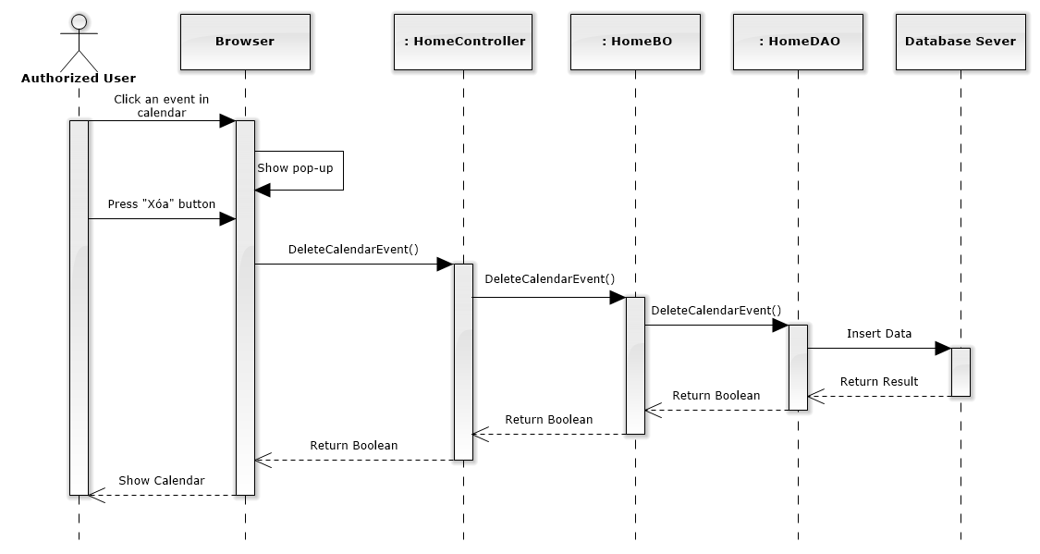

Figure 155: Delete Calendar Event Sequence Diagram

### List all cases

#### Class diagram

### 

#### Screen design

#### 

|  |  |  |  |  |
| --- | --- | --- | --- | --- |
| No | Object/ControlName | Type | Required | Description |
| 1 | “Thêm hồ sơ tác nghiệp” | Button | Yes | Click to show popup for add new case |
| 2 | Line count | Dropdown list | Yes | Select line quantity in table |
| 3 | “Tìm kiếm” | Textbox | Yes | Search case automatically |
| 4 | View all cases | Table | Yes | Show all of case |
| 5 | Case count | Label | Yes | Show case quantity of page in table |
| 6 | Paging | Button | Yes | List case page by page |

#### Sequence diagram

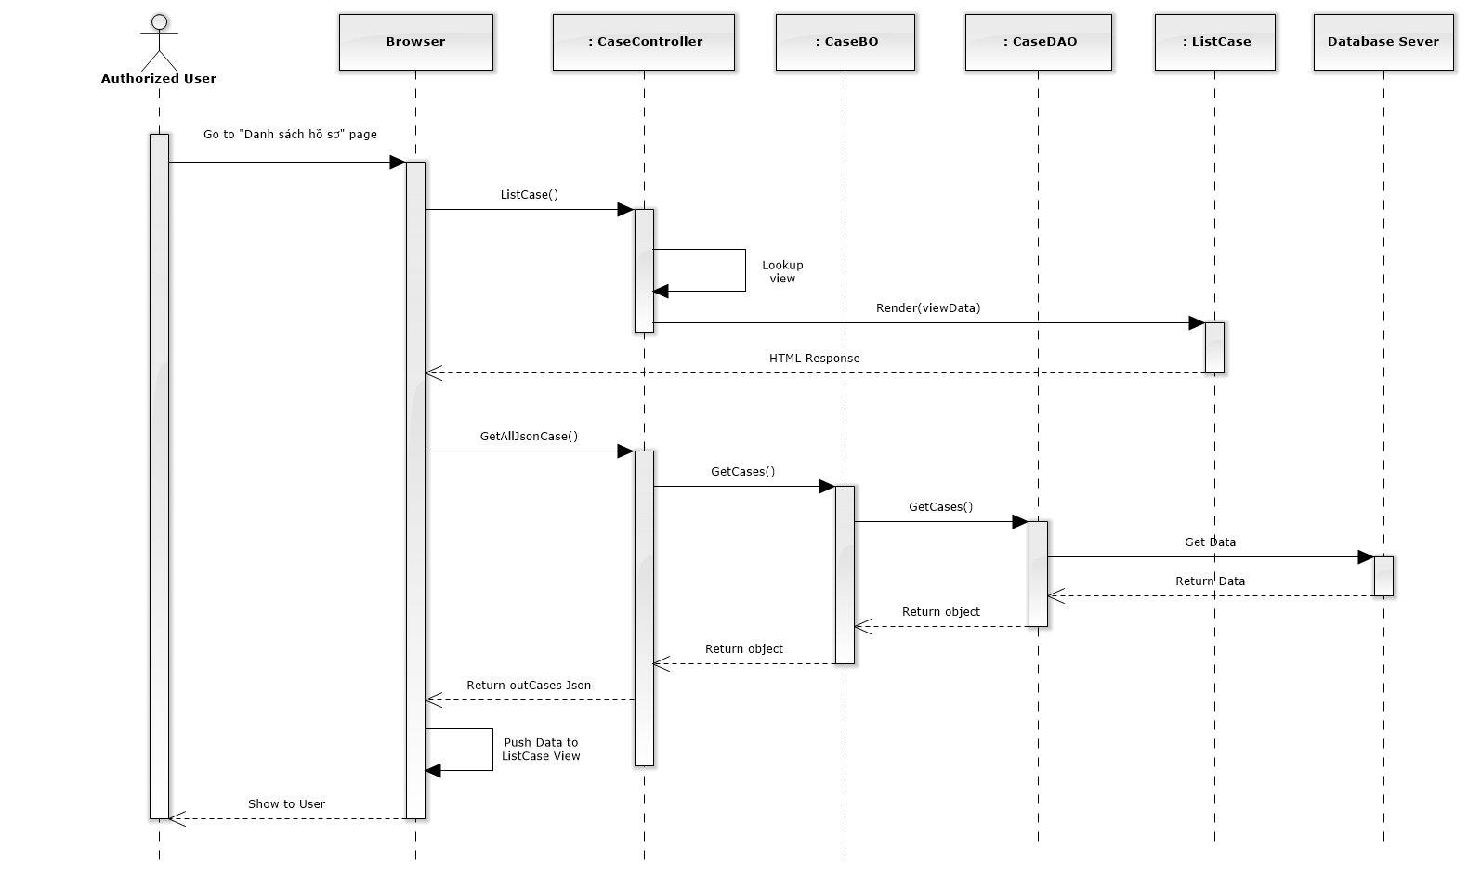

Figure 156: List All Cases Sequence Diagram

### Add new case

#### Screen design

#### 

|  |  |  |  |  |
| --- | --- | --- | --- | --- |
| No | Object/ControlName | Type | Required | Description |
| 1 | “Mã hồ sơ” | Textbox | Yes | Case code |
| 2 | “Ngày thụ lý” | Textbox list | Yes | Receipt date |
| 3 | “Thuộc văn phòng” | Textbox | Yes | Choose one office |
| 4 | “Nội dung” | Textbox | Yes | Case content |
| 5 | “Đóng” | Button | Yes | Click to close modal popup |
| 6 | “Thêm mới” | Button | Yes | Click to create a new case |

#### Sequence diagram

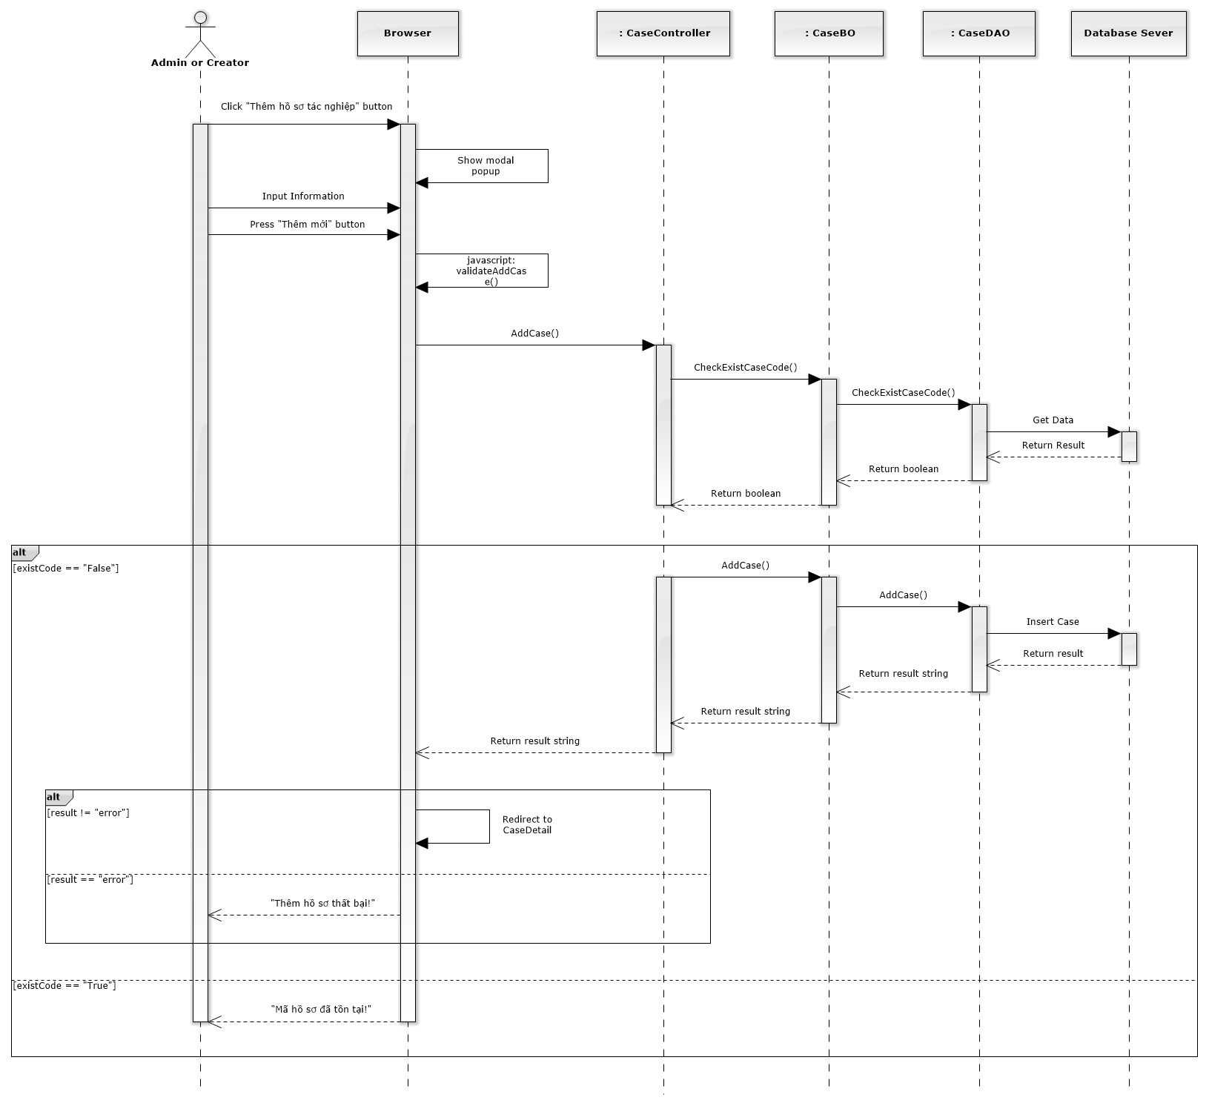

Figure 157: Add New Case Sequence Diagram

### Search case

#### Screen design

#### 

|  |  |  |  |  |
| --- | --- | --- | --- | --- |
| No | Object/ControlName | Type | Required | Description |
| 1 | “Tìm kiếm” | Textbox | Yes | Search case automatically |
| 2 | View all cases | Table | Yes | Show all result of case after searching |
| 3 | Case contain “Tranh chấp quyền” | Label | Yes | Show a word that contain in search textbox |

#### Sequence diagram

### View case detail

#### Screen design

#### 

|  |  |  |  |  |
| --- | --- | --- | --- | --- |
| No | Object/ControlName | Type | Required | Description |
| 1 | “Danh sách hồ sơ” | Link | Yes | Redirect to view all cases |
| 2 | Edit | Button | Yes | Must be click to edit infor |
| 3 | “Mã hồ sơ” | Textbox | Yes | Case code |
| 4 | “Ngày thụ lý” | Textbox | Yes | Receipt date |
| 5 | “Thuộc văn phòng” | Textbox | Yes | Choose one office |
| 6 | “Trạng thái” | Textbox | Yes | Case status |
| 7 | “Nội dung tranh chấp” | Textbox | Yes | The contents of dispute |
| 8 | “Đối tượng tranh chấp” | Textbox | Yes | The subject of dispute |
| 9 | “Quan hệ tranh chấp” | Textbox | Yes | The relation of dispute |
| 10 | “Thời hiệu” | Textbox | Yes | The statute of limitations |
| 11 | “Sự kiện pháp lý” | Textbox | Yes | Legal event |
| 12 | “Yếu tố lỗi” | Textbox | Yes | Error factor |
| 13 | “Hủy chỉnh sửa” | Button | Yes | Cancel edit infor |
| 14 | “Lưu chỉnh sửa” | Button | Yes | Save new infor |

#### Sequence diagram

### List operation events

#### Screen design

#### 

|  |  |  |  |  |
| --- | --- | --- | --- | --- |
| No | Object/ControlName | Type | Required | Description |
| 1 | Thêm sự kiện | Button | Yes | Click to add new operation event |
| 2 | Hoàn thành | Button | Yes | Click to finish edit operation event |
| 3 | Thu nhỏ / Mở rộng | Button | Yes | Reduce / Expand |
| 4 | Title | Label | Yes | Title of Operation Event |
| 5 | Time range | Label | Yes | Click to choose begin time and end time of event |
| 6 | Staff username | Label | Yes | The lawyer who create a case |
| 7 | Content | Information | Yes | Content of Operation Event |
| 8 | Pencil | Button | Yes | Edit operation event |
| 9 | Trash | Button | Yes | Delete operation event |

#### Sequence diagram

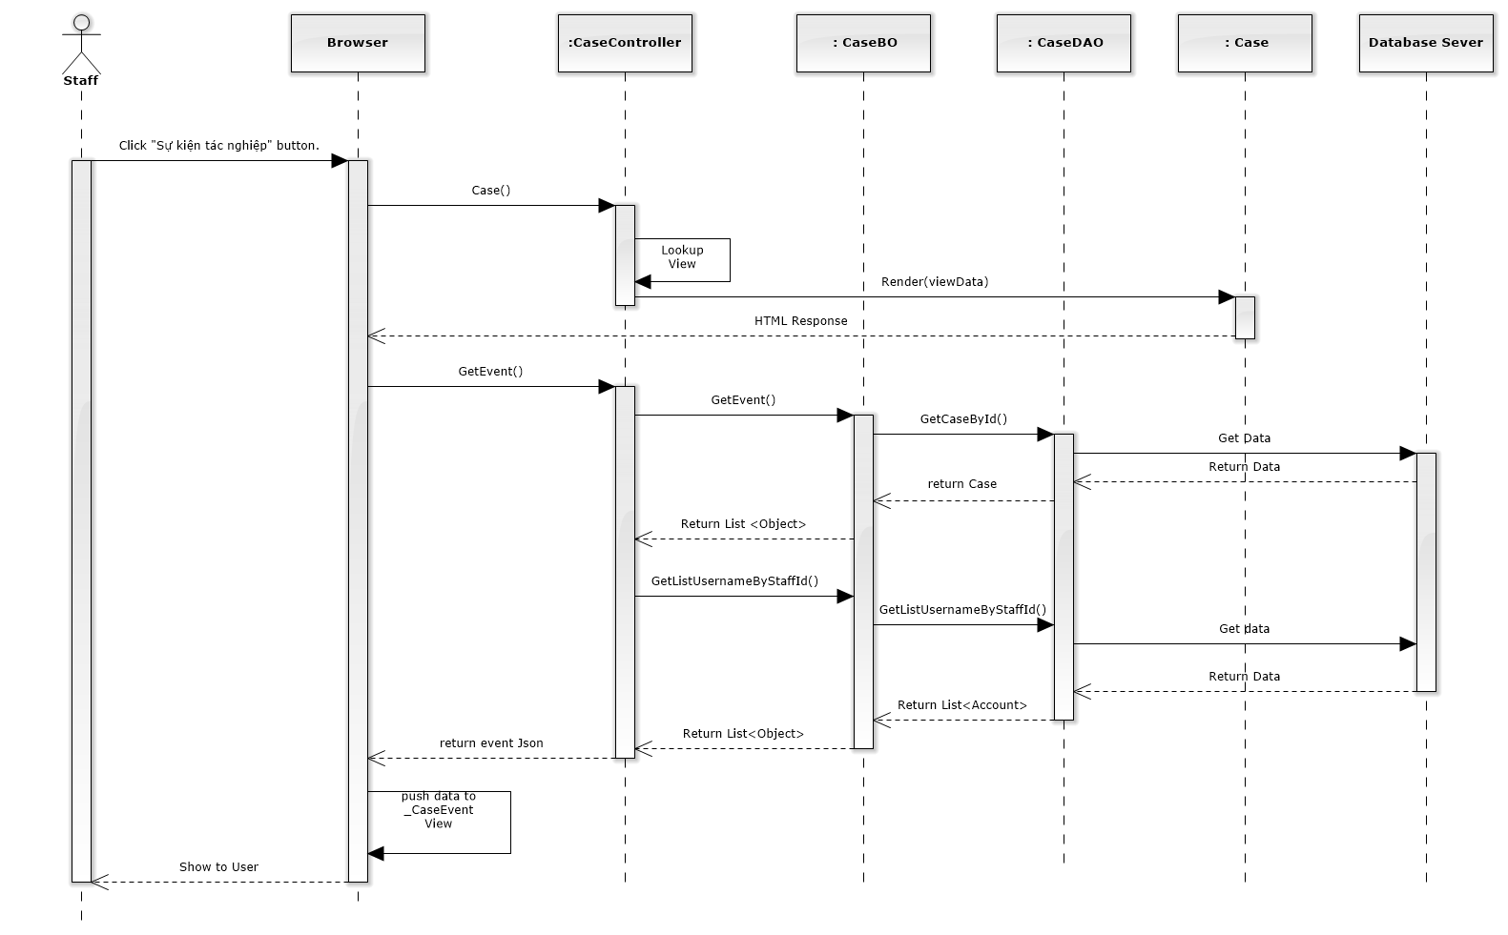

Figure 158: List Operation Events Sequence Diagram

### Add new operation event

#### Screen design

#### 

|  |  |  |  |  |
| --- | --- | --- | --- | --- |
| No | Object/ControlName | Type | Required | Description |
| 1 | Time range | Button | Yes | Click to choose begin time and end time of event |
| 2 | Title | Table | Yes | Title of Operation Event |
| 3 | Content | Label | Yes | Content of Operation Event |
| 4 | “Đóng” | Button | Yes | Click to close add new operation event |
| 5 | “Tạo sự kiện” | Button | Yes | Click to add new operation event |

#### Sequence diagram

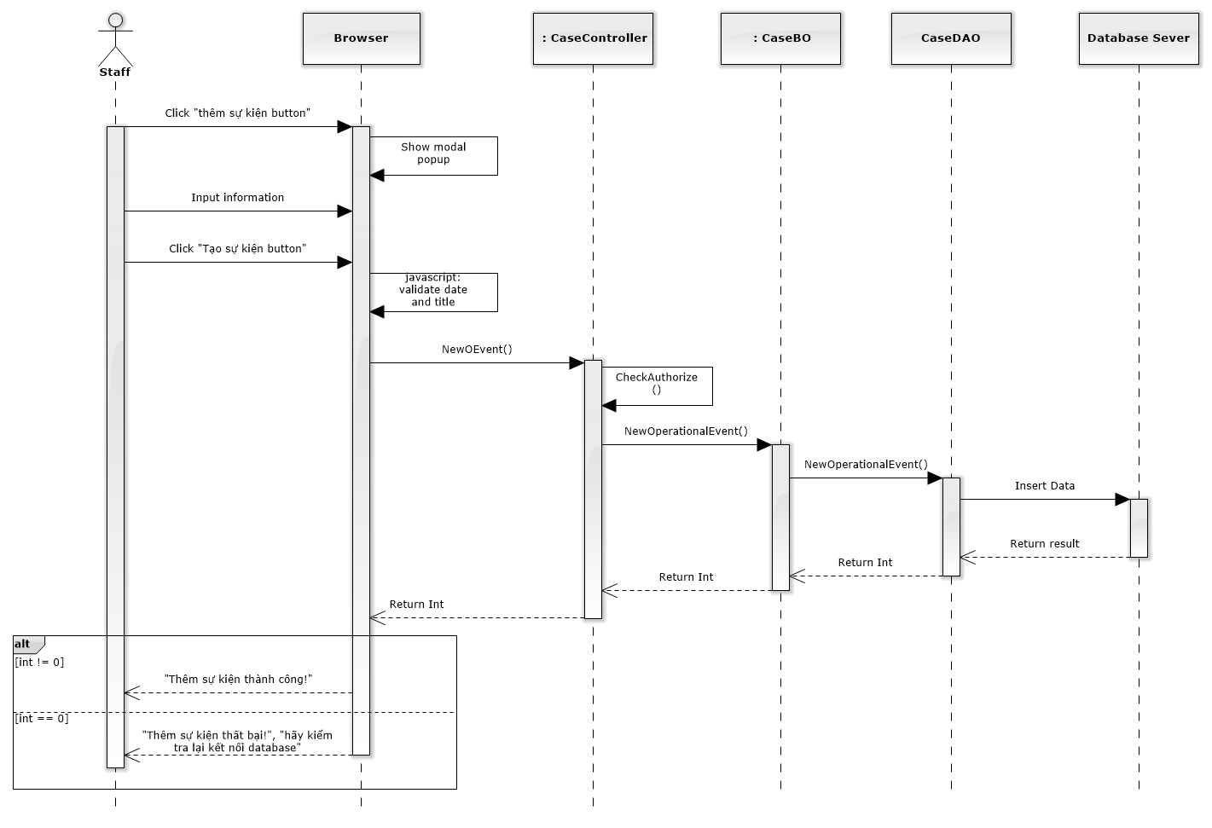

Figure 159: Add New Operation Event Sequence Diagram

### Edit operation event

#### Screen design

#### 

|  |  |  |  |  |
| --- | --- | --- | --- | --- |
| No | Object/ControlName | Type | Required | Description |
| 1 | Time range | Button | Yes | Click to choose begin time and end time of event |
| 2 | Title | Table | Yes | Title of Operation Event |
| 3 | Content | Label | Yes | Content of Operation Event |
| 4 | “Đóng” | Button | Yes | Click to close edit operation event |
| 5 | “Lưu chỉnh sửa” | Button | Yes | Click to edit operation event |

#### Sequence diagram

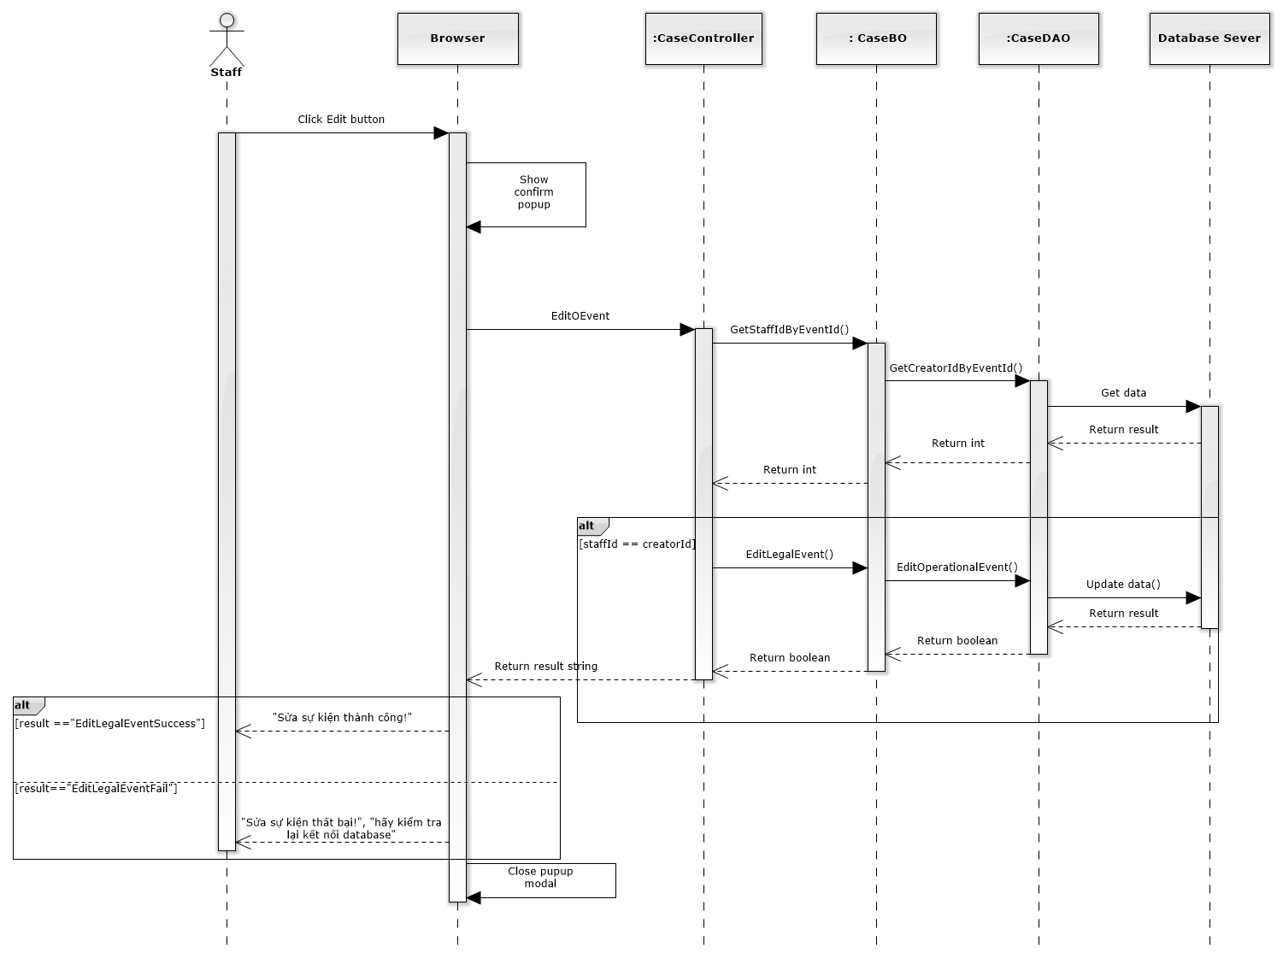

Figure 160: Edit Operation Event Sequence Diagram

### Delete operation event

#### Screen design

#### 

|  |  |  |  |  |
| --- | --- | --- | --- | --- |
| No | Object/ControlName | Type | Required | Description |
| 1 | “Bỏ qua” | Button | Yes | Click to close delete operation event |
| 2 | “Xác nhận” | Button | Yes | Click to delete operation event |

#### Sequence diagram

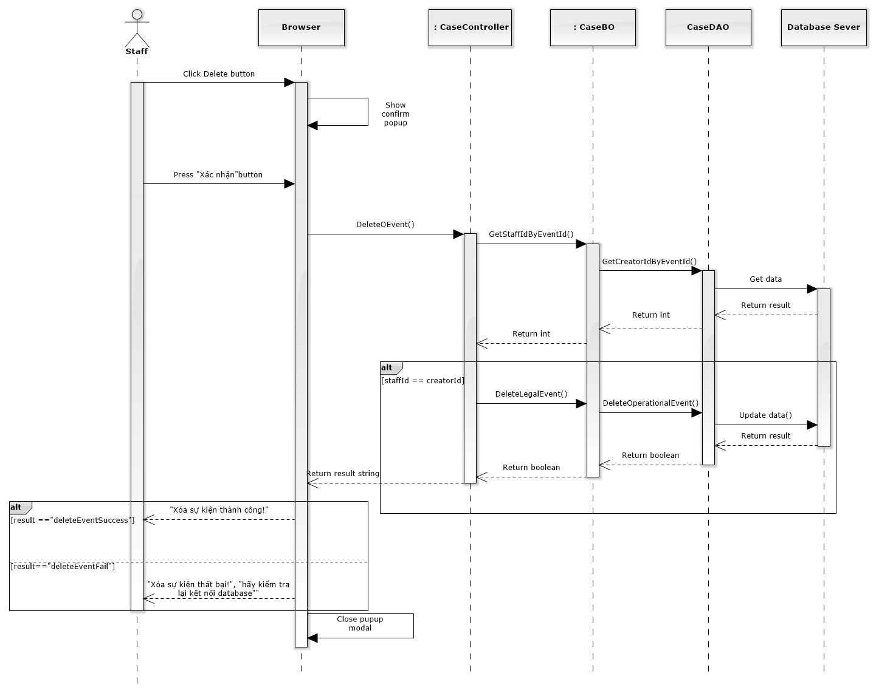

Figure 161: Delete Operation Event Sequence Diagram

##### Manage Lawyer Related

Reference to DVD: <root>/Documents/LFMS Project Document - Full Report.docx

##### Manage Customer Related

Reference to DVD: <root>/Documents/LFMS Project Document - Full Report.docx

##### Manage Subject Related

Reference to DVD: <root>/Documents/LFMS Project Document - Full Report.docx

##### Manage Document Related

Reference to DVD: <root>/Documents/LFMS Project Document - Full Report.docx

##### Manage Used Service

Reference to DVD: <root>/Documents/LFMS Project Document - Full Report.docx

##### Manage Payment

Reference to DVD: <root>/Documents/LFMS Project Document - Full Report.docx

### Manage Customer Group

#### Class diagram

### 

### List customers

#### Class diagram

### 

#### Screen design

#### 

|  |  |  |  |  |
| --- | --- | --- | --- | --- |
| No | Object/ControlName | Type | Required | Description |
| 1 | Thêm khách hàng | Button | Yes | Show Add new customer pop-up |
| 2 | Number of rows | Combo-box | Yes | Choose number of rows in table |
| 3 | Search | Textbox | Yes | Search customer |
| 4 | Customer table | Table | Yes | List Customer |
| 5 | View customer detail | Icon | Yes | Show Customer detail pop-up |
| 6 | Delete customer | Icon | Yes | Delete customer |
| 7 | Edit customer | Icon | Yes | Show edit customer pop-up |
| 8 | Paging | Button | Yes | Paging the customer list |

#### Sequence diagram

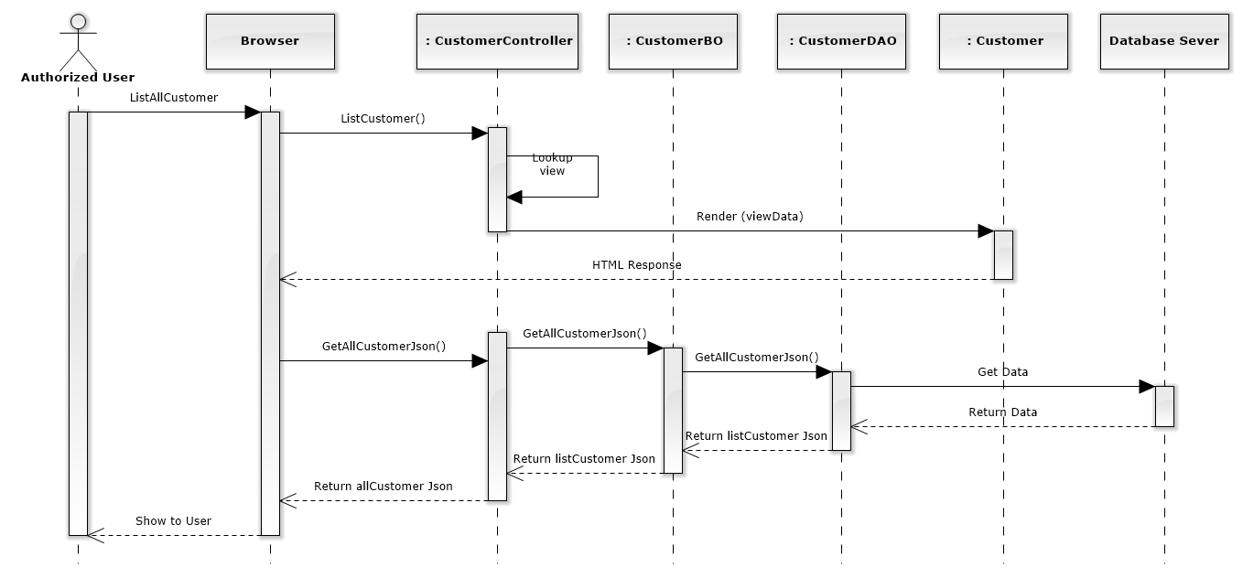

Figure 163: List Customers Sequence Diagram

### Add new customer

#### Screen design

#### 

|  |  |  |  |  |
| --- | --- | --- | --- | --- |
| No | Object/ControlName | Type | Required | Description |
| 1 | Tên Khách hàng | Textbox | Yes | Customer name |
| 2 | Người đại diện | Textbox | Yes | Presentative |
| 3 | Ngày sinh | Date picker | Yes | Date of Birth |
| 4 | Ngày cấp CMND | Date picker | Yes | Identity Date |
| 5 | Số tài khoản | Textbox | Yes | Bank account |
| 6 | Mã số thuế | Textbox | Yes | Tax code |
| 7 | Điện thoại di động | Textbox | Yes | Mobile |
| 8 | Nhóm khách hàng | Combo-box | Yes | Customer group |
| 9 | Giới tính | Radio-button | Yes | Gender |
| 10 | Số CMND | Textbox | Yes | Identity Number |
| 11 | Nơi cấp CMND | Textbox | Yes | Identity Place |
| 12 | Tên ngân hàng | Textbox | Yes | Bank Branch |
| 13 | Email | Textbox | Yes | Email |
| 14 | Điện thoại cố định | Textbox | Yes | Phone |
| 15 | Địa chỉ | Text area | Yes | Address |
| 16 | Làm trống | Button | Yes | Clear all field |
| 17 | Thêm mới | Button | Yes | Add new customer |

#### Sequence diagram

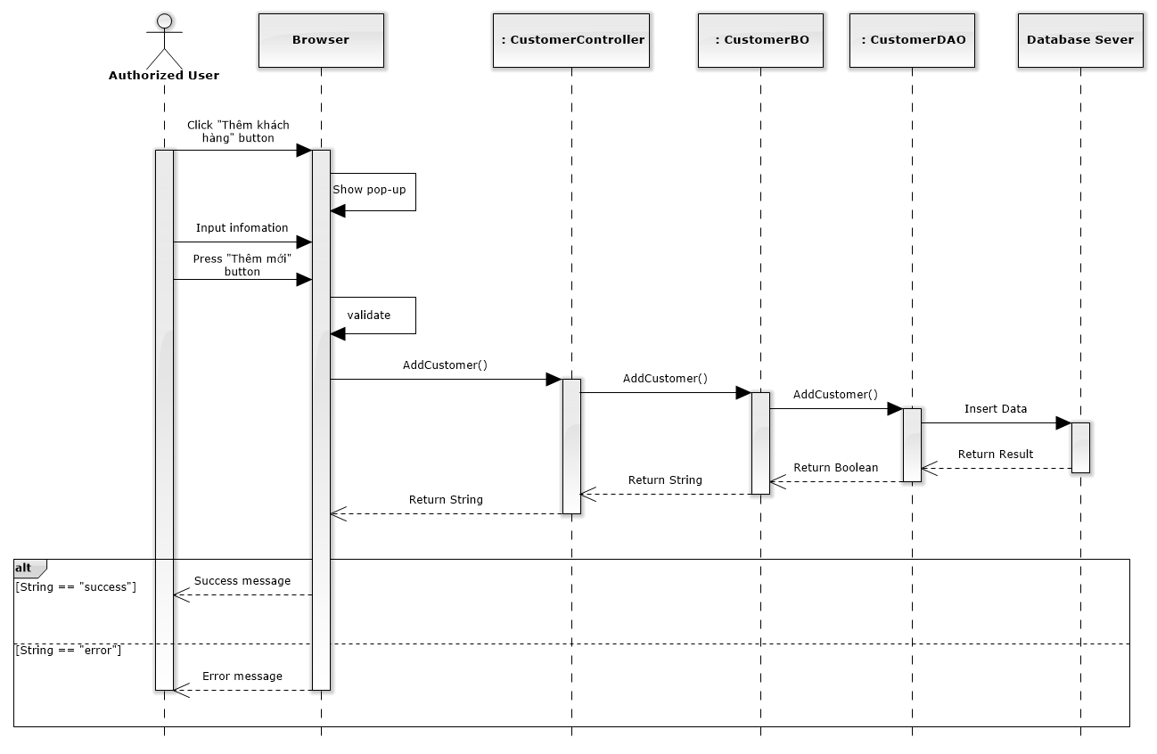

Figure 164: Add New Customer Sequence Diagram

### Edit customer

#### Screen design

#### 

|  |  |  |  |  |
| --- | --- | --- | --- | --- |
| No | Object/ControlName | Type | Required | Description |
| 1 | Tên Khách hàng | Textbox | Yes | Customer name |
| 2 | Người đại diện | Textbox | Yes | Presentative |
| 3 | Ngày sinh | Date picker | Yes | Date of Birth |
| 4 | Ngày cấp CMND | Date picker | Yes | Identity Date |
| 5 | Số tài khoản | Textbox | Yes | Bank account |
| 6 | Mã số thuế | Textbox | Yes | Tax code |
| 7 | Điện thoại di động | Textbox | Yes | Mobile |
| 8 | Nhóm khách hàng | Combo-box | Yes | Customer group |
| 9 | Giới tính | Radio-button | Yes | Gender |
| 10 | Số CMND | Textbox | Yes | Identity Number |
| 11 | Nơi cấp CMND | Textbox | Yes | Identity Place |
| 12 | Tên ngân hàng | Textbox | Yes | Bank Branch |
| 13 | Email | Textbox | Yes | Email |
| 14 | Điện thoại cố định | Textbox | Yes | Phone |
| 15 | Địa chỉ | Text area | Yes | Address |
| 16 | Đóng | Button | Yes | Close edit customer |
| 17 | Lưu chỉnh sửa | Button | Yes | Edit customer |

#### Sequence diagram

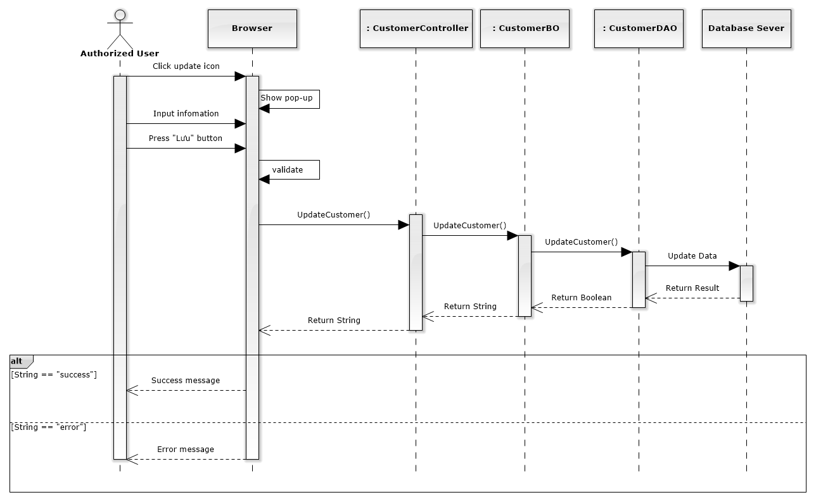

Figure 165: Edit Customer Sequence Diagram

### Delete customer

#### Screen design

#### 

|  |  |  |  |  |
| --- | --- | --- | --- | --- |
| No | Object/ControlName | Type | Required | Description |
| 1 | “Bỏ qua” | Button | Yes | Click to close delete customer |
| 2 | “Xác nhận” | Button | Yes | Click to delete customer |

#### Sequence diagram

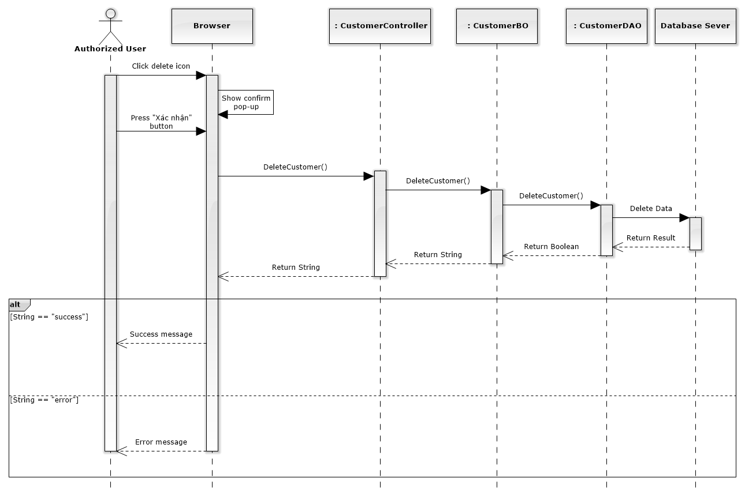

Figure 166: Delete Customer Sequence Diagram

### Manage Staff Group

Reference to DVD: <root>/Documents/LFMS Project Document - Full Report.docx

### List staffs

#### Class diagram

### 

#### Screen design

#### 

|  |  |  |  |  |
| --- | --- | --- | --- | --- |
| No | Object/ControlName | Type | Required | Description |
| 1 | Thêm nhân viên | Button | Yes | Click to show popup for add new staff |
| 2 | Number of rows | Combo-box | Yes | Choose number of rows in table |
| 3 | Image of staff | Image | Yes | Click to show popup detail of staff |
| 4 | List all staff | Table | Yes | List all staff |
| 5 | Tìm kiếm | Textbox | Yes | Search staff |
| 6 | View | Button | Yes | Click to show popup detail of staff |
| 7 | Edit | Button | Yes | Click to show popup edit detail of staff information. |
| 8 | Paging | Button | Yes | Paging page |

#### Sequence diagram

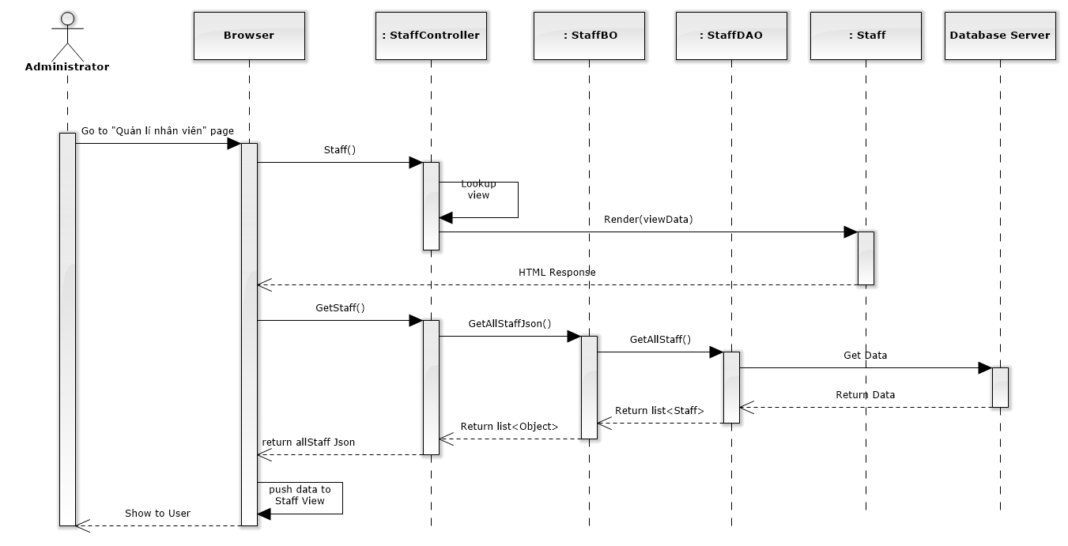

Figure 167: List Staffs Sequence Diagram

### Add new staff

#### Screen design

#### 

|  |  |  |  |  |
| --- | --- | --- | --- | --- |
| No | Object/ControlName | Type | Required | Description |
| 1 | Tên nhân viên | Textbox | Yes | Name of staff |
| 2 | Tên đăng nhập | Textbox | Yes | Username of staff |
| 3 | Chức vụ | Textbox | Yes | Position of staff |
| 4 | Giới tính | Radio button | Yes | Choose sex of staff |
| 5 | Số người phụ thuộc | Textbox | Yes | Number of dependents |
| 6 | Nhóm nhân viên | Textbox | Yes | Select group of staff |
| 7 | Ngày sinh | Datetime picker | Yes | Date of birth of staff |
| 8 | Nơi sinh | Textbox | Yes | Place of birth of staff |
| 9 | Điện thoại di động | Textbox | Yes | Phone number of staff |
| 10 | Điện thoại nhà riêng | Textbox | Yes | Telephone of staff |
| 11 | Email | Textbox | Yes | Email of staff |
| 12 | Địa chỉ liên hệ | Textbox | Yes | Address of staff |
| 13 | Thuộc văn phòng | Multiple select box | Yes | Select office of staff |
| 14 | Vai trò nhân viên | Select box | Yes | Select role of staff |
| 15 | CMND | Textbox | Yes | Indentity number of staff |
| 16 | Ngày cấp CMND | Datetime picker | Yes | Date of Identity of staff |
| 17 | Nơi cấp CMND | Textbox | Yes | Place of Identity of staff |
| 18 | Mã số thuế | Textbox | Yes | Tax number of staff |
| 19 | Số tài khoản | Textbox | Yes | Bank account number of staff |
| 20 | Chi nhánh ngân hàng | Textbox | Yes | Name of bank of staff |
| 21 | “Làm trống” | Button | Yes | Clear all field |
| 22 | “Thêm mới” | Button | Yes | Add new staff |
| 23 | Image of staff | Image | Yes | Image of staff |

#### Sequence diagram

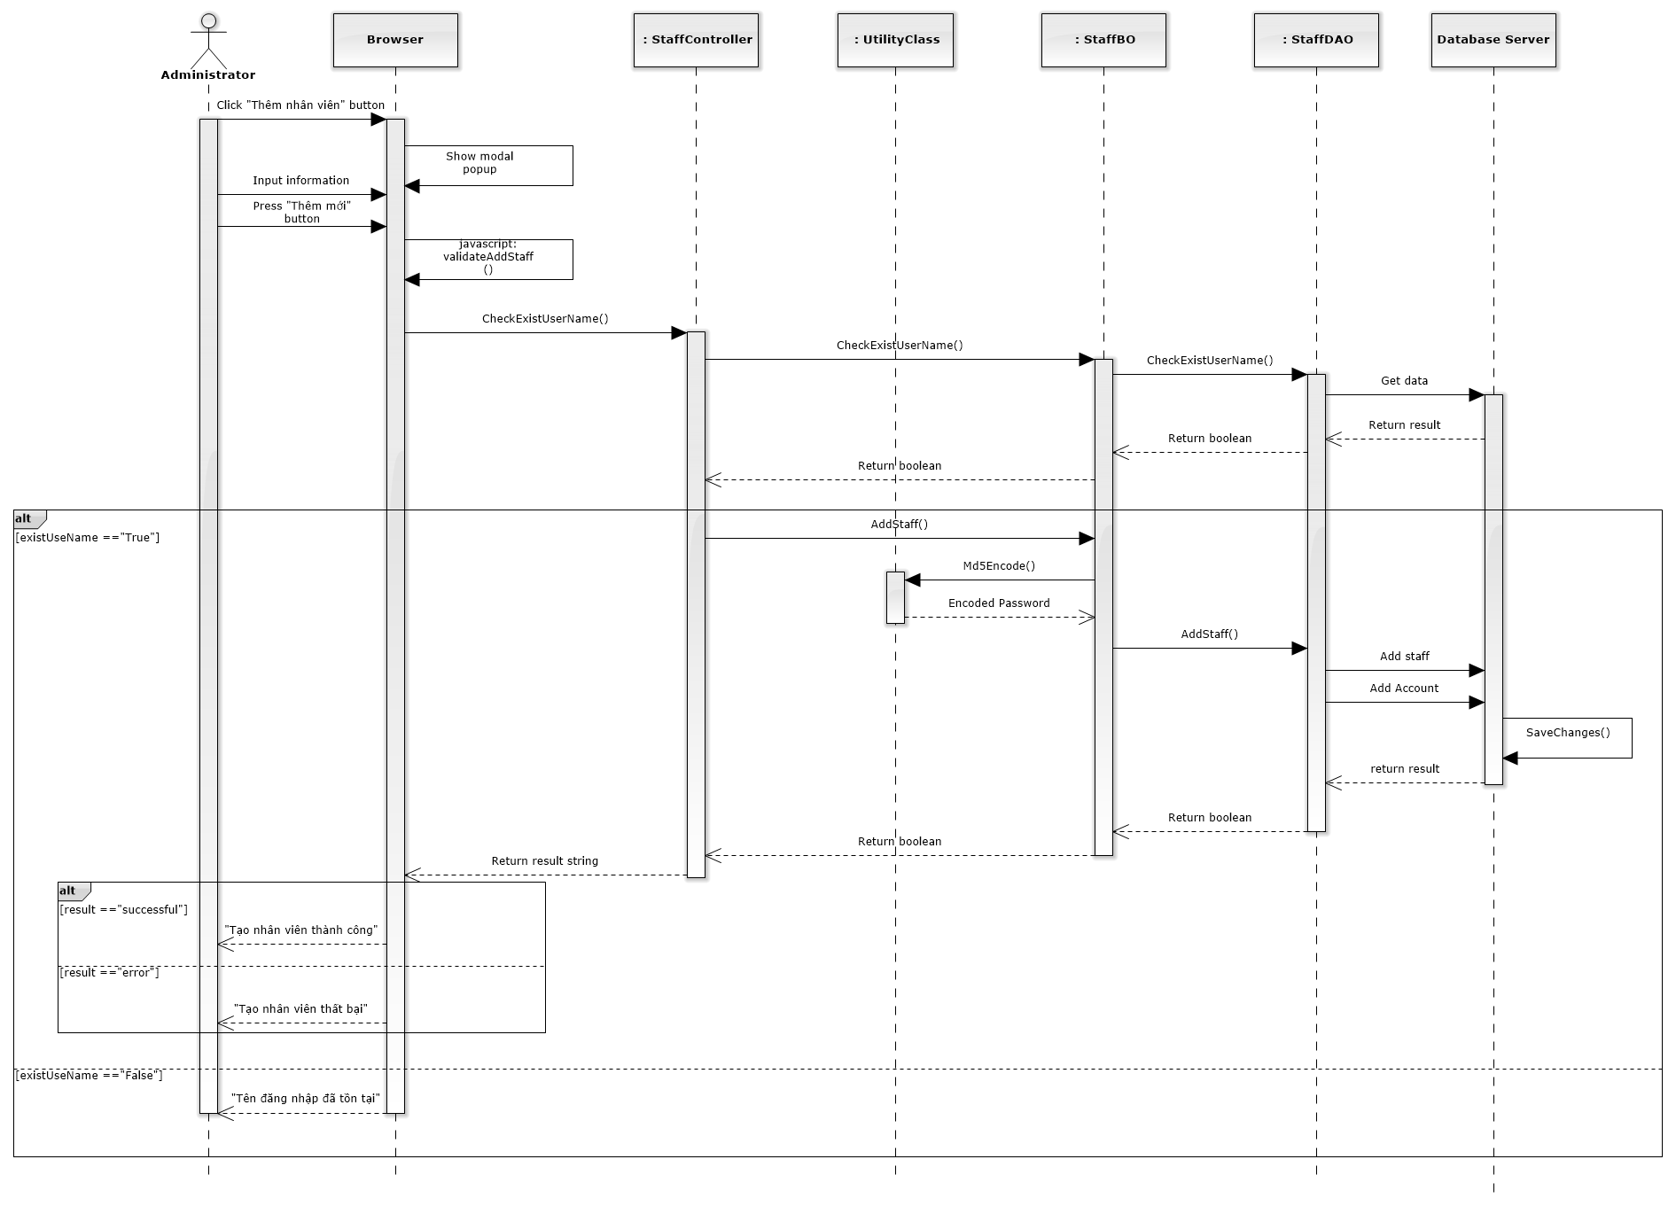

Figure 168: Add New Staff Sequence Diagram

### Edit staff

#### Screen design

#### 

|  |  |  |  |  |
| --- | --- | --- | --- | --- |
| No | Object/ControlName | Type | Required | Description |
| 1 | Image of staff | Image | Yes | Image of staff |
| 2 | Tên nhân viên | Textbox | Yes | Name of staff |
| 3 | Tên đăng nhập | Textbox | Yes | Username of staff |
| 4 | Chức vụ | Textbox | Yes | Position of staff |
| 5 | Giới tính | Radio button | Yes | Choose sex of staff |
| 6 | Số người phụ thuộc | Textbox | Yes | Number of dependents |
| 7 | Đặt lại mật khẩu | Link | Yes | Change staff password |
| 8 | Nhóm nhân viên | Textbox | Yes | Select group of staff |
| 9 | Ngày sinh | Datetime picker | Yes | Date of birth of staff |
| 10 | Nơi sinh | Textbox | Yes | Place of birth of staff |
| 11 | Điện thoại di động | Textbox | Yes | Phone number of staff |
| 12 | Điện thoại nhà riêng | Textbox | Yes | Telephone of staff |
| 13 | Email | Textbox | Yes | Email of staff |
| 14 | Địa chỉ liên hệ | Textbox | Yes | Address of staff |
| 15 | Vai trò nhân viên | Select box | Yes | Select role of staff |
| 16 | CMND | Textbox | Yes | Indentity number of staff |
| 17 | Ngày cấp CMND | Datetime picker | Yes | Date of Identity of staff |
| 18 | Nơi cấp CMND | Textbox | Yes | Place of Identity of staff |
| 19 | Mã số thuế | Textbox | Yes | Tax number of staff |
| 20 | Số tài khoản | Textbox | Yes | Bank account number of staff |
| 21 | Chi nhánh ngân hàng | Textbox | Yes | Name of bank of staff |
| 22 | “Đóng” | Button | Yes | Close edit staff |
| 23 | “Lưu chỉnh sửa” | Button | Yes | Save edit staff |

#### Sequence diagram

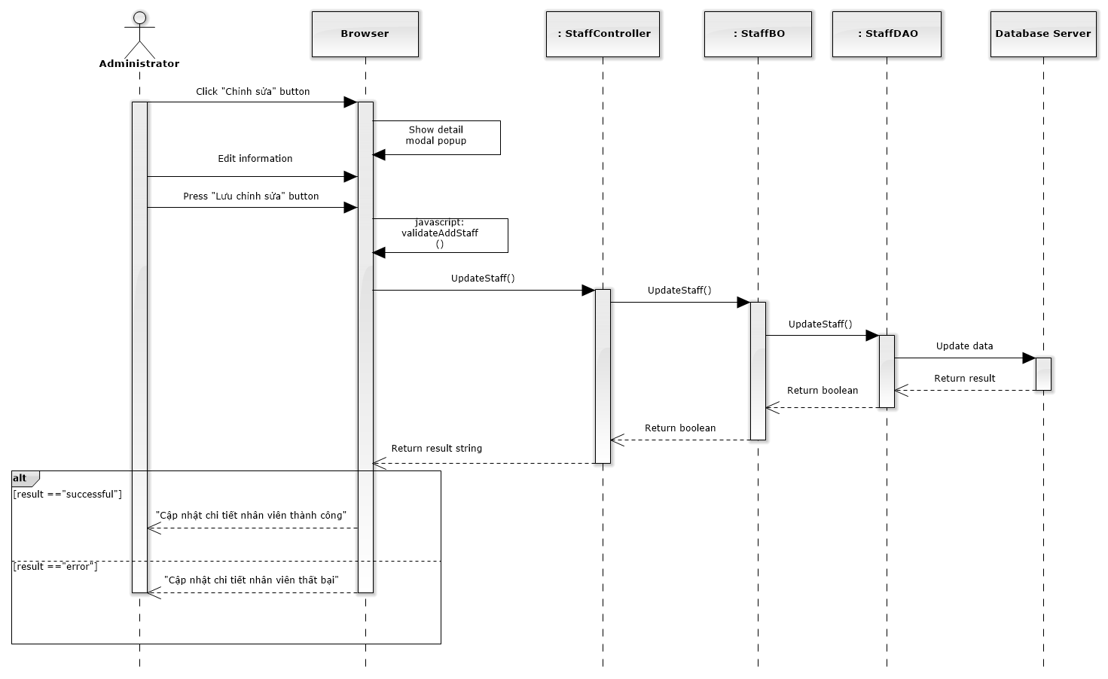

Figure 169: Edit Staff Sequence Diagram

### Deactivate/ Activate staff

#### Screen design

#### 

|  |  |  |  |  |
| --- | --- | --- | --- | --- |
| No | Object/ControlName | Type | Required | Description |
| 1 | “Bỏ qua” | Button | Yes | Click to close Deactive staff |
| 2 | “Xác nhận” | Button | Yes | Click to Deactive staff |
| 3 | Ngừng hoạt động | Link | Yes | Click to open confirm Deactive staff |

#### Sequence diagram

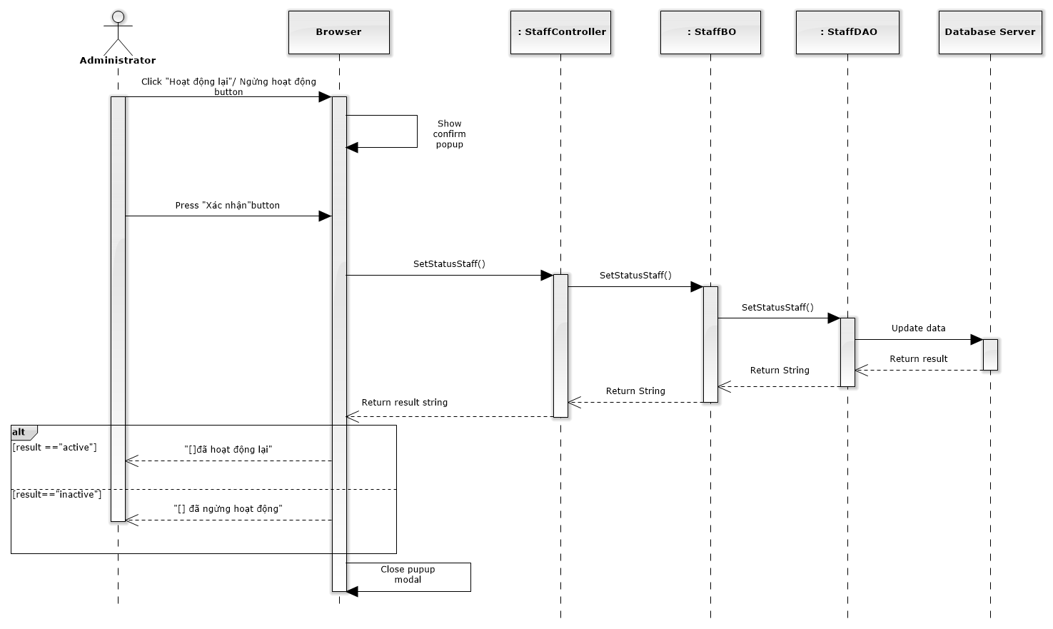

Figure 170: Deactivate / Activate Staff Sequence Diagram

### Reset password

#### Screen design

#### 

|  |  |  |  |  |
| --- | --- | --- | --- | --- |
| No | Object/ControlName | Type | Required | Description |
| 1 | “Bỏ qua” | Button | Yes | Click to close reset password staff |
| 2 | “Xác nhận” | Button | Yes | Click to reset password staff |
| 3 | Đặt lại mật khẩu | Link | Yes | Click to open reset password staff |

#### Sequence diagram

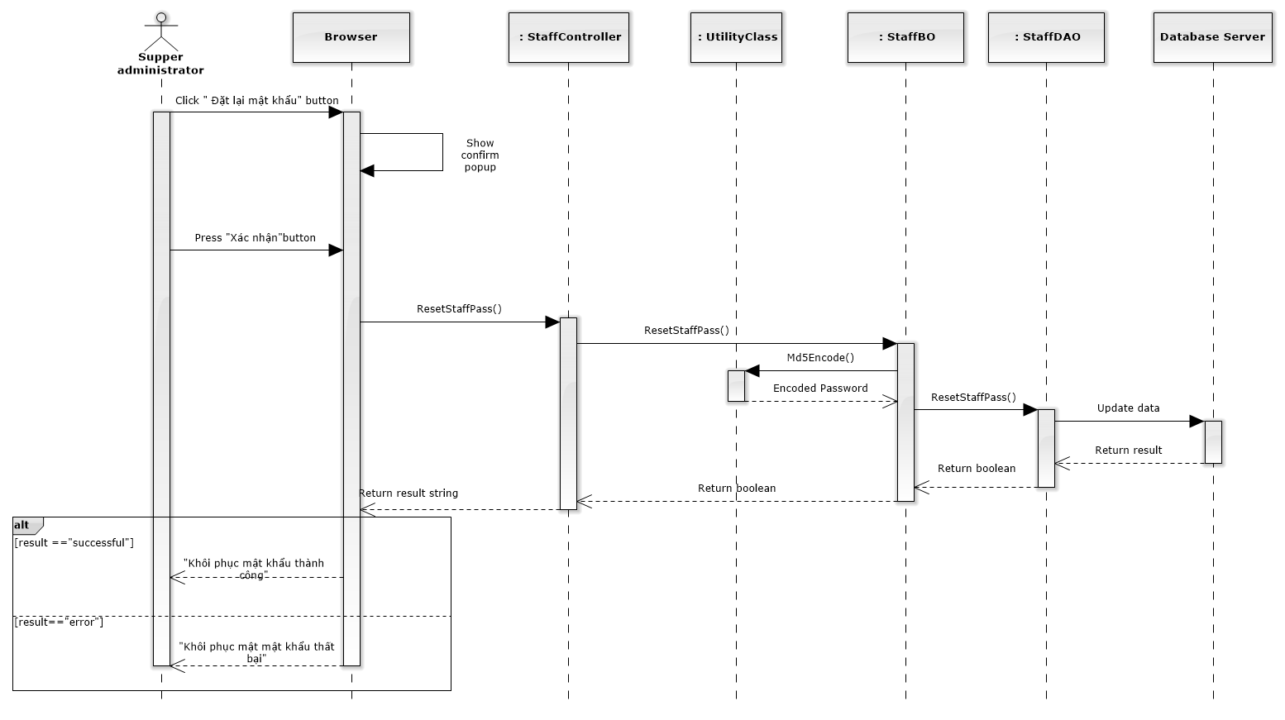

Figure 171: Reset Password Sequence Diagram

### Manage Service Type

#### Class diagram

### 

### List Services

#### Class diagram

### 

#### Screen design

#### 

|  |  |  |  |  |
| --- | --- | --- | --- | --- |
| No | Object/ControlName | Type | Required | Description |
| 1 | Thêm dịch vụ mới | Button | Yes | Show Add new service pop-up |
| 2 | Number of rows | Combo-box | Yes | Choose number of rows in table |
| 3 | Search | Textbox | Yes | Search service |
| 4 | Services table | Table | Yes | List service |
| 5 | View service detail | Icon | Yes | Show service detail pop-up |
| 6 | Edit service | Icon | Yes | Delete service |
| 7 | Delete service | Icon | Yes | Show edit service pop-up |
| 8 | Paging | Button | Yes | Paging the service list |

#### Sequence diagram

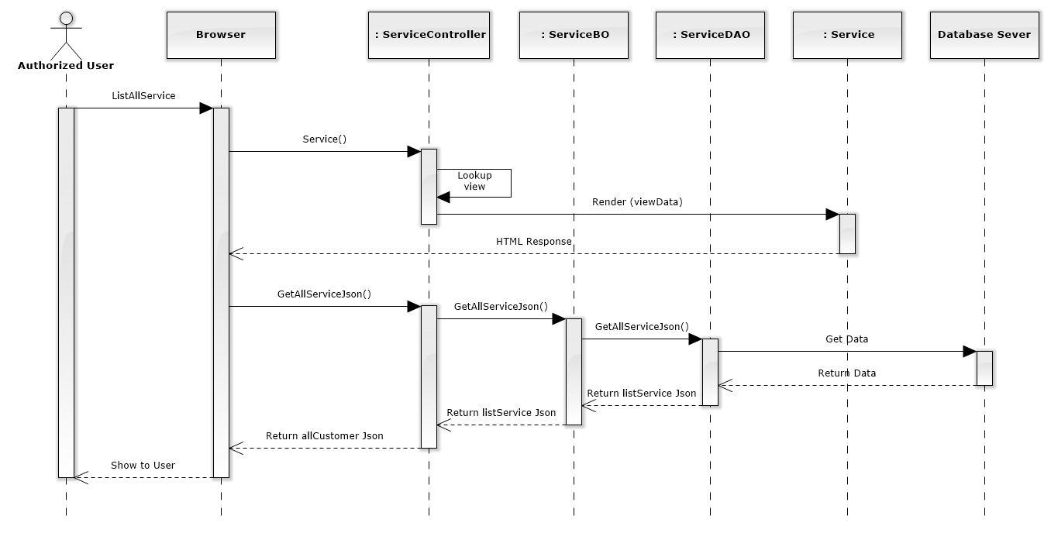

Figure 172: List Services Sequence Diagram

### Add new service

#### Screen design

#### 

|  |  |  |  |  |
| --- | --- | --- | --- | --- |
| No | Object/ControlName | Type | Required | Description |
| 1 | Tên dịch vụ | Textbox | Yes | Name Service |
| 2 | Loại dịch vụ | Combo-box | Yes | Service type |
| 3 | Mô tả | Textbox | Yes | Description |
| 4 | “Đóng” | Button | Yes | Click to close add new service pop-up |
| 5 | “Thêm mới” | Button | Yes | Click to add new service |

#### Sequence diagram

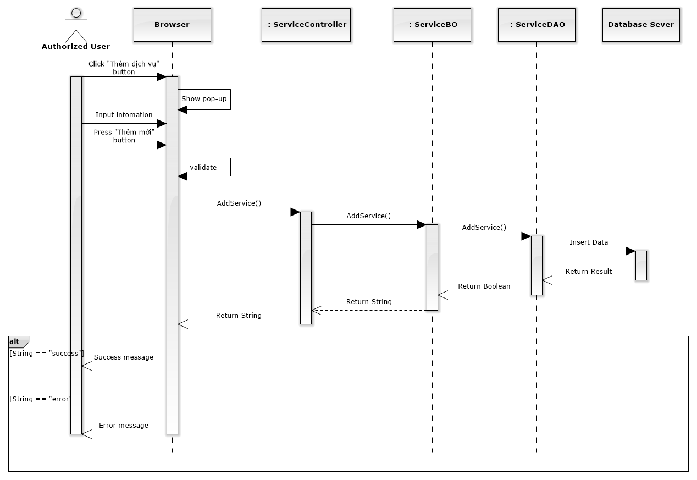

Figure 173: Add New Service Sequence Diagram

### Edit service

#### Screen design

#### 

|  |  |  |  |  |
| --- | --- | --- | --- | --- |
| No | Object/ControlName | Type | Required | Description |
| 1 | Tên dịch vụ | Textbox | Yes | Name Service |
| 2 | Loại dịch vụ | Combo-box | Yes | Service type |
| 3 | Mô tả | Textbox | Yes | Description |
| 4 | “Đóng” | Button | Yes | Click to close edit service pop-up |
| 5 | “Lưu chỉnh sửa” | Button | Yes | Click to save edit service |

#### Sequence diagram

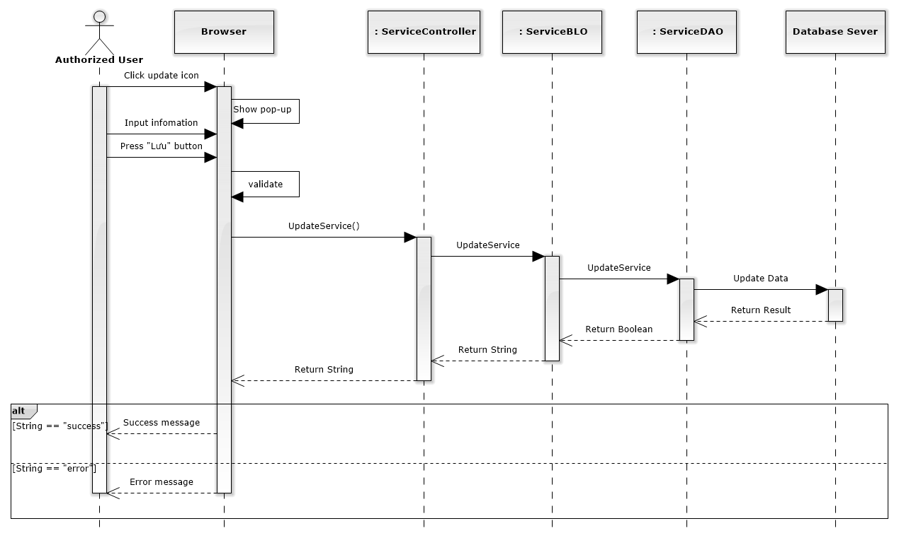

Figure 174: Edit Service Sequence Diagram

### Delete service

#### Screen design

#### 

|  |  |  |  |  |
| --- | --- | --- | --- | --- |
| No | Object/ControlName | Type | Required | Description |
| 1 | Bỏ qua | Button | Yes | Click to close delete service pop-up |
| 2 | Xác nhận | Button | Yes | Click to delete service pop-up |

#### Sequence diagram

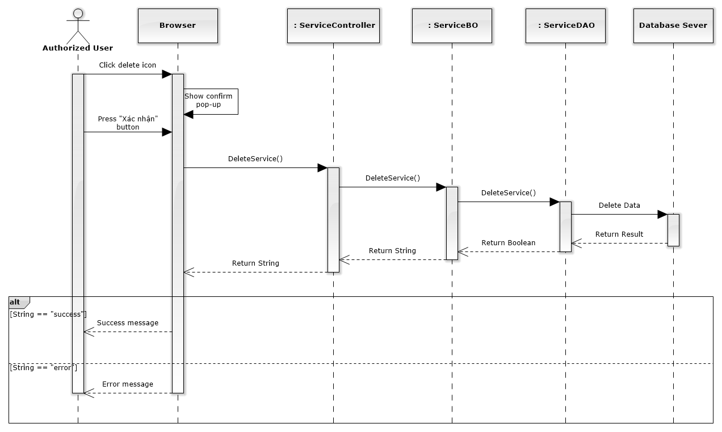

Figure 175: Delete Service Sequence Diagram

### List offices

#### Class diagram

### 

#### Screen design

#### 

|  |  |  |  |  |
| --- | --- | --- | --- | --- |
| No | Object/ControlName | Type | Required | Description |
| 1 | Thêm văn phòng | Button | Yes | Click to show popup for add new office |
| 2 | Number of rows | Combo-box | Yes | Choose number of rows in table |
| 3 | Tìm kiếm | Textbox | Yes | Search office |
| 4 | List all office | Table | Yes | List all office |
| 5 | View | Button | Yes | Click to show popup detail of office |
| 6 | Edit | Button | Yes | Click to show popup edit detail of office information. |
| 7 | Paging | Button | Yes | Paging page |

#### Sequence diagram

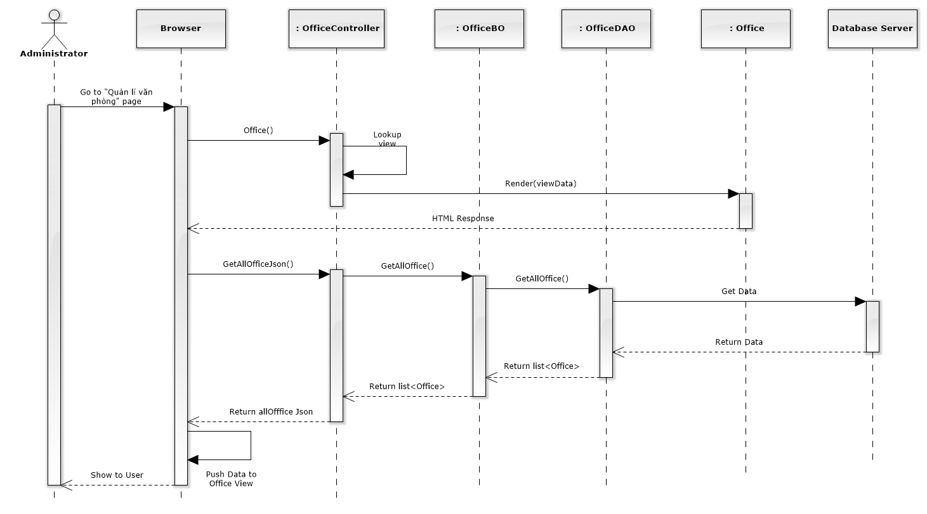

Figure 176: List Offices Sequence Diagram

### Add new office

#### Screen design

#### 

|  |  |  |  |  |
| --- | --- | --- | --- | --- |
| No | Object/ControlName | Type | Required | Description |
| 1 | Tên văn phòng | Textbox | Yes | Name of office |
| 2 | Người quản lí | Textbox | Yes | Nam’s manager of office |
| 3 | Số tài khoản | Textbox | Yes | Bank account number of office |
| 4 | Fax | Textbox | Yes | Fax of office |
| 5 | Email | Textbox | Yes | Email of office |
| 6 | Địa chỉ văn phòng | Textbox | Yes | Address of office |
| 7 | Điện thoại | Textbox | Yes | Phone number of office |
| 8 | Mã số thuế | Textbox | Yes | Tax number of office |
| 9 | Ngân hàng | Textbox | Yes | Name of bank of office |
| 10 | Website | Textbox | Yes | Website of office |
| 11 | “Làm trống” | Button | Yes | Clear field |
| 12 | “Thêm mới” | Button | Yes | Click to add new office |

#### Sequence diagram

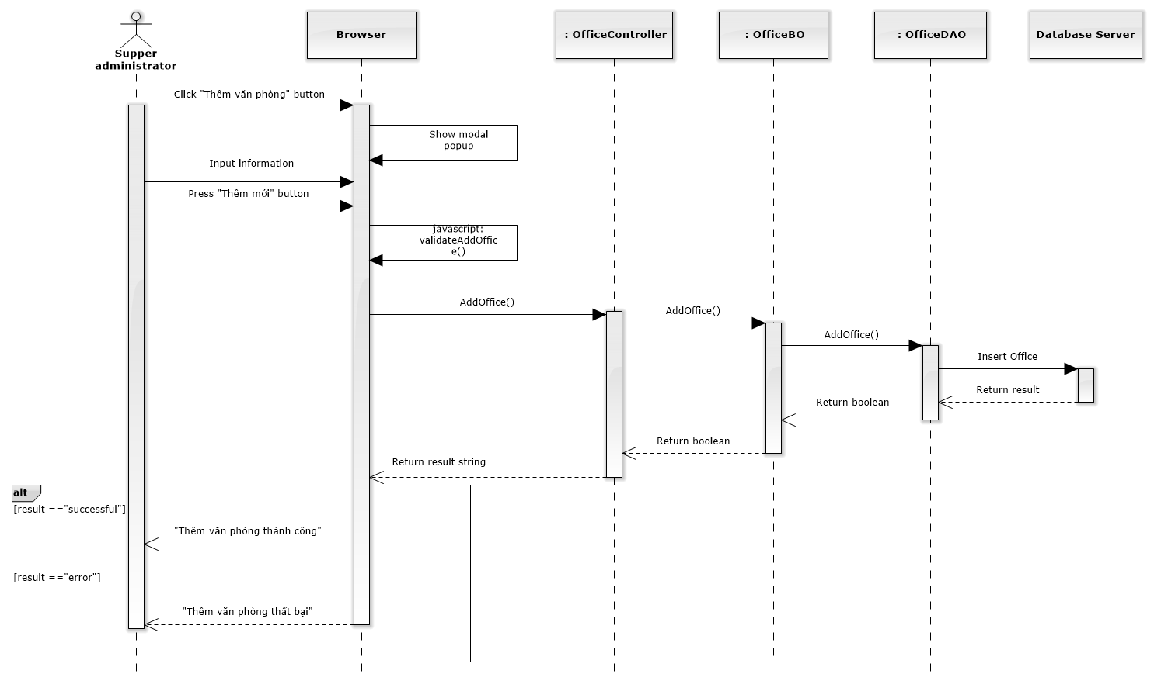

Figure 177: Add New Office Sequence Diagram

### Edit office

#### Screen design

#### 

|  |  |  |  |  |
| --- | --- | --- | --- | --- |
| No | Object/ControlName | Type | Required | Description |
| 1 | Tên văn phòng | Textbox | Yes | Name of office |
| 2 | Người quản lí | Textbox | Yes | Nam’s manager of office |
| 3 | Số tài khoản | Textbox | Yes | Bank account number of office |
| 4 | Fax | Textbox | Yes | Fax of office |
| 5 | Email | Textbox | Yes | Email of office |
| 6 | Địa chỉ văn phòng | Textbox | Yes | Address of office |
| 7 | Điện thoại | Textbox | Yes | Phone number of office |
| 8 | Mã số thuế | Textbox | Yes | Tax number of office |
| 9 | Ngân hàng | Textbox | Yes | Name of bank of office |
| 10 | Website | Textbox | Yes | Website of office |
| 11 | Ngừng hoạt động | Link | Yes | Status of office |
| 12 | “Đóng” | Button | Yes | Click to close edit office |
| 13 | “Lưu chỉnh sửa” | Button | Yes | Click to save edit office |

#### Sequence diagram

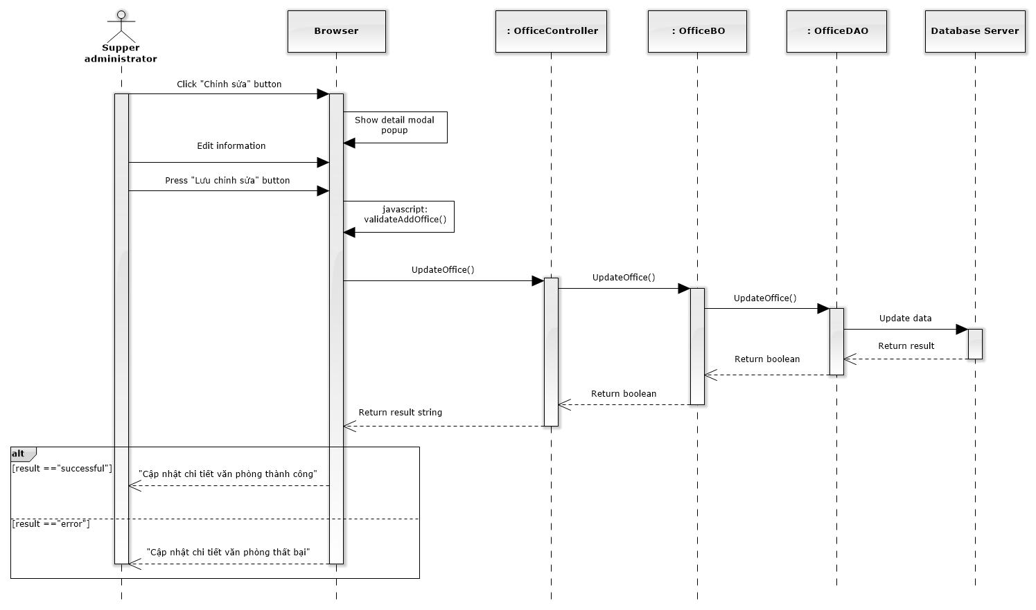

Figure 178: Edit Office Sequence Diagram

### Deactivate/ Activate office

#### Screen design

#### 

|  |  |  |  |  |
| --- | --- | --- | --- | --- |
| No | Object/ControlName | Type | Required | Description |
| 1 | “Bỏ qua” | Button | Yes | Click to close Deactive office |
| 2 | “Xác nhận” | Button | Yes | Click to Deactive office |
| 3 | Ngừng hoạt động | Link | Yes | Click to open confirm Deactive office |

#### Sequence diagram

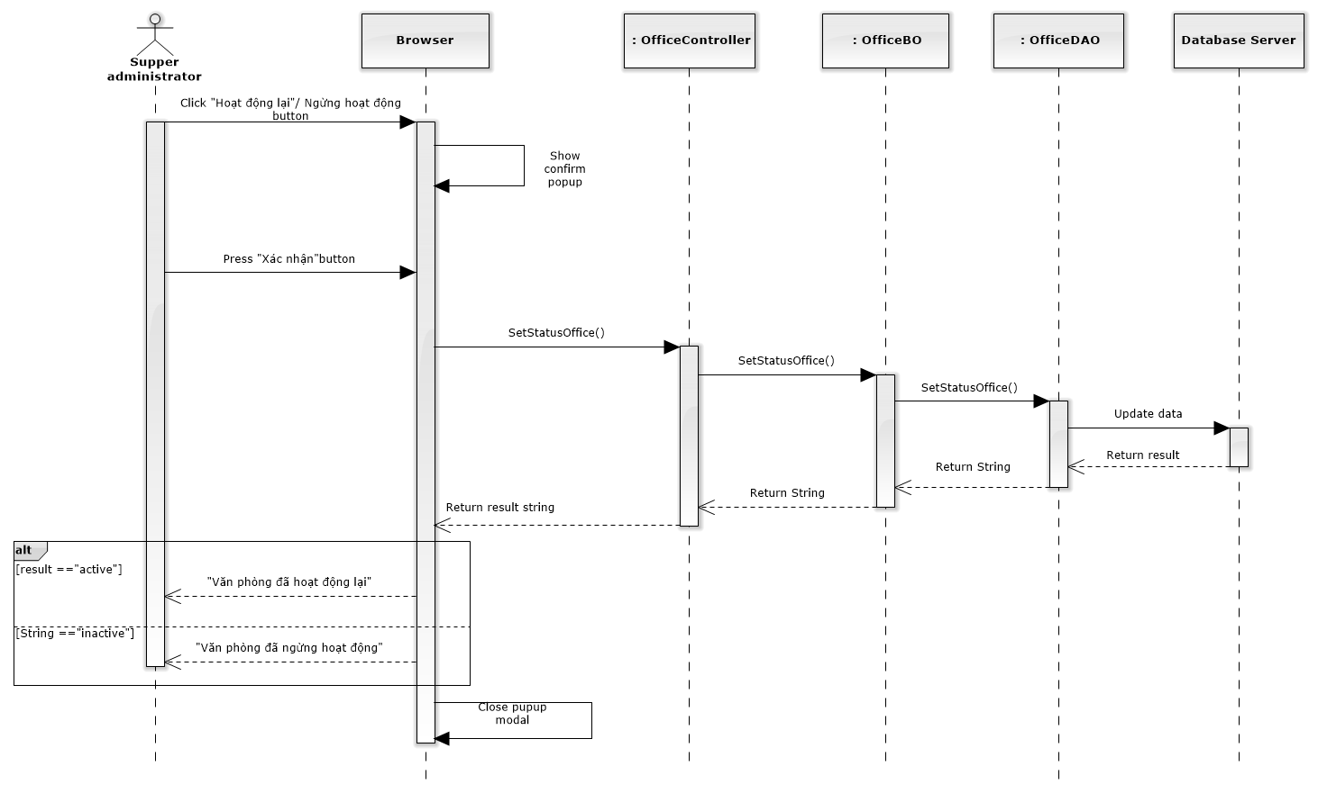

Figure 179: Deactivate / Activate Office Sequence Diagram

### Office statistic

#### Class diagram

### 

#### Screen design

#### 

#### 

|  |  |  |  |  |
| --- | --- | --- | --- | --- |
| No | Object/ControlName | Type | Required | Description |
| 1 | Chọn văn phòng | Combo box | Yes | Click to choose name of office |
| 2 | Tab statistic | Link | Yes | Click to choose tab of statistic |
| 3 | Bar chart | Image | Yes | Image display of Bar chart |
| 4 | Pie chart | Image | Yes | Image display of Bar chart |
| 5 | Name office | Text | Yes | Name of office |
| 6 | Select name office | Combo box | Yes | Select name for comparison office |
| 7 | Comparison chart | Image | Yes | Image display of Bar chart |

#### Sequence diagram

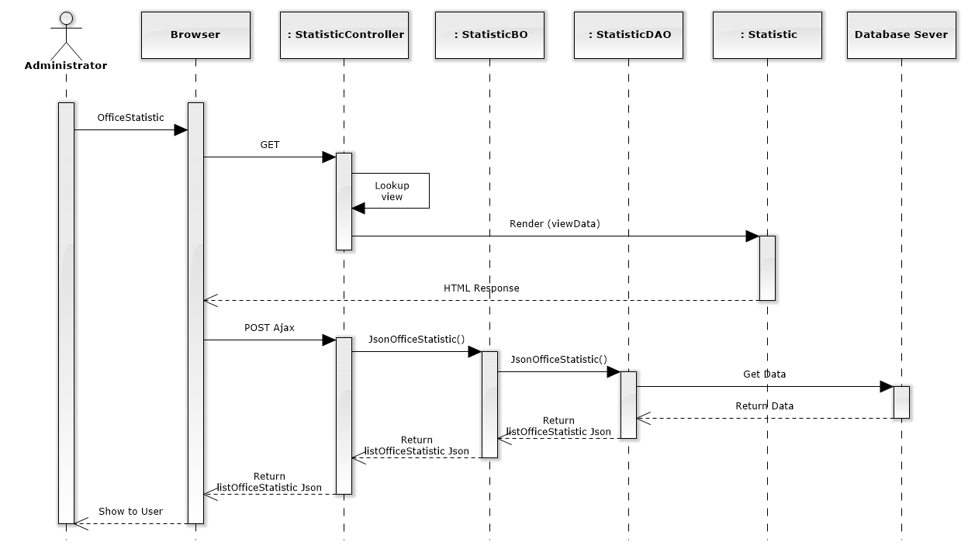

Figure 209: Office Statistic Sequence Diagram

### Staff statistic

#### Screen design

#### 

#### 

|  |  |  |  |  |
| --- | --- | --- | --- | --- |
| No | Object/ControlName | Type | Required | Description |
| 1 | Chọn luật sư | Combo box | Yes | Click to choose name of staff |
| 2 | Tab statistic | Link | Yes | Click to choose tab of statistic |
| 3 | Bar chart | Image | Yes | Image display of Bar chart |
| 4 | Select name staff | Combo box | Yes | Select name for comparison staff |
| 5 | Comparison chart | Image | Yes | Image display of Bar chart |

#### Sequence diagram

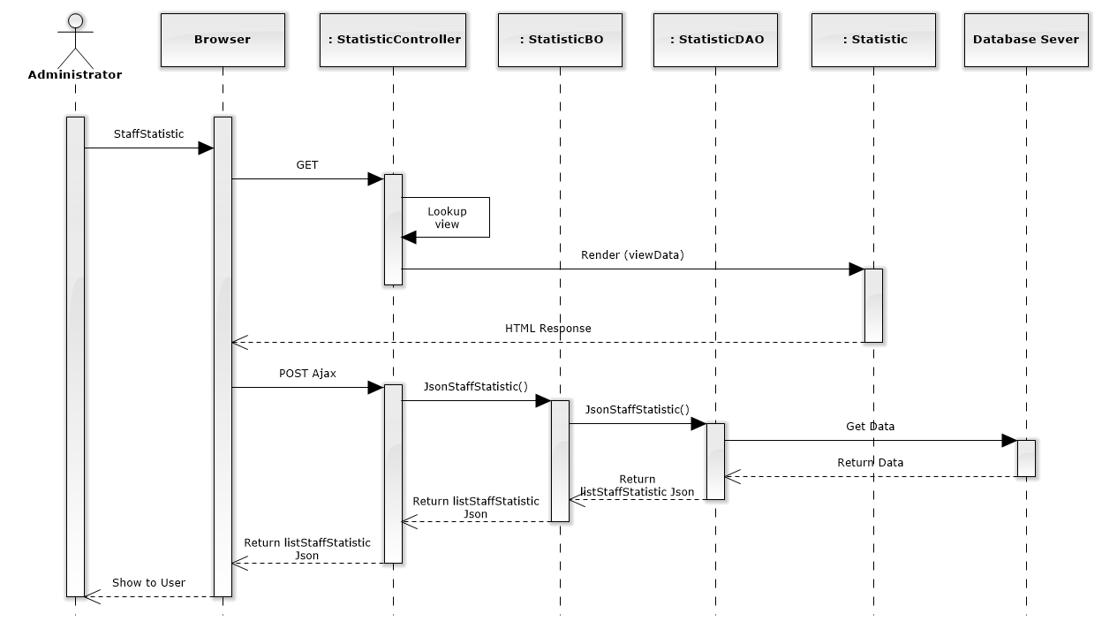

Figure 210: Staff Statistic Sequence Diagram

### Revenue statistic

#### Screen design

#### 

#### 

|  |  |  |  |  |
| --- | --- | --- | --- | --- |
| No | Object/ControlName | Type | Required | Description |
| 1 | Chọn văn phòng | Combo box | Yes | Click to choose name of office |
| 2 | Tab statistic | Link | Yes | Click to choose tab of statistic |
| 3 | Bar chart | Image | Yes | Image display of Bar chart |
| 4 | Pie chart | Image | Yes | Image display of Bar chart |
| 5 | Name office | Text | Yes | Name of office |
| 6 | Select name office | Combo box | Yes | Select name for comparison office |
| 7 | Comparison chart | Image | Yes | Image display of Bar chart |

#### Sequence diagram

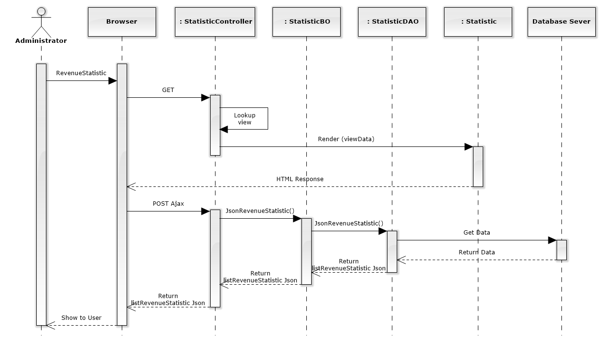

Figure 211: Revenue Statistic Sequence Diagram

1. User Interface Design

### Home

#### Home Screen Image

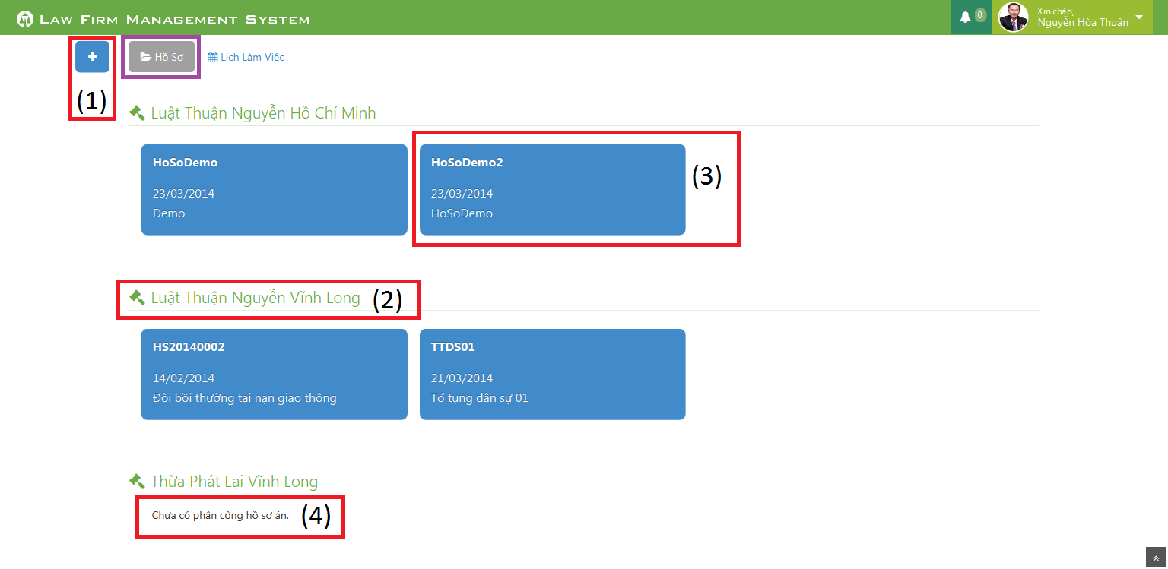

Figure 212: Home Screen Image

#### Home Description

|  |  |  |  |  |  |
| --- | --- | --- | --- | --- | --- |
| No | Name | Type | | | Description |
| 1 | Plus | | Button | Click to show popup for add new case | |
| 2 | Office name | | Label | Show name of office the staff work in | |
| 3 | Case information | | Button | Show important information of the case, click and redirect to view case detail page | |
| 4 | “Chưa có phân công hồ sơ án” | | Label | If the office have no “Đang thụ lý” case, message will be show | |

### User Control Panel

#### Notify Event

##### Notify Event Screen Image

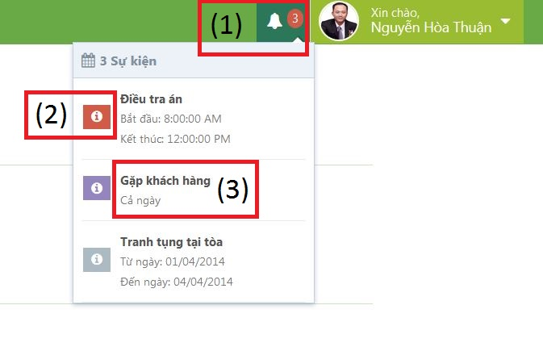

Figure 213: Notify Event Screen Image

##### Notify Event Panel Description

|  |  |  |  |  |  |
| --- | --- | --- | --- | --- | --- |
| No | Name | | Type | | Description |
| 1 | Event count | Label | | Event quantity in “today” need to do. If there is at least 1 event, ring the bell | |
| 2 | Priority | Icon | | Show priority of event | |
| 3 | Title | Label | | Show title and time range of event | |

#### Dropdown Control

##### Dropdown Control Screen Image

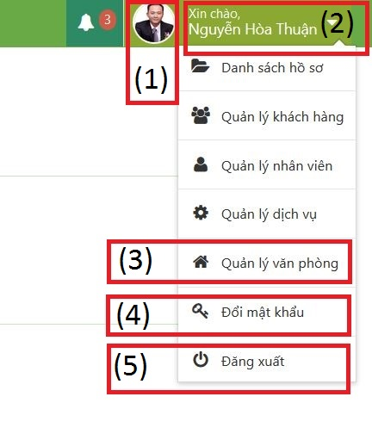

Figure 214: Dropdown Control Screen Image

##### Dropdown Control Description

|  |  |  |  |  |  |
| --- | --- | --- | --- | --- | --- |
| No | Name | | Type | | Description |
| 1 | Avatar | Image | | View avatar of staff | |
| 2 | Staff fullname | Label | | View fullname of staff | |
| 3 | Link to manage | Link | | Click on link and then redirect to manage page | |
| 4 | Link to change password | Link | | Click on link to show modal popup for change password | |
| 5 | Logout | Link | | Click on link to logout of system | |

### Calendar Event

#### Personal Calendar

##### Personal Calendar Screen Image

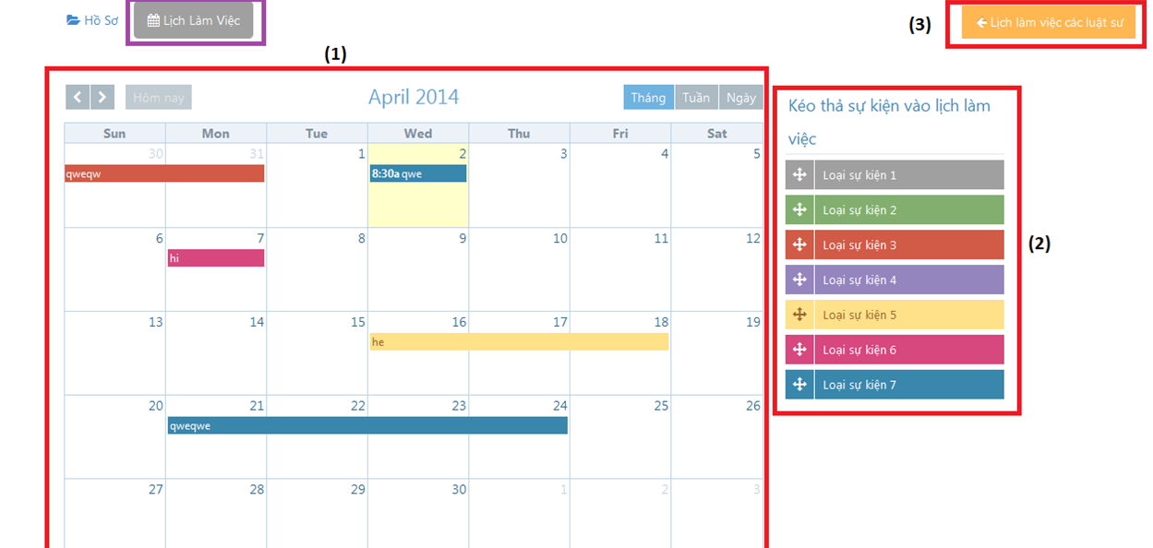

Figure 215: Personal Calendar Screen Image

##### Personal Calendar Description

|  |  |  |  |
| --- | --- | --- | --- |
| No | Name | Type | Description |
| 1 | Calendar | Full Calendar | Show all event of Staff on calendar |
| 2 | Dropable event | Object | Drag and drop into calendar to create new event |
| 3 | Lịch làm việc của các luật sư | Button | Show other staff calendar pop-up |

#### Shared Calendar

##### Shared Calendar Screen Image

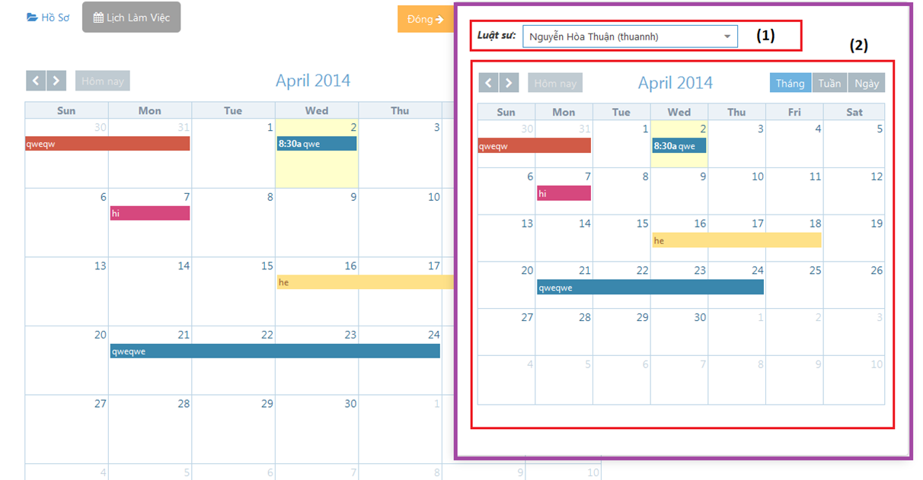

Figure 216: Shared Calendar Screen Image

##### Shared Calendar Description

|  |  |  |  |
| --- | --- | --- | --- |
| No | Name | Type | Description |
| 1 | Luật sư | Search combo-box | Staff name |
| 2 | Calendar | Full calendar | Other staff calendar event |

### Case

#### All Cases

##### All Cases Screen Image

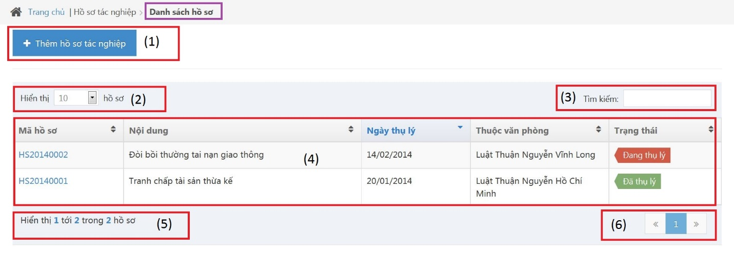

Figure 217: All Cases Screen Image

##### All Cases Description

|  |  |  |  |  |  |
| --- | --- | --- | --- | --- | --- |
| No | Name | | Type | | Description |
| 1 | “Thêm hồ sơ tác nghiệp” | Button | | Click to show popup for add new case | |
| 2 | Line count | Dropdown list | | Select line quantity in table | |
| 3 | “Tìm kiếm” | Textbox | | Search case automatically | |
| 4 | View all cases | Table | | Show all of case | |
| 5 | Case count | Label | | Show case quantity of page in table | |
| 6 | Paging | Button | | List case page by page | |

#### Add New Case

##### Add New Case Screen Image

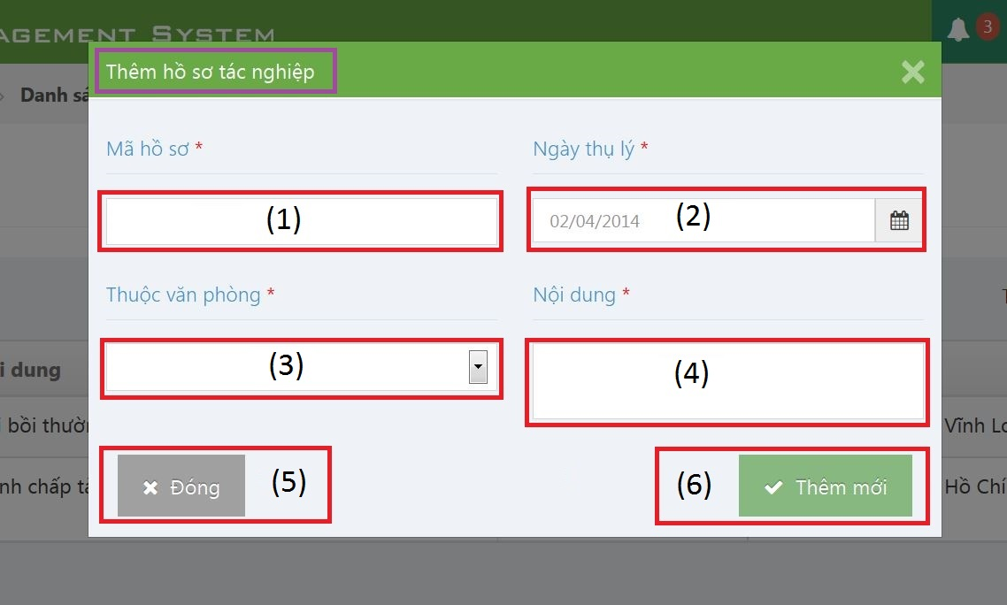

Figure 218: Add New Case Screen Image

##### Add New Case Description

|  |  |  |  |  |  |
| --- | --- | --- | --- | --- | --- |
| No | Name | | Type | | Description |
| 1 | “Mã hồ sơ” | Textbox | | Case code | |
| 2 | “Ngày thụ lý” | Textbox | | Receipt date | |
| 3 | “Thuộc văn phòng” | Textbox | | Choose one office | |
| 4 | “Nội dung” | Textbox | | Case content | |
| 5 | “Đóng” | Button | | Click to close modal popup | |
| 6 | “Thêm mới” | Button | | Click to create a new case | |

#### Case Detail

##### Case Info

###### Case Info Screen Image

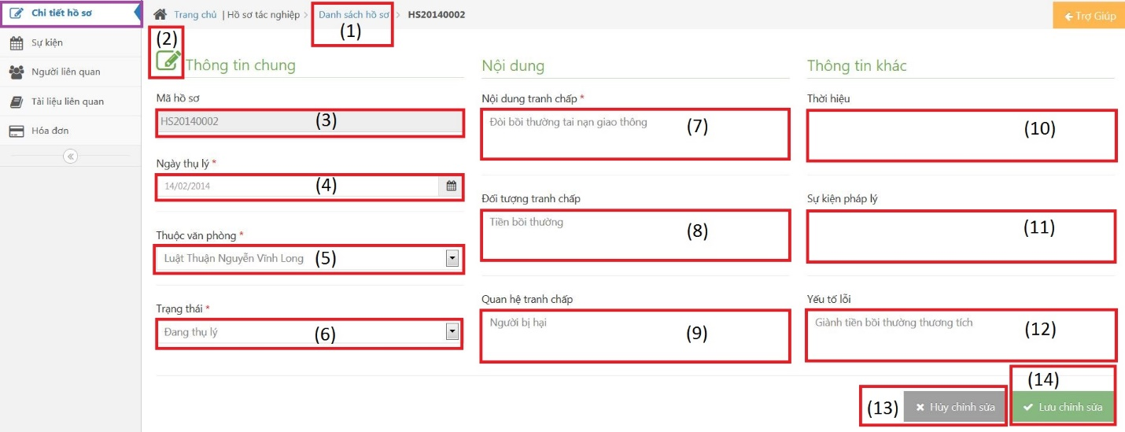

Figure 219: Case Info Screen Image

###### Case Info Description

|  |  |  |  |  |  |
| --- | --- | --- | --- | --- | --- |
| No | Name | | Type | | Description |
| 1 | “Danh sách hồ sơ” | Link | | Redirect to view all cases | |
| 2 | Edit | Button | | Must be click to edit infor | |
| 3 | “Mã hồ sơ” | Textbox | | Case code | |
| 4 | “Ngày thụ lý” | Textbox | | Receipt date | |
| 5 | “Thuộc văn phòng” | Textbox | | Choose one office | |
| 6 | “Trạng thái” | Textbox | | Case status | |
| 7 | “Nội dung tranh chấp” | Textbox | | The contents of dispute | |
| 8 | “Đối tượng tranh chấp” | Textbox | | The subject of dispute | |
| 9 | “Quan hệ tranh chấp” | Textbox | | The relation of dispute | |
| 10 | “Thời hiệu” | Textbox | | The statute of limitations | |
| 11 | “Sự kiện pháp lý” | Textbox | | Legal event | |
| 12 | “Yếu tố lỗi” | Textbox | | Error factor | |
| 13 | “Hủy chỉnh sửa” | Button | | Cancel edit infor | |
| 14 | “Lưu chỉnh sửa” | Button | | Save new infor | |

##### Operation Event

###### Operation Event Screen Image

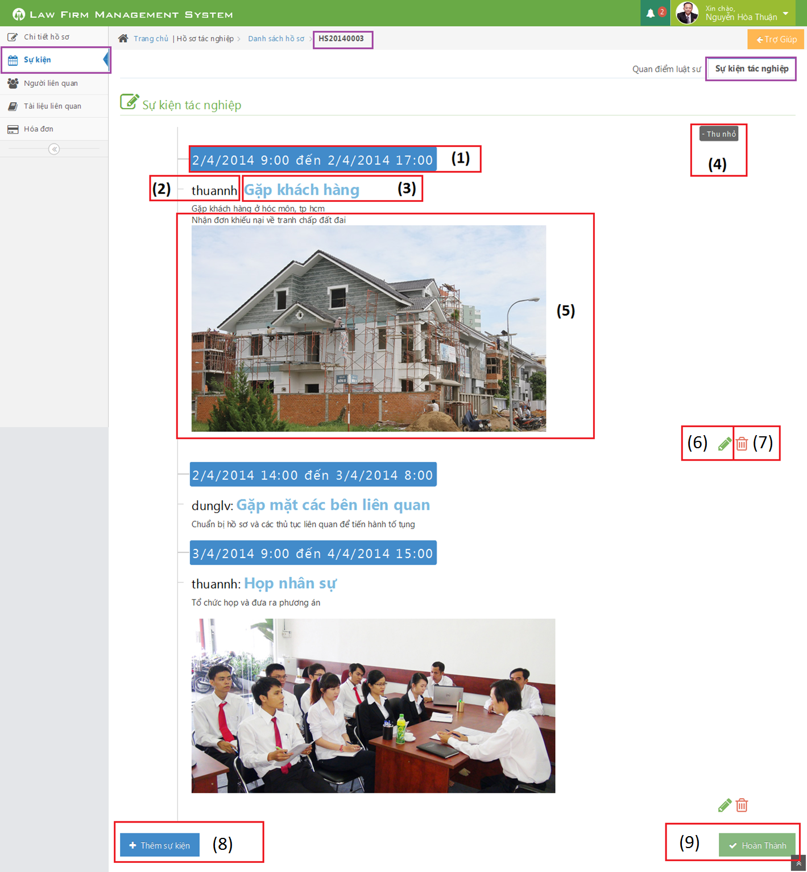

Figure 220: Operation Event Screen Image

###### Operation Event Description

|  |  |  |  |  |  |
| --- | --- | --- | --- | --- | --- |
| No | Name | | Type | | Description |
| 1 | Time range | Label | | Click to choose begin time and end time of event | |
| 2 | Staff username | Label | | The lawyer who create a case | |
| 3 | Title | Label | | Title of Operation Event | |
| 4 | Thu nhỏ / Mở rộng | Button | | Reduce / Expand | |
| 5 | Content | Information | | Content of Operation Event | |
| 6 | Pencil | Button | | Edit operation event | |
| 7 | Trash | Button | | Delete operation event | |
| 8 | Thêm sự kiện | Button | | Click to add new operation event | |
| 9 | Hoàn thành | Button | | Click to finish edit operation event | |

##### Lawyer Related

###### Lawyer Related Screen Image

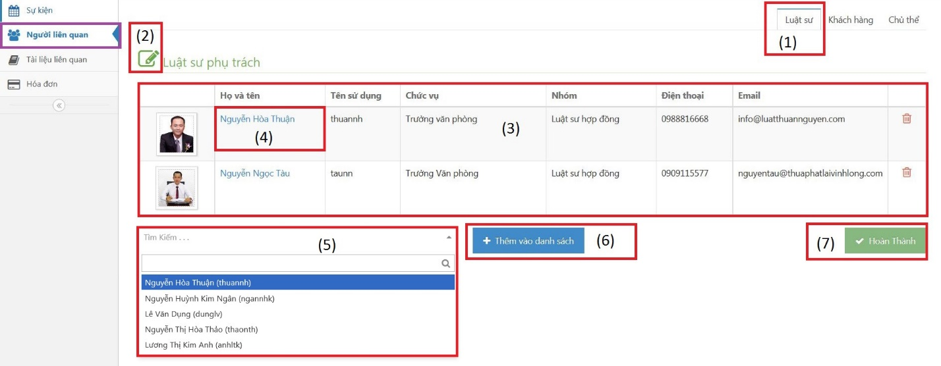

Figure 221: Lawyer Related Screen Image

###### Lawyer Related Description

|  |  |  |  |  |  |
| --- | --- | --- | --- | --- | --- |
| No | Name | | Type | | Description |
| 1 | “Luật sư” | Button | | Change to “Luật sư” tab | |
| 2 | Edit | Button | | Must be click to edit infor | |
| 3 | View all lawyers | Table | | Show all lawyers | |
| 4 | Fullname | Link | | Click to show detail of lawyer | |
| 5 | “Tìm kiếm” | Combo box | | Search lawyer before assign | |
| 6 | “Thêm vào danh sách” | Button | | Click to assign lawyer to current case | |
| 7 | “Hoàn thành” | Button | | Complete assign | |

##### Customer Related

###### Customer Related Screen Image

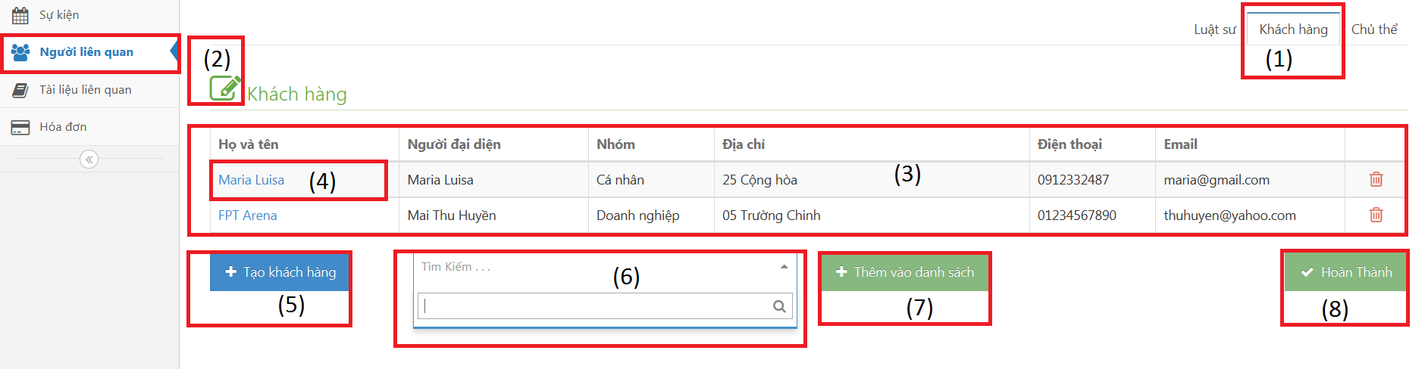

Figure 222: Customer Related Screen Image

###### Customer Related Description

|  |  |  |  |  |  |
| --- | --- | --- | --- | --- | --- |
| No | Name | | Type | | Description |
| 1 | “Khách hàng” | Button | | Change to “Khách hàng” tab | |
| 2 | Edit | Button | | Must be click to edit infor | |
| 3 | View all customers | Table | | Show all customers | |
| 4 | Fullname | Link | | Click to show detail of customer | |
| 5 | “Tạo khách hàng” | Button | | Open popup and then create customer | |
| 6 | “Tìm kiếm” | Combo box | | Search customer before add into case | |
| 7 | “Thêm vào danh sách” | Button | | Click to add lawyer into current case | |
| 8 | “Hoàn thành” | Button | | Complete add | |

##### Subject Related

###### Subject Related Screen Image

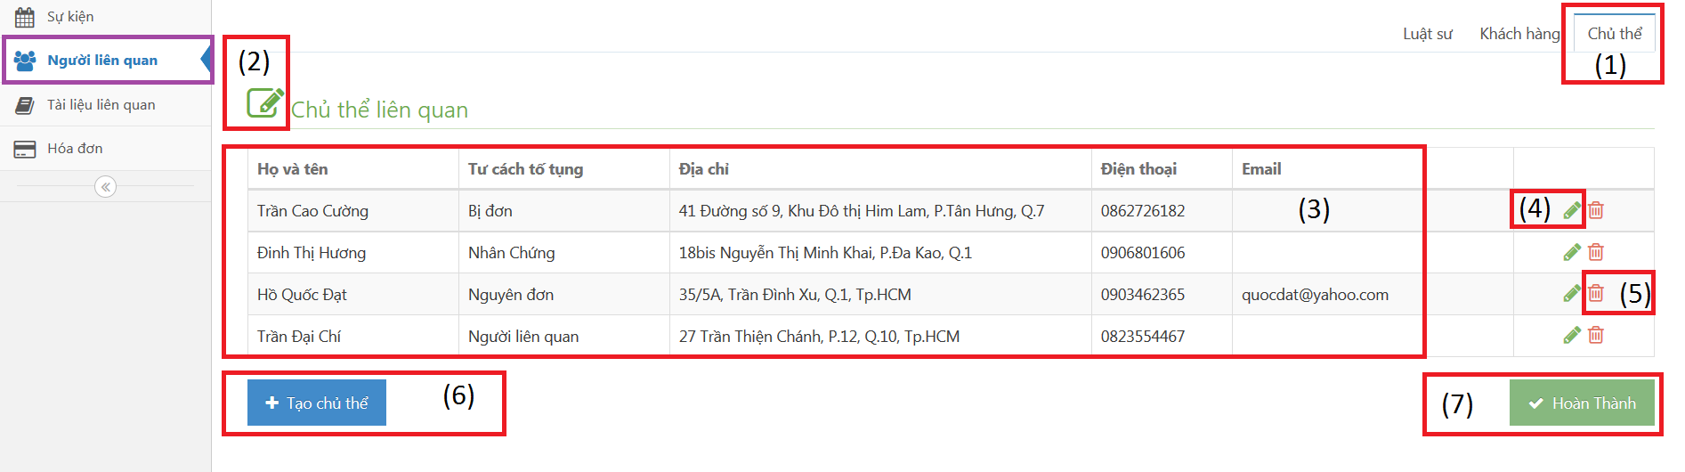

Figure 223: Subject Related Screen Image

###### Subject Related Description

|  |  |  |  |  |  |
| --- | --- | --- | --- | --- | --- |
| No | Name | | Type | | Description |
| 1 | “Chủ thể” | Button | | Change to “Chủ thể” tab | |
| 2 | Edit | Button | | Must be click to edit infor | |
| 3 | View all subjects | Table | | Show all subjects | |
| 4 | Pencil | Button | | Open popup and then edit subject | |
| 5 | Trash | Button | | Delete subject | |
| 6 | “Tạo chủ thể” | Button | | Open popup and then create subject | |
| 7 | “Hoàn thành” | Button | | Complete add | |

##### Document Related

###### Document Related Screen Image

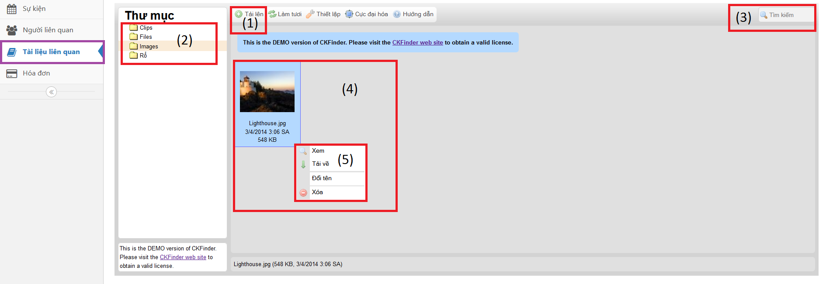

Figure 224: Document Related Screen Image

###### Document Related Description

|  |  |  |  |  |  |
| --- | --- | --- | --- | --- | --- |
| No | Name | | Type | | Description |
| 1 | “Tải lên” | Button | | Upload one or many file to server | |
| 2 | Folder | Button list | | Each folder only allow upload a few type of file | |
| 3 | “Tìm kiếm” | Textbox | | Search file name automatically | |
| 4 | File detail | Information | | Show main information of file | |
| 5 | Properties | Button list | | Allow to View, Dowload, Rename and Delete a file | |

##### Used Service / Payment

###### All Used Services / Payments Screen Image

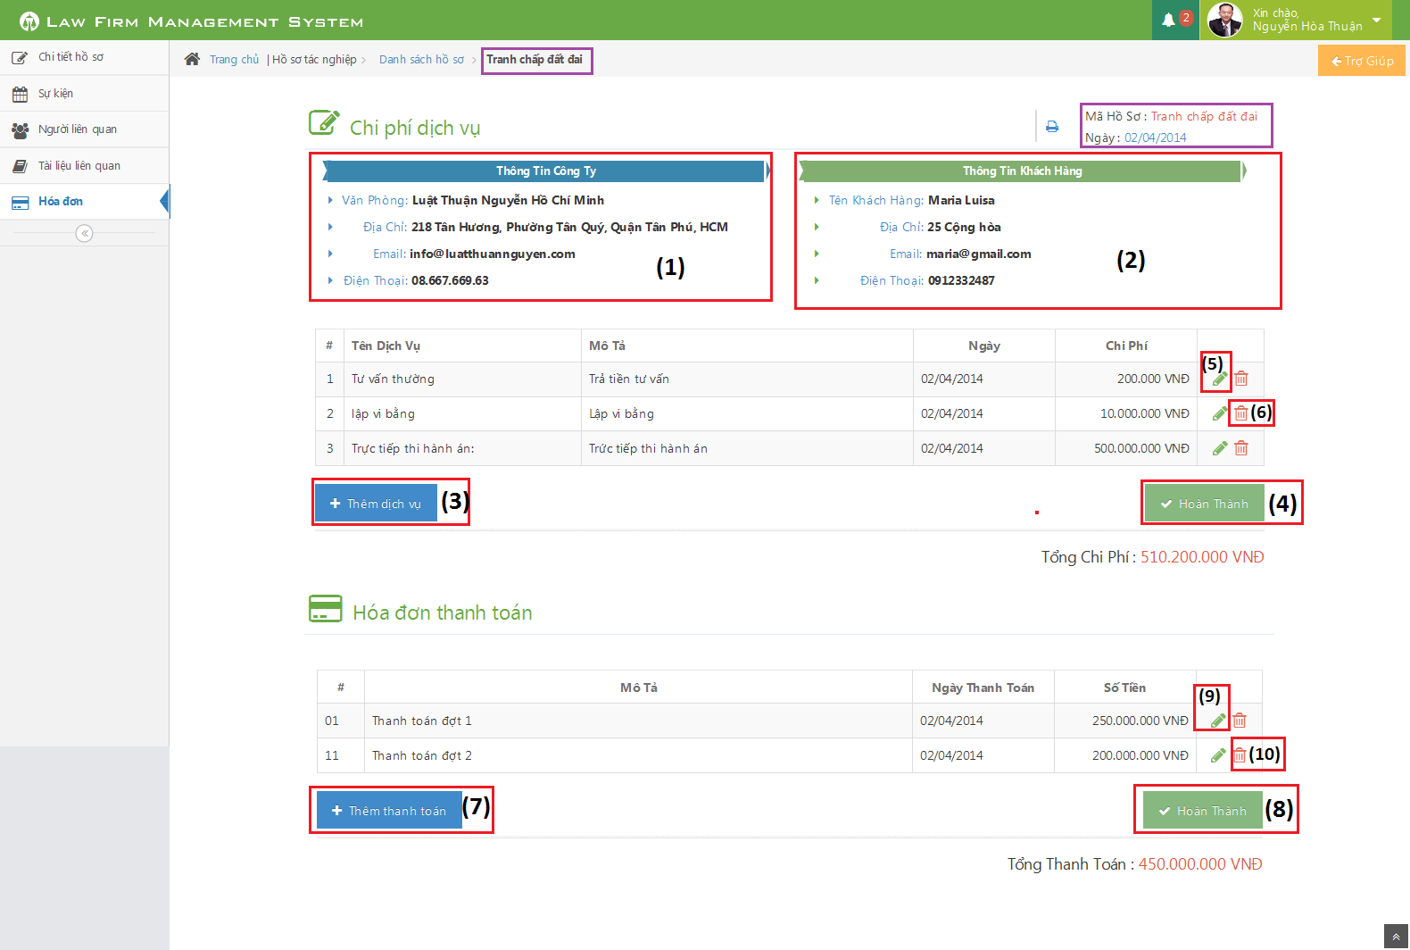

Figure 225: All Used Services / Payments Screen Image

###### All Used Services / Payments Description

|  |  |  |  |  |  |
| --- | --- | --- | --- | --- | --- |
| No | Name | Type | | | Description |
| 1 | List office detail of curent case | | Table | List detail of office in curent case | |
| 2 | List customer detail of curent case | | Table | List detail of customer in curent case | |
| 3 | Thêm dịch vụ | | Button | Click to show popup for add new Used Service | |
| 4 | Hoàn thành | | Button | Click to close table and finish add/edit Used Service | |
| 5 | Edit | | Button | Click to show popup edit detail of Used Service | |
| 6 | Delete | | Button | Click to show popup confirm delete Used Service | |
| 7 | Thêm thanh toán | | Button | Click to show popup for add new Payment | |
| 8 | Hoàn thành | | Button | Click to close table and finish add/edit Payment | |
| 9 | Edit | | Button | Click to show popup edit detail of Payment | |
| 10 | Delete | | Button | Click to show popup confirm delete Payment | |

##### Thư Viện Pháp Luật

###### Thư Viện Pháp Luật Screen Image

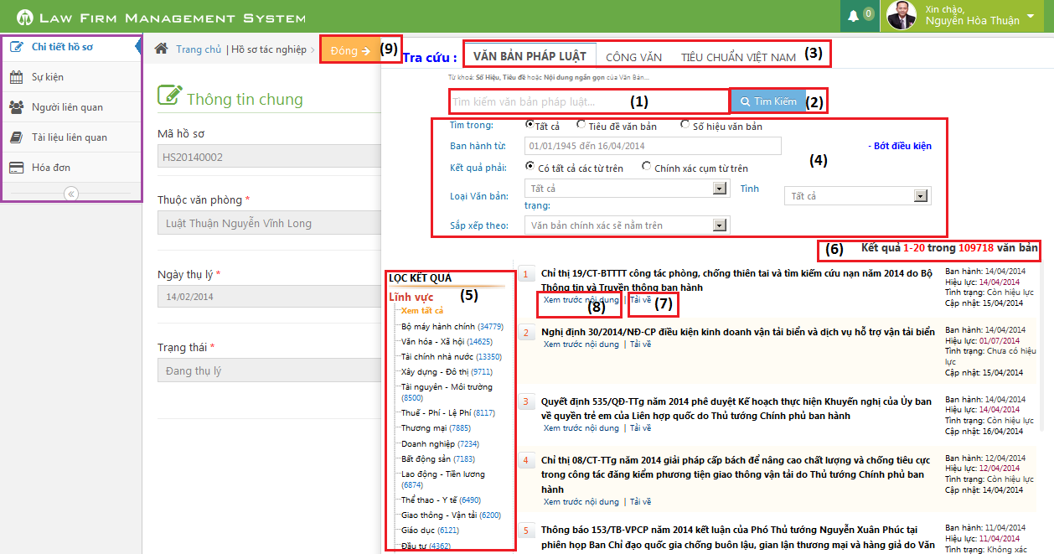

Figure 226: Thư Viện Pháp Luật Screen Image

###### Thư Viện Pháp Luật Description

|  |  |  |  |
| --- | --- | --- | --- |
| No | Name | Type | Description |
| 1 | Input keyword to search | Text box | Input key to search document |
| 2 | Tìm kiếm | Button | Press to search document |
| 3 | Type search of document | Button | Three type of search document |
| 4 | Choose or input other condition of search | Lable | Choose or input to add other condition of search |
| 5 | Choose a link to search other type of document | Lable | Choose a link to search other type of document |
| 6 | Result of search | Lable | Result of search |
| 7 | Download | Button | Click to download document to curent Case |
| 8 | View | Button | Click to view detail of document |
| 9 | Close | Button | Close Search Popup |

### Customer

#### All Customers

##### All Customers Screen Image

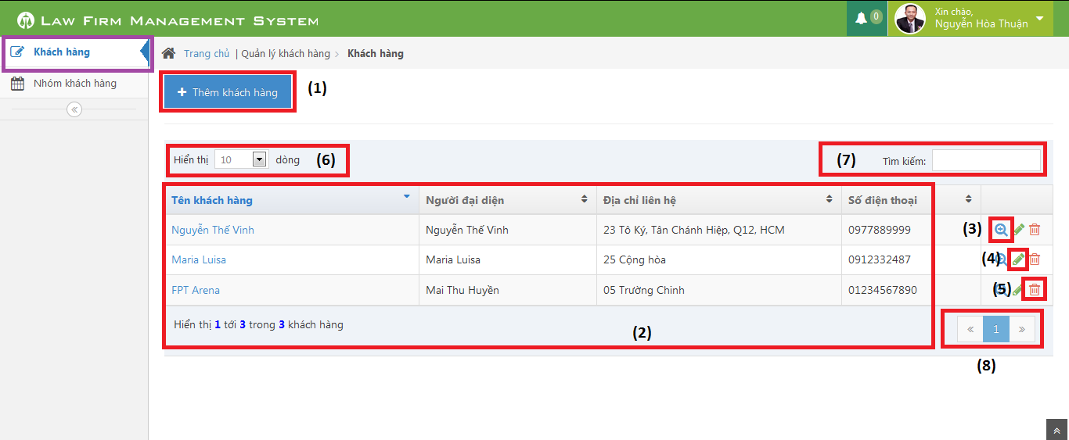

Figure 227: All Customers Screen Image

##### All Customers Description

|  |  |  |  |
| --- | --- | --- | --- |
| No | Name | Type | Description |
| 1 | Thêm khách hàng | Button | Show Add new customer pop-up |
| 2 | Customer table | Table | List Customer |
| 3 | View customer detail | Icon | Show Customer detail pop-up |
| 4 | Edit customer | Icon | Show edit customer pop-up |
| 5 | Delete customer | Icon | Delete customer |
| 6 | Number of rows | Combo-box | Choose number of rows in table |
| 7 | Search | Textbox | Search customer |
| 8 | Paging | Button | Paging the customer list |

#### Customer Detail

##### Customer Detail Screen Image

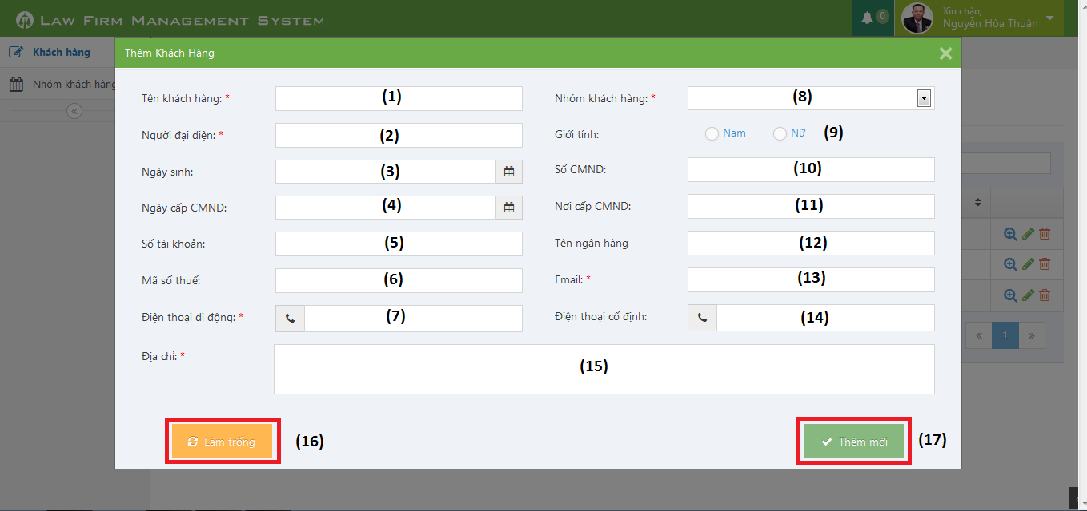

Figure 228: Customer Detail Screen Image

##### Customer Detail Description

|  |  |  |  |
| --- | --- | --- | --- |
| No | Name | Type | Description |
| 1 | Tên Khách hàng | Textbox | Customer name |
| 2 | Người đại diện | Textbox | Presentative |
| 3 | Ngày sinh | Date picker | Date of Birth |
| 4 | Ngày cấp CMND | Date picker | Identity Date |
| 5 | Số tài khoản | Textbox | Bank account |
| 6 | Mã số thuế | Textbox | Tax code |
| 7 | Điện thoại di động | Textbox | Mobile |
| 8 | Nhóm khách hàng | Combo-box | Customer group |
| 9 | Giới tính | Radio-button | Gender |
| 10 | Số CMND | Textbox | Identity Number |
| 11 | Nơi cấp CMND | Textbox | Identity Place |
| 12 | Tên ngân hàng | Textbox | Bank Branch |
| 13 | Email | Textbox | Email |
| 14 | Điện thoại cố định | Textbox | Phone |
| 15 | Địa chỉ | Text area | Address |
| 16 | Làm trống | Button | Clear all field |
| 17 | Thêm mới | Button | Add new customer |

### Staff

#### All Staffs

##### All Staffs Screen Image

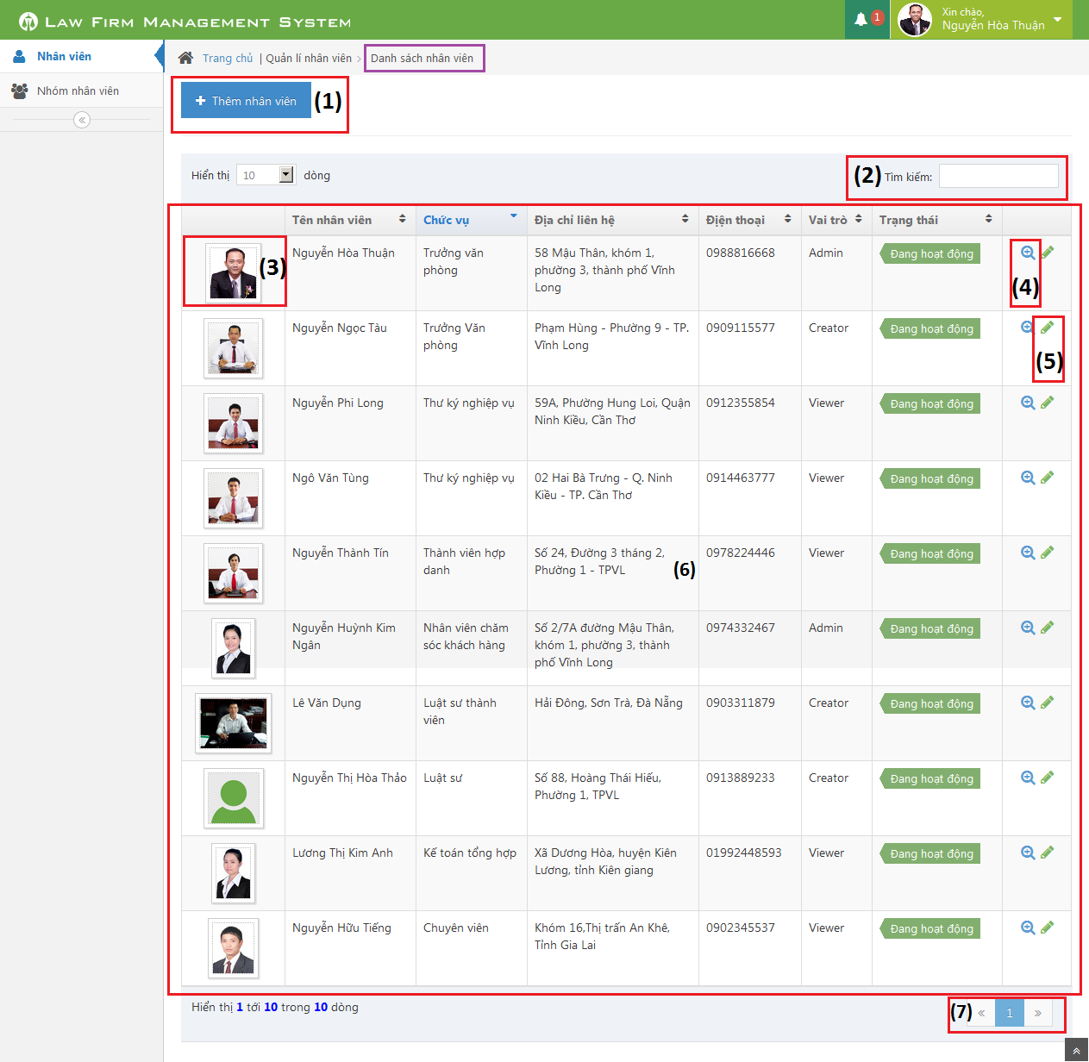

Figure 229: All Staffs Screen Image

##### All Staffs Description

|  |  |  |  |  |  |
| --- | --- | --- | --- | --- | --- |
| No | Name | | Type | | Description |
| 1 | Thêm nhân viên | Button | | Click to show popup for add new staff | |
| 2 | Tìm kiếm | Textbox | | Search staff | |
| 3 | Image of staff | Image | | Click to show popup detail of staff | |
| 4 | View | Button | | Click to show popup detail of staff | |
| 5 | Edit | Button | | Click to show popup edit detail of staff information. | |
| 6 | List all staff | Table | | List all staff | |
| 7 | Paging | Button | | Paging page | |

#### Staff Detail

##### Staff Detail Screen Image

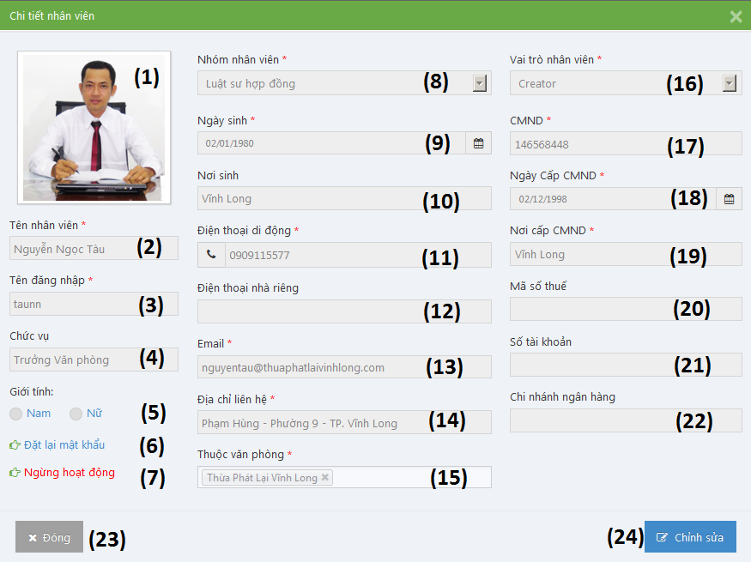

Figure 230: Staff Detail Screen Image

##### Staff Detail Description

|  |  |  |  |
| --- | --- | --- | --- |
| No | Name | Type | Description |
| 1 | Image of staff | Image | Image of staff |
| 2 | Tên nhân viên | Textbox | Name of staff |
| 3 | Tên đăng nhập | Textbox | Username of staff |
| 4 | Chức vụ | Textbox | Position of staff |
| 5 | Giới tính | Radio button | Choose sex of staff |
| 6 | Đặt lại mật khẩu | Link | Reset password of staff to default |
| 7 | Ngừng hoạt động / Hoạt động lại | Link | Change status of staff |
| 8 | Nhóm nhân viên | Textbox | Select group of staff |
| 9 | Ngày sinh | Datetime picker | Date of birth of staff |
| 10 | Nơi sinh | Textbox | Place of birth of staff |
| 11 | Điện thoại di động | Textbox | Phone number of staff |
| 12 | Điện thoại nhà riêng | Textbox | Telephone of staff |
| 13 | Email | Textbox | Email of staff |
| 14 | Địa chỉ liên hệ | Textbox | Address of staff |
| 15 | Thuộc văn phòng | Multiple select box | Select office of staff |
| 16 | Vai trò nhân viên | Select box | Select role of staff |
| 17 | CMND | Textbox | Indentity number of staff |
| 18 | Ngày cấp CMND | Datetime picker | Date of Identity of staff |
| 19 | Nơi cấp CMND | Textbox | Place of Identity of staff |
| 20 | Mã số thuế | Textbox | Tax number of staff |
| 21 | Số tài khoản | Textbox | Bank account number of staff |
| 22 | Chi nhánh ngân hàng | Textbox | Name of bank of staff |
| 23 | Đóng | Button | Close Popup and back to list staff screen. |
| 24 | Lưu chỉnh sửa | Button | Update staff information to database |

### Service

#### All Services

##### All Services Screen Image

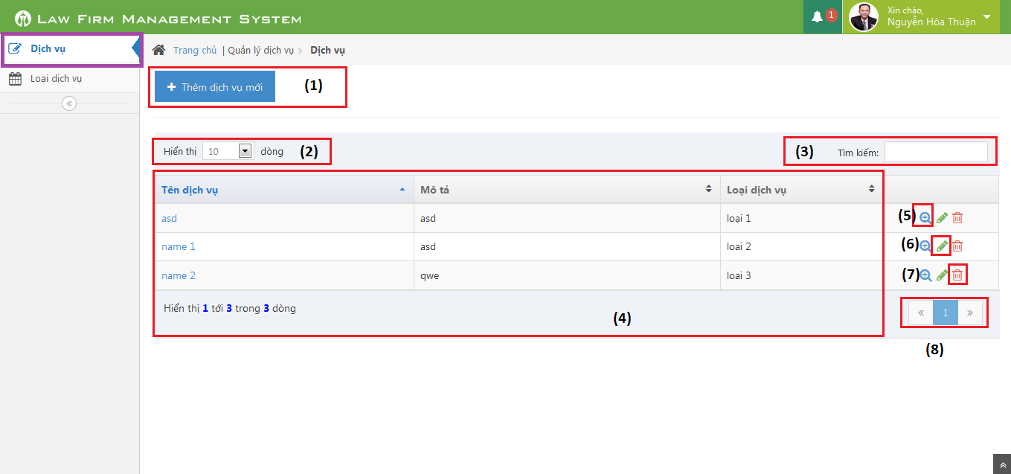

Figure 231: All Services Screen Image

##### All Services Description

|  |  |  |  |
| --- | --- | --- | --- |
| No | Name | Type | Description |
| 1 | Thêm dịch vụ mới | Button | Add new service |
| 2 | Dòng hiển thị | Combo-box | Rows of record in table |
| 3 | Tìm kiếm | Textbox | Search service |
| 4 | List Services | Table | List all services |
| 5 | View customer detail | Icon | Show Customer detail pop-up |
| 6 | Edit customer | Icon | Show edit customer pop-up |
| 7 | Delete customer | Icon | Delete customer |
| 8 | Paging | Button | Paging the customer list |

#### Service Detail

##### Service Detail Screen Image

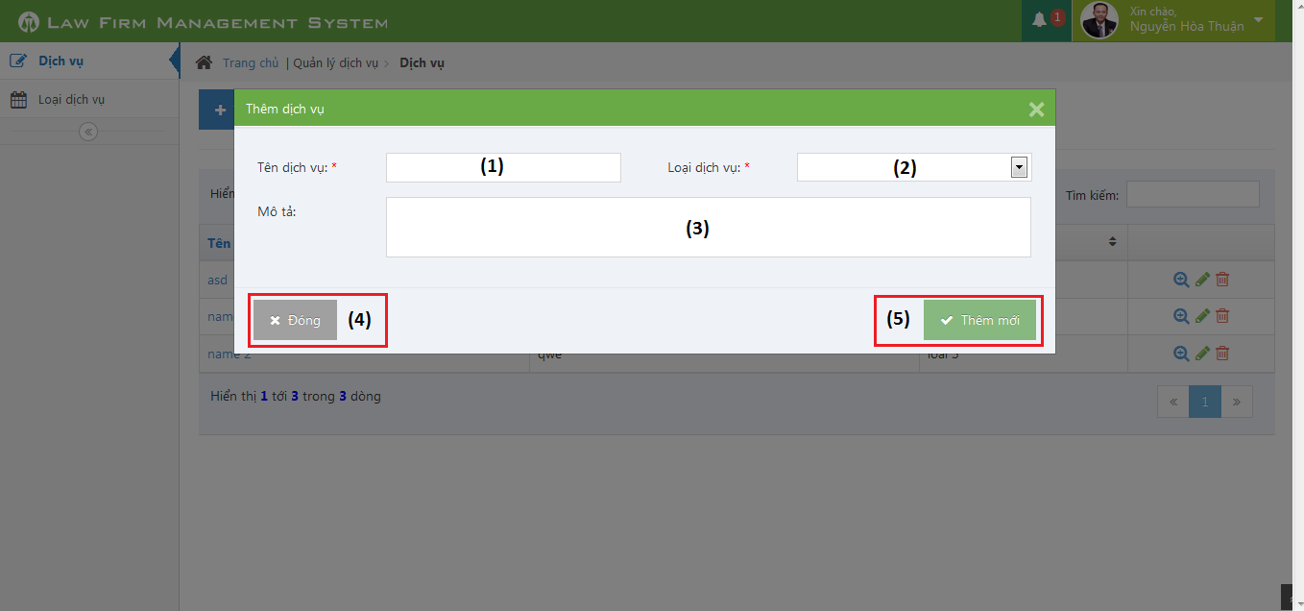

Figure 232: Service Detail Screen Image

##### Service Detail Description

|  |  |  |  |
| --- | --- | --- | --- |
| No | Name | Type | Description |
| 1 | Tên dịch vụ | Textbox | Add new service |
| 2 | Loại dịch vụ | Combo-box | Service type |
| 3 | Mô tả | Text area | Description |
| 4 | Đóng | Button | Close pop-up |
| 5 | Thêm mới | Button | Add new service |

### Office

#### All Offices

##### All Offices Screen Image

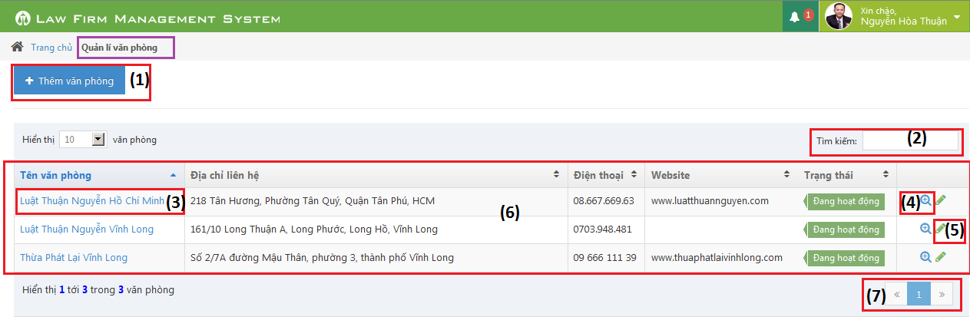

Figure 233: All Offices Screen Image

##### All Offices Description

|  |  |  |  |  |  |
| --- | --- | --- | --- | --- | --- |
| No | Name | | Type | | Description |
| 1 | Thêm văn phòng | Button | | Click to show popup for add new offce | |
| 2 | Tìm kiếm | Textbox | | Search ofice | |
| 3 | Name of office | bable | | Click to show popup detail of office | |
| 4 | View | Button | | Click to show popup detail of office | |
| 5 | Edit | Button | | Click to show popup edit detail of office information. | |
| 6 | List all office | Table | | List all office | |
| 7 | Paging | Button | | Paging page | |

#### Office Detail

##### Office Detail Screen Image

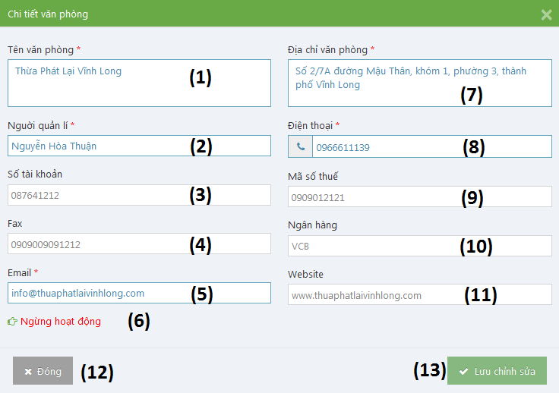

Figure 234: Office Detail Screen Image

##### Office Detail Description

|  |  |  |  |
| --- | --- | --- | --- |
| No | Name | Type | Description |
| 1 | Tên văn phòng | Textbox | Name of office |
| 2 | Người quản lí | Textbox | Nam’s manager of office |
| 3 | Số tài khoản | Textbox | Bank account number of office |
| 4 | Fax | Textbox | Fax of office |
| 5 | Email | Textbox | Email of office |
| 6 | Ngừng hoạt động / Hoạt động lại | Link | Change status of office |
| 7 | Địa chỉ văn phòng | Textbox | Address of office |
| 8 | Điện thoại | Textbox | Phone number of office |
| 9 | Mã số thuế | Textbox | Tax number of office |
| 10 | Số tài khoản | Textbox | Bank account number of office |
| 11 | Ngân hàng | Textbox | Name of bank of office |
| 12 | Đóng | Button | Close Popup and back to list office screen. |
| 13 | Lưu chỉnh sửa | Button | Update office information to database |

### Salary

#### All Salary

##### All Salary Screen Image

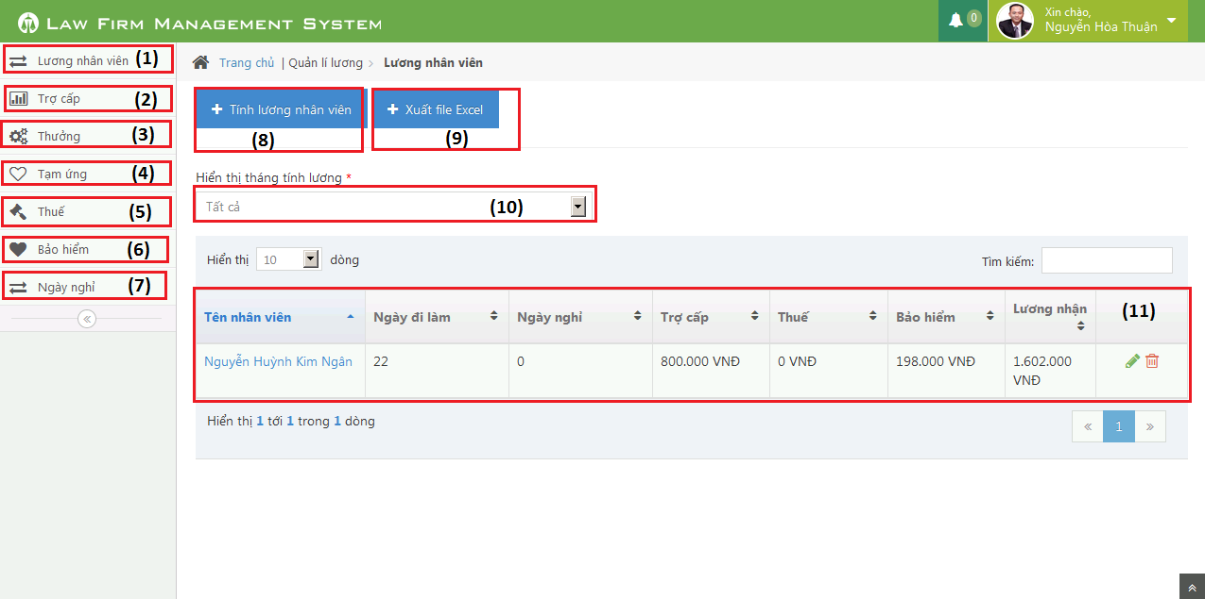

##### All Salary Description

|  |  |  |  |
| --- | --- | --- | --- |
| No | Name | Type | Description |
| 1 | Lương nhân viên | Button | Manager caculator staff’s salary |
| 2 | Trợ cấp | Button | Manager benefit |
| 3 | Thưởng | Button | Manager reward |
| 4 | Tạm ứng | Button | Manager impress |
| 5 | Thuế | Button | Manager tax |
| 6 | Bảo hiểm | Button | Manager assurance |
| 7 | Ngày nghỉ | Button | Manager timesheet |
| 8 | Tính lương nhân viên | Button | Caculator staff’s salary |
| 9 | Xuất file excel | button | Export to excel |
| 10 | Hiển thị lương nhân viên theo tháng | Textbox | Sort staff’s salary by month |
| 11 | Table lương nhân viên | table | Table diplay all staff’s salary |

### Salary Detail

##### Salary Detail Screen Image

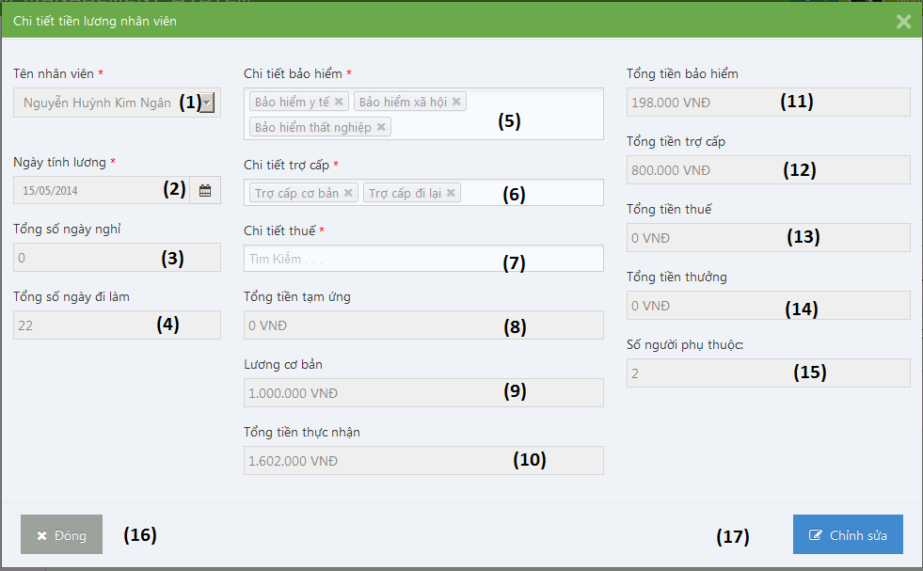

##### Salary Detail Description

|  |  |  |  |
| --- | --- | --- | --- |
| No | Name | Type | Description |
| 1 | Tên nhân viên | Textbox | Name’s staff |
| 2 | Ngày tính lương | Textbox | Date count salay |
| 3 | Tổng số ngày nghỉ | Textbox | Total absent |
| 4 | Tổng số ngày đi làm | Textbox | Total present |
| 5 | Chi tiết bảo hiểm | Textbox | Detail assurance |
| 6 | Chi tiết trợ cấp | Textbox | Detail benefit |
| 7 | Chi tiết thuế | Textbox | Detail tax |
| 8 | Tổng tiền tạm ứng | Textbox | Total impress |
| 9 | Lương cơ bản | Textbox | Base salary |
| 10 | Tổng tiền thực nhận | Textbox | Actual money |
| 11 | Tổng tiền bảo hiểm | Textbox | Total assurance |
| 12 | Tổng tiền trợ cấp | Textbox | Total benefit |
| 13 | Tổng tiền thuế | Textbox | Total tax |
| 14 | Tổng tiền thưởng | Textbox | Total rewward |
| 15 | Số người phụ thuộc: | Textbox | Number people |
| 16 | Đóng | Button | Close pop up |
| 17 | Chỉnh sửa | Button | Edit satff salary |

1. Database Design

### Relational Database Diagram

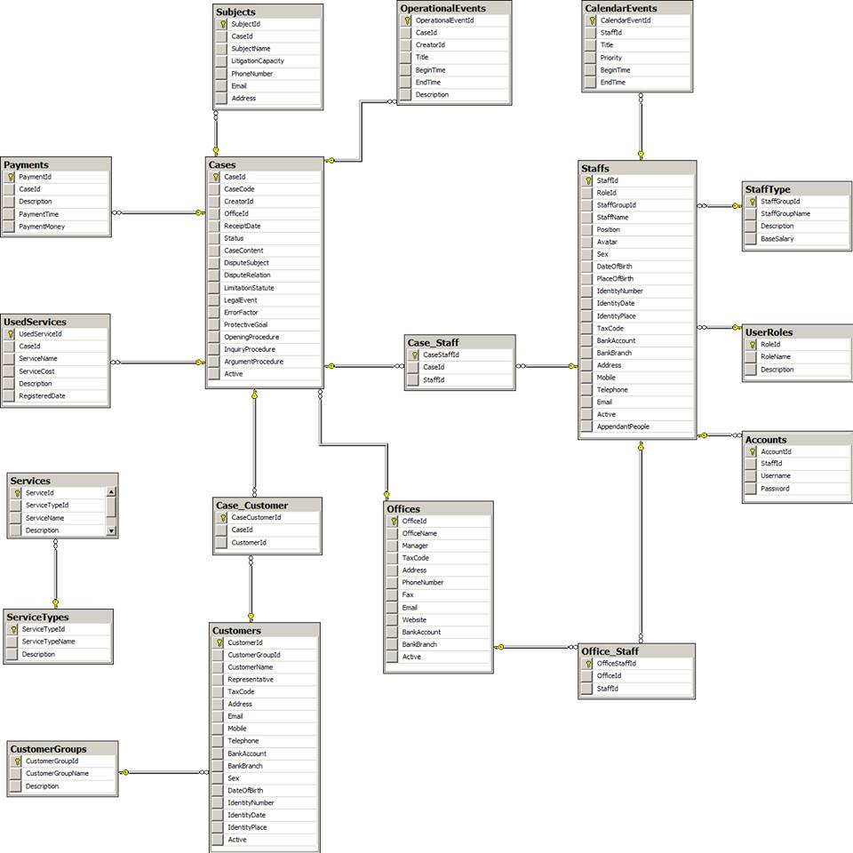

Figure 235: Relational Database Diagram

### Table Dictionary

#### Cases Table

|  |  |  |  |  |
| --- | --- | --- | --- | --- |
| Field Name | Type | Null | P/F Key | Thuật ngữ tiếng Việt |
| CaseId | int |  | PK |  |
| CaseCode | nvarchar(50) |  |  | Mã hồ sơ |
| CreatorId | int |  | FK |  |
| OfficeId | int |  | FK |  |
| ReceiptDate | date |  |  | Ngày thụ lý |
| Status | nvarchar(50) |  |  | Trạng thái hồ sơ |
| CaseContent | nvarchar(MAX) |  |  | Nội dung |
| DisputeSubject | nvarchar(MAX) | x |  | Đối tượng tranh chấp |
| DisputeRelation | nvarchar(MAX) | x |  | Quan hệ tranh chấp |
| LimitationStatute | nvarchar(MAX) | x |  | Thời hiệu |
| LegalEvent | nvarchar(MAX) | x |  | Sự kiện pháp lý |
| ErrorFactor | nvarchar(MAX) | x |  | Yếu tố lỗi |
| ProtectiveGoal | nvarchar(MAX) | x |  | Mục tiêu bảo vệ |
| OpeningProcedure | nvarchar(MAX) | x |  | Phần thủ tục bắt đầu |
| InquiryProcedure | nvarchar(MAX) | x |  | Phần thủ tục xét hỏi |
| ArgumentProcedure | nvarchar(MAX) | x |  | Phần tranh luận |
| Active | bit |  |  |  |

#### OperationEvents Table

|  |  |  |  |  |
| --- | --- | --- | --- | --- |
| Field Name | Type | Null | P/F Key | Thuật ngữ tiếng Việt |
| OperationalEventId | int |  | PK |  |
| CaseId | int |  | FK |  |
| CreatorId | int |  | FK |  |
| Title | nvarchar(100) |  |  | Tiêu đề |
| BeginTime | datetime |  |  | Thời gian bắt đầu |
| EndTime | datetime |  |  | Thời gian kết thúc |
| Description | nvarchar(MAX) | x |  | Mô tả nội dung |

#### Subjects Table

|  |  |  |  |  |
| --- | --- | --- | --- | --- |
| Field Name | Type | Null | P/F Key | Thuật ngữ tiếng Việt |
| SubjectId | int |  | PK |  |
| CaseId | int |  | FK |  |
| SubjectName | nvarchar(50) |  |  | Tên chủ thể |
| LitigationCapacity | nvarchar(50) |  |  | Tư cách tố tụng |
| PhoneNumber | nvarchar(20) | x |  | Số điện thoại |
| Email | nvarchar(50) | x |  | Hòm thư |
| Address | nvarchar(100) | x |  | Địa chỉ |

#### UsedServices Table

|  |  |  |  |  |
| --- | --- | --- | --- | --- |
| Field Name | Type | Null | P/F Key | Thuật ngữ tiếng Việt |
| UsedServiceId | int |  | PK |  |
| CaseId | int |  | FK |  |
| ServiceName | nvarchar(50) |  |  | Tên dịch vụ sử dụng |
| ServiceCost | int |  |  | Chi phí của dịch vụ |
| RegisteredDate | date |  |  | Ngày đăng ký dịch vụ |
| Description | nvarchar(MAX) |  |  | Mô tả chi tiết |

#### Payments Table

|  |  |  |  |  |
| --- | --- | --- | --- | --- |
| Field Name | Type | Null | P/F Key | Thuật ngữ tiếng Việt |
| PaymentId | int |  | PK |  |
| CaseId | int |  | FK |  |
| Description | nvarchar(MAX) |  |  | Mô tả chi tiết |
| PaymentTime | datetime |  |  | Thời gian thanh toán |
| PaymentMoney | int |  |  | Số tiền thanh toán |

#### Staffs Table

|  |  |  |  |  |
| --- | --- | --- | --- | --- |
| Field Name | Type | Null | P/F Key | Thuật ngữ tiếng Việt |
| StaffId | int |  | PK |  |
| StaffGroupId | int |  | FK |  |
| StaffName | nvarchar(50) |  |  | Tên nhân viên |
| Position | nvarchar(50) | x |  | Chức vụ |
| Avatar | nvarchar(100) | x |  | Đường dẫn ảnh đại diện |
| Sex | nvarchar(30) | x |  | Giới tính |
| DateOfBirth | date |  |  | Ngày sinh |
| PlaceOfBirth | nvarchar(100) | x |  | Nơi sinh |
| IdentityNumber | nvarchar(12) |  |  | Số CMND |
| IdentityDate | date |  |  | Ngày cấp |
| IdentityPlace | nvarchar(50) |  |  | Nơi cấp |
| TaxCode | nvarchar(14) | x |  | Mã số thuế |
| BankAccount | nvarchar(20) | x |  | Số TK ngân hàng |
| BankBranch | nvarchar(50) | x |  | Chi nhánh ngân hàng |
| Address | nvarchar(100) |  |  | Địa chỉ |
| Mobile | nvarchar(20) |  |  | Số di động |
| Telephone | nvarchar(20) | x |  | Số máy bàn |
| Email | nvarchar(50) |  |  | Hòm thư |
| Active  AppendantPeople | bit  int | x |  | Người phụ thuộc |

#### StaffType Table

|  |  |  |  |  |
| --- | --- | --- | --- | --- |
| Field Name | Type | Null | P/F Key | Thuật ngữ tiếng Việt |
| StaffGroupId | int |  | PK |  |
| StaffGroupName | nvarchar(50) |  |  | Tên nhóm nhân viên |
| Description  BaseSalary | nvarchar(MAX)  float | x  x |  | Mô tả chi tiết  Lương cơ bản |

#### UserRoles Table

|  |  |  |  |  |
| --- | --- | --- | --- | --- |
| Field Name | Type | Null | P/F Key | Thuật ngữ tiếng Việt |
| RoleId | int |  | PK |  |
| RoleName | nvarchar(50) |  |  | Tên vai trò |
| Description | nvarchar(MAX) | x |  | Mô tả chi tiết |

#### Accounts Table

|  |  |  |  |  |
| --- | --- | --- | --- | --- |
| Field Name | Type | Null | P/F Key | Thuật ngữ tiếng Việt |
| AccountId | int |  | PK |  |
| StaffId | int |  | FK |  |
| RoleId | int |  | FK |  |
| Username | nvarchar(50) |  |  | Tên đăng nhập |
| Password | nvarchar(50) |  |  | Mật khẩu |

#### CalendarEvents Table

|  |  |  |  |  |
| --- | --- | --- | --- | --- |
| Field Name | Type | Null | P/F Key | Thuật ngữ tiếng Việt |
| CalendarEventId | int |  | PK |  |
| StaffId | int |  | FK |  |
| Title | nvarchar(100) |  |  | Tiêu đề |
| Priority | nvarchar(50) |  |  | Mức độ ưu tiên |
| BeginTime | datetime |  |  | Thời gian bắt đầu |
| EndTime | datetime |  |  | Thời gian kết thúc |

#### Customers Table

|  |  |  |  |  |
| --- | --- | --- | --- | --- |
| Field Name | Type | Null | P/F Key | Thuật ngữ tiếng Việt |
| CustomerId | int |  | PK |  |
| CustomerGroupId | int |  | FK |  |
| CustomerName | nvarchar(50) |  |  | Tên khách hàng |
| Representative | nvarchar(50) | x |  | Người đại diện |
| TaxCode | nvarchar(14) | x |  | Mã số thuế |
| Address | nvarchar(100) |  |  | Địa chỉ |
| Email | nvarchar(50) |  |  | Hòm thư |
| Mobile | nvarchar(20) |  |  | Số di động |
| Telephone | nvarchar(20) | x |  | Số máy bàn |
| BankAccount | nvarchar(20) | x |  | Số TK ngân hàng |
| BankBranch | nvarchar(50) | x |  | Chi nhánh ngân hàng |
| Sex | nvarchar(20) | x |  | Giới tính |
| DateOfBirth | date | x |  | Ngày sinh |
| IdentityNumber | nvarchar(12) | x |  | Số CMND |
| IdentityDate | date | x |  | Ngày cấp |
| IdentityPlace | nvarchar(50) | x |  | Nơi cấp |
| Active | bit |  |  |  |

#### CustomerGroups Table

|  |  |  |  |  |
| --- | --- | --- | --- | --- |
| Field Name | Type | Null | P/F Key | Thuật ngữ tiếng Việt |
| CustomerGroupId | int |  | PK |  |
| CustomerGroupName | nvarchar(50) |  |  | Tên nhóm khách hàng |
| Description | nvarchar(MAX) | x |  | Mô tả chi tiết |

#### Offices Table

|  |  |  |  |  |
| --- | --- | --- | --- | --- |
| Field Name | Type | Null | P/F Key | Thuật ngữ tiếng Việt |
| OfficeId | int |  | PK |  |
| OfficeName | nvarchar(100) |  |  | Tên văn phòng |
| Manager | nvarchar(50) |  |  | Quản lý |
| TaxCode | nvarchar(14) | x |  | Mã số thuế |
| Address | nvarchar(100) |  |  | Địa chỉ |
| PhoneNumber | nvarchar(20) |  |  | Số điện thoại |
| Fax | nvarchar(20) | x |  | Số Fax |
| Email | nvarchar(50) |  |  | Hòm thư |
| Website | nvarchar(50) | x |  | Địa chỉ web |
| BankAccount | nvarchar(20) | x |  | Số TK ngân hàng |
| BankBranch | nvarchar(50) | x |  | Chi nhánh ngân hàng |
| Active | bit |  |  |  |

#### Services Table

|  |  |  |  |  |
| --- | --- | --- | --- | --- |
| Field Name | Type | Null | P/F Key | Thuật ngữ tiếng Việt |
| ServiceId | int |  | PK |  |
| ServiceTypeId | int |  | FK |  |
| ServiceName | nvarchar(50) |  |  | Tên dịch vụ |
| Description | nvarchar(MAX) | x |  | Mô tả chi tiết |

#### ServiceTypes Table

|  |  |  |  |  |
| --- | --- | --- | --- | --- |
| Field Name | Type | Null | P/F Key | Thuật ngữ tiếng Việt |
| ServiceTypeId | int |  | PK |  |
| ServiceTypeName | nvarchar(50) |  |  | Tên loại dịch vụ |
| Description | nvarchar(MAX) | x |  | Mô tả chi tiết |

Bữa tiệc nào cũng phải tàn. Cuộc tình nào rồi cũng tan, nhanh hay muộn là do mỗi người. Vậy là đã 2 lần, nhiều lần rồi cô đơn vẫn ko từ bỏ tôi. Nó theo tôi như bóng với hình. 16t lần đầu tôi biết. Biết thế nào là mộng vs mơ, biết thế nào là yêu vs nhớ...  
16T tôi quen ai. Ai đó làm tôi tưởng nhầm đó là tình yêu. Nhưng hoá ra, chỉ là trò đùa, là cơn khát mà ai đó xem tôi như nước. Qen ko lâu nhưng tôi cũng buồn tôi cũng sầu và tôi cũng nhớ. Nhưng nỗi thất vọng đó bỗng xoá nhoà khi tôi biết anh.Quen dc anh đó là niềm vui to lớn. Yêu dc anh, hạnh phúc ngập tràn. 17T- tôi yêu anh. Anh ko đẹp nhưng anh rất tốt. Anh ko đẹp nhưng rất yêu tôi. Yêu tôi lúc ấy. Khoảng thời gian đó, một năm thôi cũng đã quá lớn đối với tôi say trong hạnh phúc. Nghĩ lại mà đau...   
Chuyện trên đời không ai biết trc. Hợp tan là lẽ thường tình. Nhưng làm sao tôi phải chấp nhận sự thật này. Hạnh phúc như giấc mơ và tôi đã mơ 365 ngày, đến lúc cũng phải tỉnh dậy. Sự thật phũ phàng nhưng vẫn là sự thật. Ngày tôi quen anh cũng là ngày chia ly. Lúc đó, lúc mà nghe anh nói, tôi dường như không còn là mình nữa. Tôi tức giận, tôi gào thét, tôi như muốn gặp anh mà đâm lấy một phát. Suy nghĩ lúc đó, thật nông nổi. Ko thể chấp nhận dc, tôi ko còn cách nào là khóc. Khóc ngày khóc đêm, khóc trong bóng tối, khóc khi nghe anh nói: mình chia tay. Vừa khóc, tôi vừa nhớ lại giấc mơ của trăm ngày qua. Bao nhiêu niềm vui lúc ấy cũng không thể xóa đi nước mắt bây giờ. Bao nhiêu kỉ niệm lúc ấy, hiện về rất rõ, rõ đến nỗi tôi ko thể nào ngừng khóc và nhớ về anh. Nếu vô tình anh biết dc những dòng này, chắc có lẽ sẽ bật cười và nói: mày ngu quá đi.  
ừ thì tôi ngu. Ừ thỉ tôi yêu anh. Tôi sẽ ngu về tất cả nhưng chắc một điều, yêu anh là ko ngu.   
Bởi yêu anh tôi như đứa trẻ dc nuông chiều, dc tự do, và biết nhiều điều lạ. Anh là một con người đầu tiên yêu tôi thật lòng.  
Nhưng tất cả giờ đây chỉ còn trong suy tưởng của tôi. Anh đã xa tôi thật rồi. Cũng đã gần nửa tháng nhưng tôi vẫn nhớ về anh. Nhớ nụ cười, ánh mắt ấy và cả lời nói đùa. Nếu có một điều ước ngay lúc này, tôi sẽ ước rằng: anh hãy là anh của ngày xưa, một người yêu tôi thật lòng, một người làm tất cả vì tôi.  
Giờ đây, vắng anh, tôi ko còn dc nghe sự quan tâm, tôi ko còn ai lo lắng. Trách tôi lúc ấy, quá vô tư quá thờ ơ để rồi mất anh trong nước mắt. Tin nhắn cuối anh trao tôi là chúc em sống tốt nhưng anh biết ko: hạnh phúc tôi còn ko biết giữ thì tương lai có đến rồi cũng đi. Ko có gì đau hơn khi mất anh. Ko có gì tồi tệ khi giờ phút này đây tôi viết lên tâm sự này. Yêu anh, nhớ anh sẽ là việc làm thường xuyên dù ai có nói tôi ngu. Quá khứ tôi có thể quên nhưng tình yêu tôi trao anh sẽ mãi như lúc này, bởi tôi tự hứa với lòng rằng: Khép trái tim lại... Thơ ơi!